Autonomous Dalek Project Report

Tom Queen

10286169

Contents

Introduction 7

Abstract 7

Research 8

Types of sensor 8

Overview 8

Depth map (Kinect) 8

Stereo vision 9

Odometry 9

IMU 10

Ultrasonic range finders 11

Encoders 13

Testing 16

Initial prototype design 17

Overview 17

Sensors used 17

ROS 19

Terminology 19

Overview 19

Rosserial 19

SLAM 20

Smach 20

Ostmaps 21

Interfacing to the wheelchair 21

Overview 21

CAN/DX BUS 21

Membrane keypad 22

Batteries 22

Joystick 22

Microcontroller 23

Theory 23

ROS 23

TF 23

Costmaps 24

Build 28

Base 28

ROS 29

Move_base.launch 29

31

Costmap configuration 32

Local_costmap_prarams.yaml 32

Global_costmap_params.yaml 32

Costmap_common_params.yaml 33

Base planner configuration 33

Base_local_planner_params.yaml 33

Ultrasonics 34

PCB 35

Schematics 35

36

Board layout 37

Arduino Nano Pinout 38

Modifications 38

Changing microcontroller 38

Pin remapping 38

Level shifter 38

Using wheelchair controllers regulated voltage reference 40

Voltage level recalibration 41

Controller enable circuit 42

Odometry 43

Rationale 43

Code 44

Results 46

ROSbag 48

Overview 48

Code 48

Smach 50

States implemented 51

Foo and Bar 51

Launch-State 51

Wait-state 52

Goal set state 52

Goal check state 52

Code 53

Motor control 57

59

Encoders 59

Sensor box 59

Encoder wheel 65

Circuit 68

Code 69

Issues 70

Result 72

PID 72

Rationale 72

Controlling robots rotation and forward velocity 75

Results 81

Controlling robots left and right wheels 82

Results 86

Velocity limit control 87

Testing 87

RPLIDAR modifications 88

Testing 89

Tkinter 89

Overview 89

Specifications 90

How to use the Robot 91

ROS network setup 91

Robot setup 93

Waypoints and patrol routes 95

Conclusion 96

References 96

Bibliography 97

Appendix 1 – Arduino main code 98

Appendix 2 – dalekMotors.cpp 114

Appendix 3 – dalekMotors.h 116

Appendix 4 – dalekSonics.cpp 117

Appendix 5 – dalekSonics.h 118

Appendix 6 – Modified ros.h 119

Appendix 7 – Full tkinter GUI and smach state machine 120

Appendix 8 – Gantt chart – initial 144

Appendix 9 – Gantt chart – rev 2 145

Appendix 10 – Gantt chart - rev 3 146

# Introduction

Autonomous robotic systems have advanced significantly over the last two decades. However, autonomous robots are still almost entirely constrained to research laboratories with large budgets. This report describes the theory and process of developing a stable robotic platform based on ROS (Robot Operating System) with the aim of autonomous navigation which can be built on by future students.

The PR2 robot from willow garage is at the cutting edge of autonomous robotic research. It consists of two robotic grippers, two on-board Xeon servers (each with 8-core i7 processors and 24GB RAM), two LIDARS and a host of other sensor systems. The PR2 robot is built by willow garage, who designed ROS.

The PR2 robot costs over $360,000.

This project will attempt to approach the autonomous navigation capabilities of the PR2 robot within the constraints of a £100 budget, a £250 LIDAR and two laptop computers.

# Abstract

In this project an autonomous robot platform is being constructed. The chassis will be the base of an electric wheelchair. LIDAR, ultrasonic range-finders, wheel encoders and remote control systems will be utilised to provide autonomous navigational functionality. The main processing unit of the robot will be an on-board laptop, with a remote laptop connected via Wi-Fi used to present data about the robots environment and send objectives to the robot. A waypoint and patrol route system will be developed, as well as a remote graphical user interface (GUI) to allow untrained personal to interact with the robot.

# Research

## Types of sensor

### Overview

There are numerous sensors available for robotic development applications, each with varying degrees of usefulness depending on the task at hand. Generally for SLAM applications multiple sensors are used, some complimentary and some redundant (MOSHE KAM, 1997). Data from various sensors is fused together to build up a picture of the robots location and environment.

### Depth map (Kinect)

The Kinect from Microsoft is a low-cost depth mapping solution. The first model combined a structured light projector with an infrared camera and an RGB camera, along with a four-element microphone array. The second model (Kinect for Xbox One) replaces the structured light projector for a time of flight based sensor (Hamed Sarbolandi, 2015). Using the microphone array, the Kinect can locate where a sound is coming from and uses this information to isolate audio streams and remove unwanted echoes and other noises in the room (Microsoft, 2017).

The low cost of this widely available sensor makes it a potentially attractive option for self-navigating robotic systems. For this reason, a prototype was built using this sensor for SLAM. A video of this prototype can be viewed here: <https://www.youtube.com/watch?v=BFhCPYAblIw> .

The package RGBDslam was cloned to the local ROS workspace and a Kinect was placed on the SLAMbot prototype platform. As you can see from the video above, upon moving the robot immediately loses track of its location and at no point manages to resolve this incorrect location estimate. A further drawback is that the Kinect requires an external 12V power supply. As the robot is designed to be a mobile platform, a mains to 12V converter would not be suitable. A 12V supply could be build but it would require modification of the Kinect hardware.

It may be possible to significantly improve the localisation abilities of a Kinect based system using odometry information from wheel encoders. However, by observing how poorly the robot performed using a Kinect it was assumed that the odometry would have to be very accurate for this to be a viable option. It was for these reasons that the Kinect was discarded as a potential localisation sensor.

Another option regarding the Kinect would be to generate odometry from an additional laser scanner.

A Kinect would bring the additional functionality to the robot in the form of gesture recognition and voice detection. However, the Kinect requires the background of a scene to remain stationary for gesture recognition to take place so the robot would have to stop moving in order to identify persons.

### Stereo vision

Stereo vision is another popular approach to robot localisation and mapping. Stereo vision is where two parallel cameras are placed a known distance apart. By identifying groups of pixels and calculating the horizontal shift between the two images, a computer can calculate the distance between the cameras and the identified pixels.

Stereo vision works well in textured environments, as it is easier to find the same group of pixels in both images. If a stereo vision system is looking at a blank wall however, it generally doesn’t find any uniquely matching points and cannot calculate the distance to the wall. Stereo vision requires a well-lit area, whereas LIDAR can operate in the dark as it generates its own laser points.

Cameras are very cheap sensors, however stereo vision SLAM is a more computationally intensive approach to localisation (Santo, 2016). As prototypes using LIDAR had already been built and had been found to be very computationally intensive, it was decided that stereo vision would probably result in a significant degradation of robot performance.

For future development, an FPGA-based processor for stereo vision could meet the computational requirements and make the system cheaper.

### Odometry

Odometry is the use of data from motion sensors to estimate change in position over time. It is used in robotics by some legged or wheeled robots to estimate their position relative to a starting location. This method is sensitive to errors due to the integration of velocity measurements over time to give position estimates. Rapid and accurate data collection, instrument calibration, and processing are required in most cases for odometry to be used effectively (Odometry, 2017).

All the SLAM packages available from ROS (except Hector SLAM) require external odometric data. This data is known to be imperfect. Traditional SLAM packages (such as AMCL) take this odometry data as the ‘seed’ for the initial guess of the robots location. By deriving a kinematic model of a differential drive robot and its encoding systems, error covariences can be calculated. These numbers represent how each movement of the robot is likely to affect the uncertainty of the robots position. By tracking how these error covariances affect the system over time, we are able to calculate the certainty with which we know the robots location.

Loop closure is when a SLAM package can recognise that it has been to a location before. When this occurs, the package is able to dramatically increase the certainty of its location. When a SLAM package such as AMCL is used in conjunction with a robot whose error covariences are known, loop closure events trigger the SLAM package to set the odometric error accumulators back down to the certainty with which the loop closure event knows the robots location.

Another benefit of odometry is its forcing the SLAM systems location estimates to be continuous. As Hector SLAM relies only on laser scan data its estimates are discontinuous to aid with the ‘kidnapped robot’ problem, which is where an autonomous robot in operation is carried to another location. Due to this, location estimates from Hector SLAM do not have to be continuous in location. Using wheel odometry and a different SLAM package; if the robot were to ever move too fast and loose itself the odometry from the wheels would tell the SLAM system to make location estimates within the vicinity of the robots last known location.

The initial SLAMbot prototype would sometimes get ‘lost’. If ever it exceeded a velocity of approximately 0.1m/s it would lose track of its location, generally vanishing from the map and reappearing tens of meters away. For this reason, it was decided to encode the wheels of the robot to force location estimates to be continuous, and allow the velocity of the wheels to be controlled closed-loop.

### IMU

An IMU (inertial measurement unit) can provide odometry information to a navigation system, similar to the information from wheel encoders. Using an extended Kalman filter (EKF), gyroscope accelerometer and magnetometer data can be transformed providing a velocity and heading of the robot. This too can have the effect of forcing the location estimates to be continuous. IMUs are cheap sensors due to MEMS technology allowing them to be embedded inside silicon ICs, and with mathematical filtering can provide useable rotation and acceleration information.

An IMU would be a useful addition to this robot and will be strongly considered in future development.

### Ultrasonic range finders

Ultrasonic range-finders provide cheap time of flight based data to robotic systems. Due to the natural divergence of sound waves, their transverse resolution is poor and decreases with distance. Their longitudinal resolution is significantly better (in the range of one to two centimetres for cheap sensors). The poor transverse resolution of the sensor makes it unsuitable for mapping of environments (although still useable for localisation (Teddy N. Yap, 2009)). The very low price of these sensors does make them useful for obstacle avoidance applications. The RPLIDAR has been chosen for this project. It provides only a 2D scan of the room at a single height, and can provide erroneous readings when scanning transparent and reflective surfaces. In combining ultrasonic sensors with LIDAR we are able to increase the obstacle avoiding abilities of the robot for obstacles outside the plane of the laser scanner.

The ultrasonic range-finder chosen was a HC-SR05. This was chosen for its low price and relatively high precision (1cm). This sensor supports two modes of operation, single and dual pin. The timing diagram for dual pin mode can be found in figure 1.

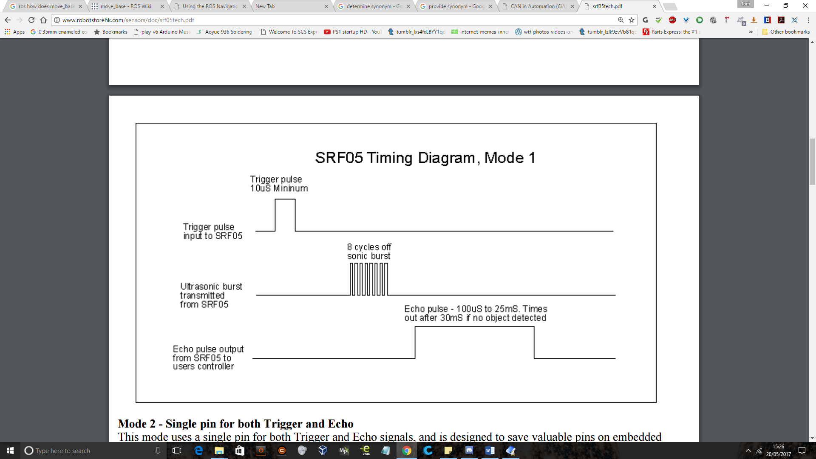

Figure - SRF05 Timing Diagram

The sensor must be connected to a 5V supply to function. The trigger pin is pulled high for a minimum of 10uS before being pulled low again. This causes the SRF05 to release an eight-cycle ultrasonic burst from its transmitter. Once this pulse is released, the SRF05s echo output goes high until the pulse is returned. By measuring the high time of the echo output, we can determine the time of flight of the ultrasonic burst. This duration includes the time taken for the burst to get to an object and then return to the sensor (round trip), so it must be divided by two to get just the duration to the object. By knowing the speed of sound in standard room temperature and pressure to be 340m/s. From this we can derive the following formula:

$d=s* \frac{t}{2}$, where d is distance in meters, s is the speed of sound in m/s and t is time in seconds.

The function on the microcontroller to count the duration of a pulse returns time in microseconds. To save the microcontroller from performing unnecessary calculations with each distance measurement we can simplify the above formula as shown below.

$$d=344*\frac{t}{2}$$

$$d=172*t\left(S\right)$$

$$d=\frac{170}{1x{10}^{6}}*t(μS)$$

$$d=t\left(μS\right)*\frac{170}{{1*10}^{6}}=\frac{t\left(μS\right)}{\left(\frac{1*{10}^{6}}{172}\right)}=\frac{t(μS)}{5800}$$

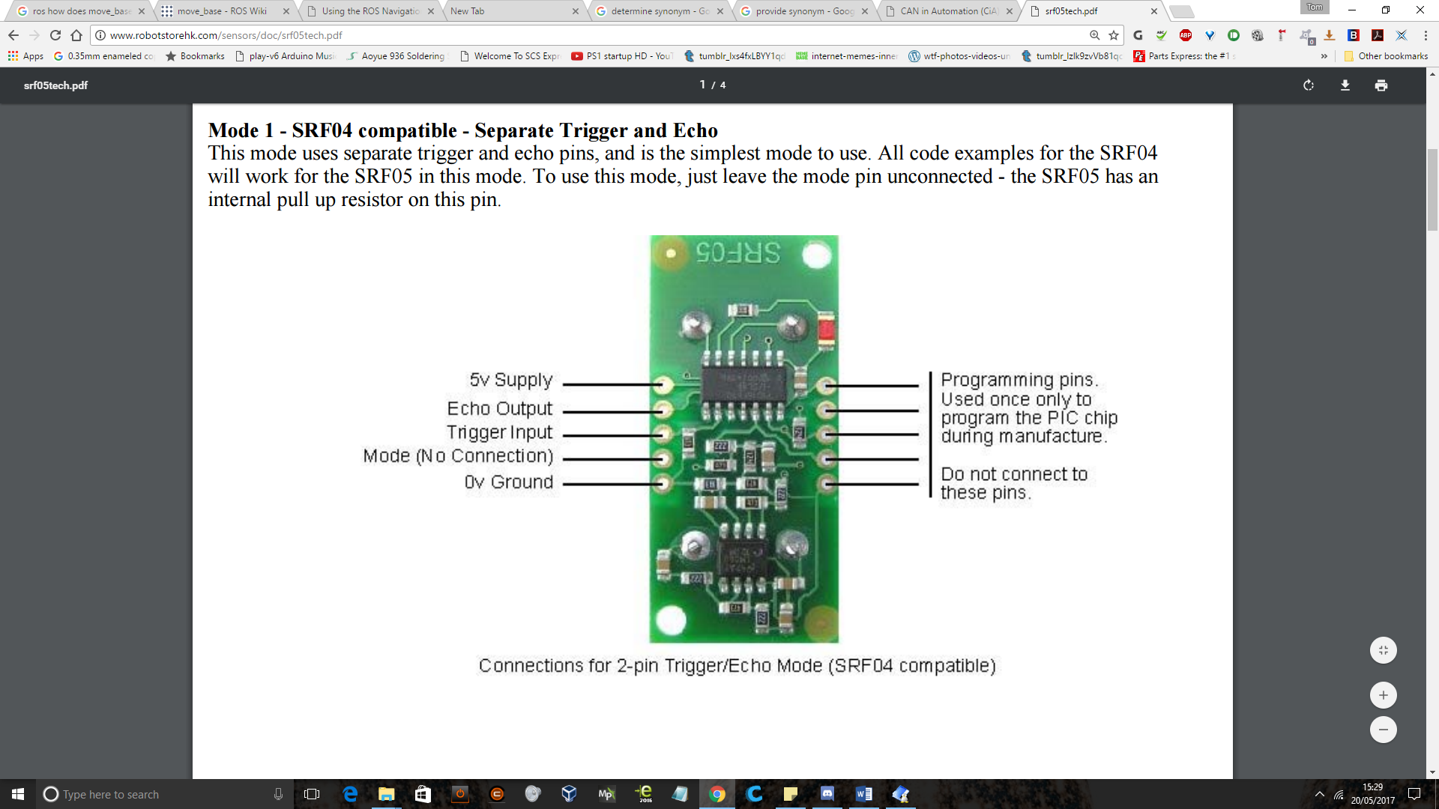

Figure - SRF05 pinout

The other mode of operation with the SRF05 is one pin mode. To activate this mode, the mode pin must be tied to ground.

Echo and trigger are tied together and connected to a digital pin on a microcontroller. The microcontroller sets the pin as an output, pulls it high for 10uS and pulls it low again before switching the pin to an input. The SRF05 will then pulse this pin high for a duration equal to that of the round-trip time of flight.

It was decided to implement the ultrasonic sensors in one pin mode to increase the number of potential ultrasonic sensors on the robot.

### Encoders

To generate the odometry and control the speed of the wheels it was decided to implement quadrature encoding. Absolute encoding was considered, but the added complexity wouldn’t necessarily improve the resolution of the system.

Quadrature encoders work by detecting the passing of markers, often using light or magnetism. A single sensor counting pulses can determine the speed of a rotating wheel. By placing another sensor any number of slots plus half a slot away from the first, and measuring which sensor triggers first, the direction of rotation can be determined. This allows the wheels position and angular velocity to be calculated. Quadrature encoders are relative; in that they can determine the position of the wheel relative to its starting position. However, if the system is restarted, the quadrature encoder normally loses track of the position and subsequent pulses are counted from zero again. To make quadrature encoders absolute, homing switches, non-volatile memory or one pulse per revolution calibration slots could be added. This project does not require absolute encoding, so these methods will not be implemented.

Some test wheels of varying resolutions were generated using the online encoder wheel generator found at <http://www.bushytails.net/~randyg/encoder/encoderwheel.html> . They were printed onto A3 card (figure 1) and moved past the encoder sensor output. The collectors of the phototransistors in the encoder sensor boxes were viewed on an oscilloscope to determine how high a resolution the sensors could work at. The highest resolution test disc (380 divisions, 190 black and 190 white) was clearly identifiable on the oscilloscope and so this resolution was chosen.

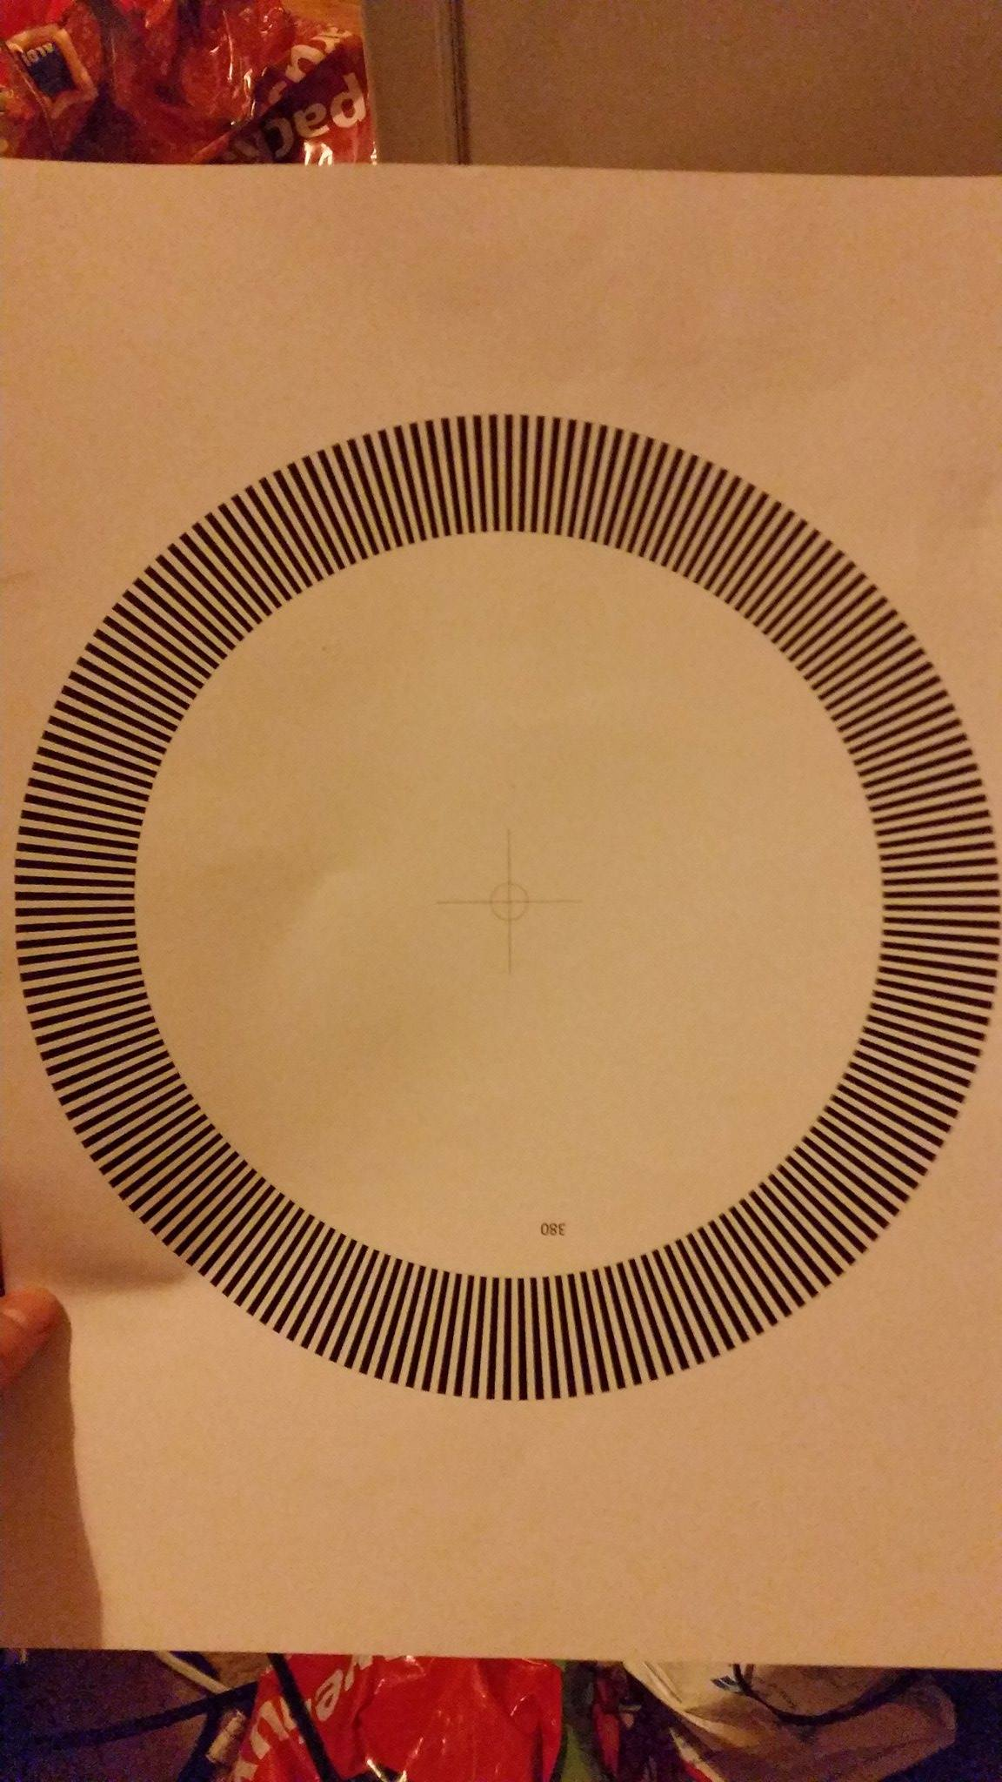

Figure 3 - Test wheel for encoder - 380 divisions

The RPR-220UC30N reflective sensor was chosen for its sensing distance. Most reflective sensors work at a 1mm-2mm range, but the RPR-220 works from 4mm to 14mm. A reflective sensor was chosen instead of a transmissive due to the difficulties involved with positioning sensors on either side of the wheel.

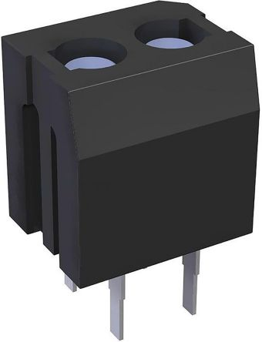

Figure - RPR-220UC30N

The RPR-220 contains an LED and a photo transistor. Graphs 1 – 4 were extracted from the RPR-220 datasheet and used to calculate the collector and LED resistors.

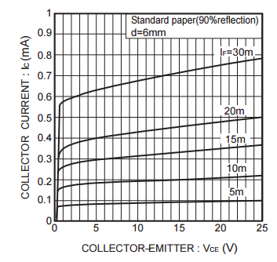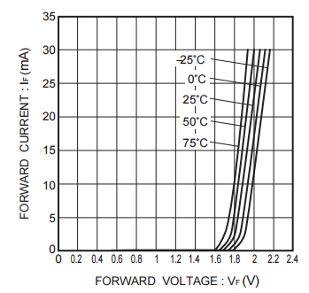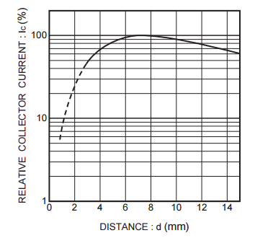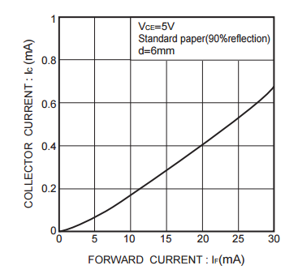

Graph 4 – Output characteristics

Graph 3 – Forward current vs forward voltage

Graph 1 – Reflective output vs distance

Graph 2 – Collector current (Phototransistor) vs forward current (LED)

$$If=15mA$$

$$Ic=0.3mA$$

$$\frac{5v}{0.3mA}=16.66k$$

$$5-\left(16.6k*0.3mA\right)=0.02V$$

$5-\left(16.6k*5nA\right)=$ 4.917V

If 90% reflective paper is 6mm from the sensor and 15mA is flowing through the LED, then the collector current should equal 0.3mA. With a 5V supply, a 16.8k collector resistor will drop 5V and the collector voltage will fall towards zero. If the paper becomes 0% reflective, then at room temperature the transistor should draw 5nA. This will drop 80mV over the resistor, and the collector current will rise to 4.92V.

A 300ohm resistor in series with the LED will let the LED draw 16.6mA.

$$\frac{5}{300}=0.016mA$$

#### Testing

The circuit in schematic 1 was built on a breadboard.

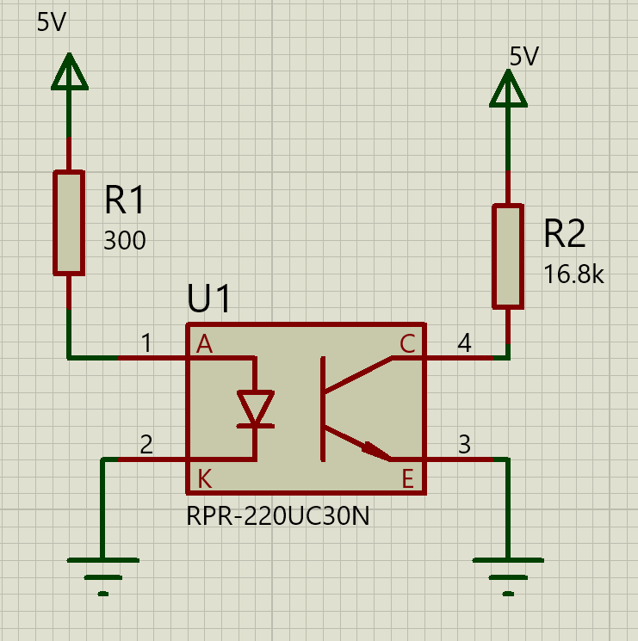

Schematic – Reflective sensor test circuit

The test cards described in the ‘Encoders’ section were placed 12mm from the sensor and moved past the sensor. The collector voltage was measured on an oscilloscope. When a black section was in front of the sensor, the collector voltage was 3.9V. When a white section was in front of the sensor, the collector measured 273mV. This should provide an adequate voltage swing for the microcontroller to detect.

# Initial prototype design

## Overview

As a proof of concept, a prototype was developed before the start of the main project. This prototype consisted of a laptop with an I5 CPU running ROS indigo on Ubuntu, a MDF frame, two geared DC motors, an Arduino and a Hokuyo URG-04X LIDAR.

## Sensors used

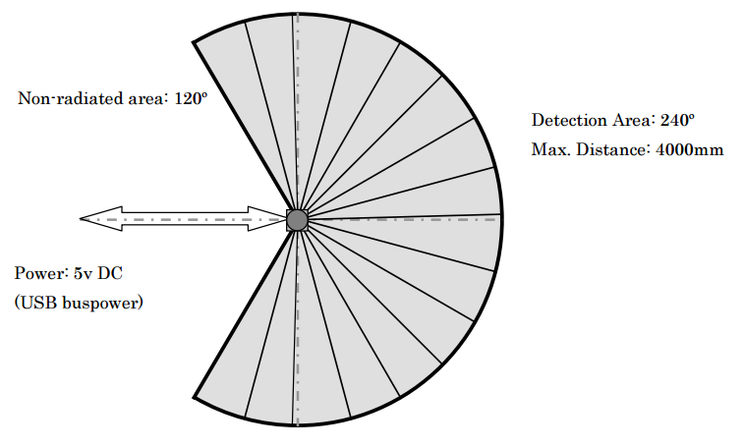The scan area of this sensor is a 240o semicircle with a maximum radius of 4000mm and a minimum radius of 60mm. The angular resolution is approximately 0.36o (360o/1024). Linear accuracy is +-10mm between 60mm and 1000mm, and +-1% of the measurement between 1000mm and 4095mm. This loss of accuracy with range is due to the laser diverging by up to 40mm at a range of 4 meters. The scanning time of this sensor is 100ms, which means that at full speed it is capable of sending full scans to the computer at a rate of 10Hz.

As the Hokuyo LIDAR sensor rotates, it takes a one dimensional measurement of distance every 0.36o. The sensor then sends a long list of distance measurements out for every rotation. A computer is then able to turn these distance measurements into a two-dimensional map by plotting each distance as a point (or a line to a point) relative to the position of the sensor.

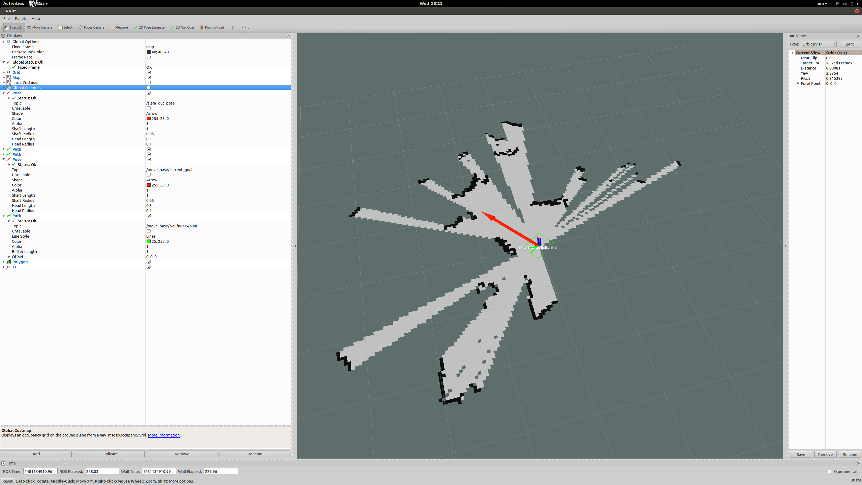

The Hokuyo URG-04LX is designed for indoor use only. This is due to the power and wavelength of the laser that it uses. The laser in this sensor is 785nm which lies in the infrared part of the spectrum, and there is plenty of infrared radiation around to disrupt it. The sun emits radiation across the entire EM spectrum. Some range finding systems which use light to measure distance will not work outdoors as the light they emit can be completely overpowered by the suns EM radiation. Possible solutions to this include using more powerful lasers and choosing a wavelength of light which our upper atmosphere absorbs more of, thus reducing interference from the sun.

Due to the 10Hz update frequency, this laser scanner may not provide enough data to a fast-moving vehicle. An autonomous car traveling at 80 miles per hour will be moving at 35m/s. This Hokuyo scanner would provide it with an updated map every 3.5 meters. This data alone may not be enough for the vehicle to continuously localize itself, although as real would applications would also include a GPS sensor to increase the accuracy of the localization system, this LIDAR may provide enough data for obstacle avoidance in conjunction with other sensor systems.

## ROS

### Terminology

* Nodes: A node is an executable that uses ROS to communicate with other nodes.
* Messages: ROS data type used when subscribing or publishing to a topic.
* Topics: Nodes can publish messages to a topic as well as subscribe to a topic to receive messages.
* Master: Name service for ROS (i.e. helps nodes find each other)
* rosout: ROS equivalent of stdout/stderr
* roscore: Master + rosout + parameter server

(ROS, 2017)

### Overview

Robot operating system (ROS) is a collection of software frameworks used for robot software development. It provides services such as hardware abstraction, low-level device control, passing messages between programmes and package management. Most ROS packages are open source, and there is a large active community. To build packages, ROS uses its own modified version of CMake called catkin. Catkin combines CMake macros and python scripts to add functionality on top of the normal CMake workflow. Some of these additions include automatic ‘find package’ infrastructure and building multiple, interdependent projects simultaneously (ROS, 2017).

ROS packages are downloaded as source code and then built with the catkin_make command. This means that any aspect of any ROS program can be modified and rebuilt quickly. A typical ROS source package is hosted on github and found through google or the ROS wiki. The package is downloaded using ‘git clone’ to a folder named ‘src’ inside the catkin workspace. To build the package, ‘catkin_make’ is called from the catkin workspace root folder. Catkin then calls ‘rosdep’ which attempts to locate and download any missing libraries or dependant packages, before running a modified version of CMake to build the downloaded source code.

### Rosserial

Rosserial is a ROS package which lets an Arduino run as a ROS node, allowing it to publish and subscribe to topics. This provides a breakout board for the ROS system running on a host machine, providing an electronics interface to the software packages running on the machine. See appendices 1 through 5 for the full Arduino code listing which utilised rosserial.

## SLAM

Traditionally it has been possible to generate maps using sensors, and also to use sensor data to localize a robot within a pre-defined map. The problem with this approach is that a robot either has to already have a map of a potentially unknown area, or be manually driven around a building whilst generating maps before it is able to autonomously work out its location. Monte Carlo localization is one approach for localizing within a pre-defined map using a particle filter.

SLAM stands for Simultaneous Localization And Mapping. It was originally developed by Hugh Durrant-Whyte and John J. Leonard based on earlier work by Smith, Self and Cheeseman. Durrant-Whyte and Leonard originally termed it SMAL but it was later changed to give a better impact. SLAM is concerned with the problem of building a map of an unknown environment by a mobile robot while at the same time navigating the environment using the map. SLAM consists of multiple components; Landmark extraction, data association, state estimation, state update and landmark update. SLAM usually uses sensors to map landmarks in a point cloud and will then use landmarks to check for errors in the odometry data and correct its position on the map.

A commonly used program to overcome the problem of SLAM is called AMCL (Adaptive Monte Carlo Localization). This software initially generates a map of its environment, and then takes a pose estimate using data from wheel encoders (odometry). Wheel encoder odometry is notoriously unreliable and suffers from a great deal of drift. AMCL corrects the estimated position from odometry by attempting to match landmarks in laser scans with previously found landmarks, thus reducing the drift of the odometry data and increasing its accuracy. This correction is applied to the robot by AMCL publishing a transformation which describes the robots distance and orientation relative to the robots starting point.

To account for the unreliable odometry from the wheel encoders, a ROS package called Hector SLAM was chosen. Hector SLAM is different from AMCL in that it generates its own virtual odometry data solely by relying on landmarks in the point cloud to determine its position.

## Smach

Smach is a task-level architecture for creating complex, high level robot behaviour. Smach is effectively a python library for the creation, management and introspection of state machines. Each smach state machine can also be a state in a larger state machine, allowing complex nested state machines to be developed.

To use smach, states are defined as classes where the possible outcomes are defined in the initialisation of the class and any functionality is defined in an ‘execute’ method. Once states are defined, a state machine is created in the programs main, and the inter-linking of the states are defined within this state machine.

## Interfacing to the wheelchair

### Overview

Upon initial inspection of the wheelchair base, the 12v SLA (Sealed Lead Acid) batteries read 1MΩ and 1.1V each. The controller wouldn’t turn on (even with an external power supply) and the controller data link to the motor driver appeared to use proprietary messages on a modified CAN bus network.

### CAN/DX BUS

CAN bus signals have four message types, the most common of which is ‘data’. This type consists of four subsections including an 11-bit or 29-bit identifier, a 15-bit checksum, an acknowledgement bit and the message contents. CAN was designed by Bosch for earth moving machines in 1983 to 1987 (CAN In Automation (CIA), 2017). Because of this it relies on very tight timing tolerances and calculates checksums with each received message to ensure system safety at all times.

DXBUS is a private, modified version of CAN bus. It is designed to be a modular power-chair control system which can be adapted for the development of many configurations of wheelchair. The most basic DX configuration possible consists of a DX power module which connects to the batteries and motors, and a DX master remote which connects to the DX power module. The system can be expanded to include lighting and actuation modules, secondary remotes and environmental control modules.

The link between the power module and master remote is a four-element cable. Two high current wires carry the battery voltage to the master remote, and two smaller wires carry the differentially signalled data based off the CAN protocol.

As this is a proprietary system, the messages between the remote and the power module are not freely available. The DX bus company was contacted but were unable to provide any useful information regarding interfacing to the power module.

### Membrane keypad

After speaking to the DX bus technical advisor and upon closer examination of the master remote it was discovered that the only faulty part was the membrane keypad. There are three wires connecting to the ‘on’ button on the keypad. Two are permanently connected and the third is momentarily touched to the other two to trigger a ‘power on’. Manually joining these wires in this configuration resulted in the controller and power module starting up.

### Batteries

The batteries initially measured 1.1v instead of 12v-14.1v, and 1MΩ instead of 20mΩ. Connecting an ammeter across the terminals resulted in microamps flowing through the meter.

To revive the batteries, 30V was put across each set of terminals. Over the next fifteen minutes the internal resistance dropped and the batteries started to take current. The applied voltage was then reduced to 16V and after a few hours down to 14.1V. Over this time the batteries took between 4 and 8 amps each. After a day of charging the batteries seemed to come back to life. However, over a few discharge cycles the batteries capacity dropped again to below useable levels.

### Joystick

The joystick took a 5V power supply from the controller, and returned four signals to the controller. Two were for forwards and reverse, and two were for left and right. Two of these signals appeared to be redundant, and it is hypothesised that they exist for error checking. If the joystick is centred, all the signals read 2.5V. If the joystick is pushed to make the wheelchair move forwards, the first of the forward/backwards pair will rise to 3.5V and the other will drop to 1.5V. Conversely, if the joystick is pushed backwards, the first of the forward/backwards pair will drop to 1.5V and the other will rise to 3.5V. The same applies to the other pair. See page 9 of the logbook for a diagram of this.

If any of the pairs are not symmetrically balanced around 2.5V, the controller flashes an error code and immediately disables the motors. It was discovered that the USB voltage from the laptop connected to the micro varied between 5.01V and 5.16V. These variations caused the controller to detect an imbalance and switch off. It was also discovered that connecting a ground wire from the wheelchair controller to the microcontroller normally caused the wheelchair controller to signal an error code. The ground wire was left disconnected providing no reference voltage between the systems. This worked most of the time until a different power supply was used with the wheelchair base. It was hypothesised that the new power supply was noisier than the old one, and the lack of ground reference was causing large voltage swings between the systems. This was later amended and can be read about further in the ‘Modifications’ section of ‘PCB’ in ‘Build’.

### Microcontroller

It was decided to use a microcontroller to emulate the joystick signals. An Arduino nano was initially chosen due to its small footprint and compatibility with rosserial. The arduinos analog output is actually a PWM signal, which requires low-pass filtering to turn it into a DC signal with voltage equal to the duty cycle multiplied by the supply voltage. This microcontroller was later upgraded.

# Theory

## ROS

### TF

The TF (Transformation Frame) package in ROS is designed to let the user keep track of multiple coordinate frames over time. Tf maintains the relationship between coordinate frames in a tree structure buffered in time, and lets the user transform points, vectors, etc between any two coordinate frames at any desired point in time. (ROS wiki, 2017)

Most ROS packages use TF. For example, if a 1x1 meter square robot has data from an ultrasound sensor saying an obstacle is 55cm away from it, the position of the senor on the robot must be known for the obstacle avoidance systems to respond accordingly. If the sensor is at the front of the robot, then we know an obstacle is 55cm in front of the robot. If, however, the sensor is in the centre of the robot then the obstacle will be only 5cm in front of the robot. This applies to most sensors on a robotic platform.

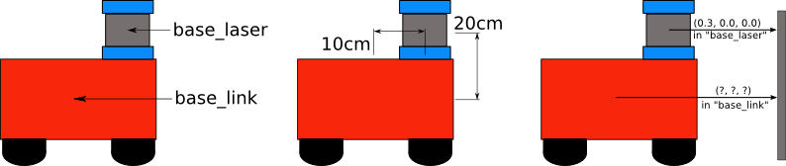

There are three main ways to use TF. Static publishers, URDF models with the robot state publisher and dynamic publishers. Static publishers provide a constant, fixed transform between two frames. Static transforms can be set-up in launch files using the following syntax:

<node pkg="tf" type="static_transform_publisher" name="name_of_publisher" args="x y z yaw pitch roll frame_id child_frame_id period_in_ms" />

An example publisher is shown below:

<node pkg="tf" type="static_transform_publisher" name="world_to_map_broadcaster" args="0 0 0 0 0 0 world map 40" />

The above line creates a static publisher called ‘world_to_map_broadcaster’ between the ‘world’ and ‘map’ frames. The arguments say that their origins are the same and that an error should be generated if the transform isn’t republished within 40mS.

Where ‘Name=’ is the name of the publisher. The ‘args=’ section describes the transform, the frames to apply the transform to and the timeout tolerance.

Another way to setup TF is via a URDF (Universal Robotic Description Format) model, in conjunction with the robot state publisher. A URDF model can be thought of as a kinematic model with extra properties. In a launch file, the robot state publisher is pointed to a URDF file. The robot state publisher will publish transforms for each frame in the URDF model.

The simplest URDF model consists solely of stationary transforms between frames. From this, moveable links can be added, as can inertial and collision properties.

The URDF model is constructed in an xml file. The URDF model for the Dalek can be found in appendixXX3

The third method of utilising TF is via dynamic publishers. For example, the Hector_SLAM package provides a continuously updating transform from the ‘odom’ frame to the ‘base_link’ frame. The transform is calculated by the SLAM package and describes the robots position relative to its starting point.

### Costmaps

Costmap_2d is a ROS package which uses sensor data to build a 2D (or 3D) occupancy grid, before inflating costs based off this occupancy grid and a specified ‘inflation radius’.

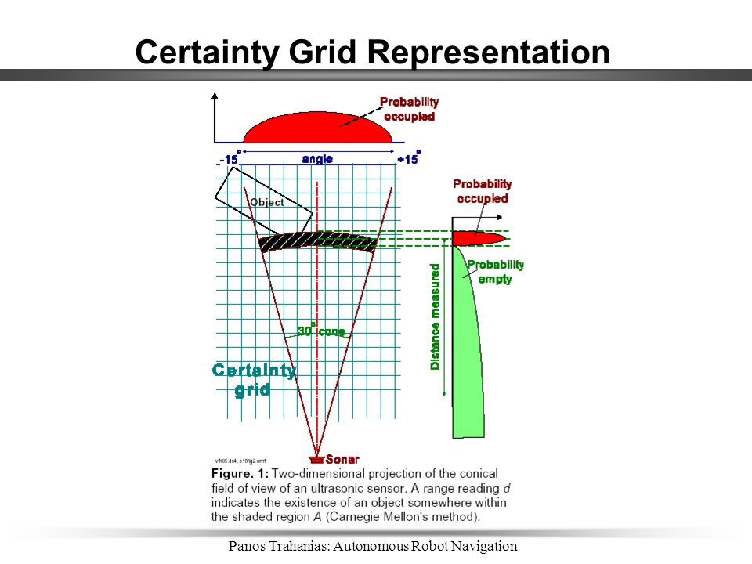Occupancy grid mapping refers to a family of computer algorithms involved in probabilistic robotics for mobile robots which addresses the problem of generating maps from noisy and uncertain data. An occupancy grid represents a map of the environment as an evenly distributed field of variables (cells), each representing the probability of an obstacle being at that location in the environment. An example of how the probabilistic nature of occupancy maps is useful when dealing with uncertain data can be seen in figure 5.

Figure 5 - Ultrasonic sensor occupancy grid

The wave front of an ultrasonic sensor diverges as it propagates away from the sensor. This means that, with increasing distance, there is less certainty about the absolute position of the detected object. An occupancy map will take this into account, and weight the cells inside the diverged wave front according to the probability that an obstacle lies there.

For the occupancy grid to function, it has to know the size and shape of the robot footprint. This is described as a set of coordinates which are joined together. The coordinates describing the footprint for the Dalek are as follows: [[-0.45, -0.23], [-0.357, -0.38], [0.083, -0.38], [0.2985, -0.32], [0.514, -0.178], [0.616, 0], [0.514, 0.178], [0.2985, 0.32], [0.083, 0.38], [-0.357, 0.38], [-0.45, 0.23]]

Plotting these points forms the graph found in graph 1.

Graph - Dalek footprint

Costmap_2D takes two main parameters: cost scaling factor and inflation radius.

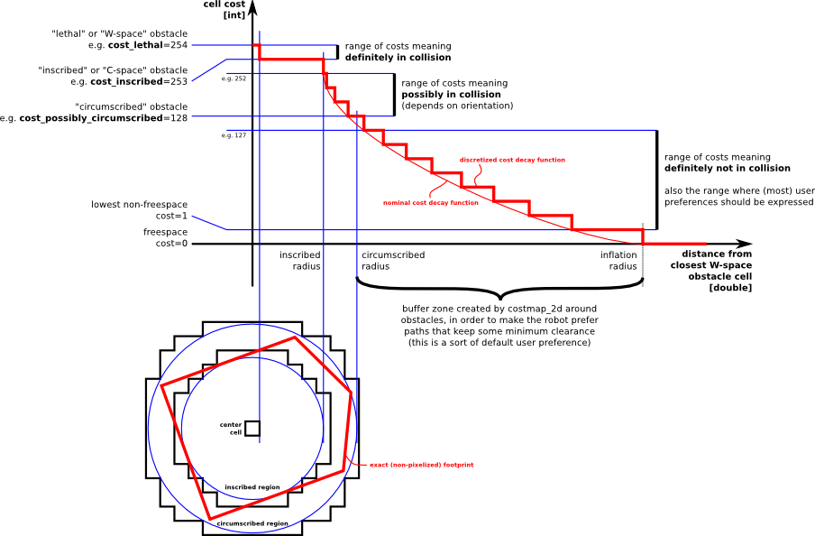

Figure – Inflation

The cost scaling factor is a parameter which scales the calculated cost in each cell via the following equation: $e^{(-1.0 * cost_scaling_factor * (distance_from_obstacle - inscribed_radius))}*253$

As the cost scaling factor is multiplied by -1, setting this parameter lower has the effect of increasing the cost values of nearby cells. Increasing the cost value of cells makes the robot view these cells as more ‘dangerous’. If this value is too low then the robot will see most cells as ‘lethal’ and will find it difficult to calculate a valid route. If this value is too high then the robot will plot routes too close to obstacles and collide frequently.

As the occupancy grid is probabilistic, cost values are propagated outwards from occupied cells and decrease with distance. The inflation radius parameter in costmap_2d defines the radius to which the occupancy grid should propagate cost values outwards from occupied cells. The inflation radius has the effect of adding a ‘buffer’ zone around obstacles as the robot moves through its environment, causing the robot to choose paths which keep some minimum clearance from obstacles. Setting this too low increases the likelihood of collisions and causes the robot to stay very close to walls as it moves through a room. Setting it too high can cause the route planner to pick inefficient routes through a room and increases computational load.

The navigation stack employs both local and global path planners, and so must have local and global costmaps. The global costmap is used by the global planner to generate a route to the desired location. Likewise, the local costmap is used by the local planner, but to modify the global route based on local and dynamic obstacles. Each costmap has its own set of parameters stored in local_costmap_params.yaml and global_costmap_params.yaml. There are a group of parameters which are shared by both costmaps which are stored in costmap_common_params.yaml. These configuration files are loaded into the respective costmaps by the move_base.launch file in the slambot_2dnav directory of the catkin workspace.

# Build

## Base

The footprint for the base panel was taken from the NSD-2005 Dalek plans from [http://www.projectDalek.co.uk](http://www.projectdalek.co.uk) . The base panel was copied into a solidworks sketch, converted to a dxf file and cut out of engineering card in the university laser cutter. As the laser cutter couldn’t fit the whole footprint, the decision was made to cut the design into four pieces. The parts were joined back together with tape.

The initial cut was done in card so that it could be measured against the wheelchair base and any adjustments could be made. A few minor changes were made to the file (added a few extra slots) before the design was finalised.

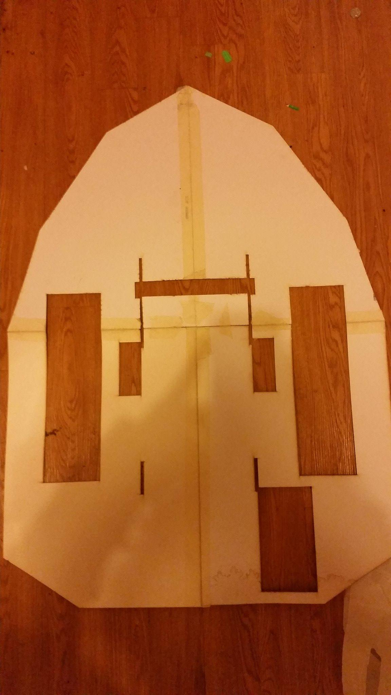

As the full panel wouldn’t fit in the university laser cutter, a 1.2m x 1.2m sheet of 12mm MDF was carried to a CNC router in Cornwall. The sheet was screwed into the bed of the router and cut using 0.7mm passes at 600mm/min to 1300mm/min.

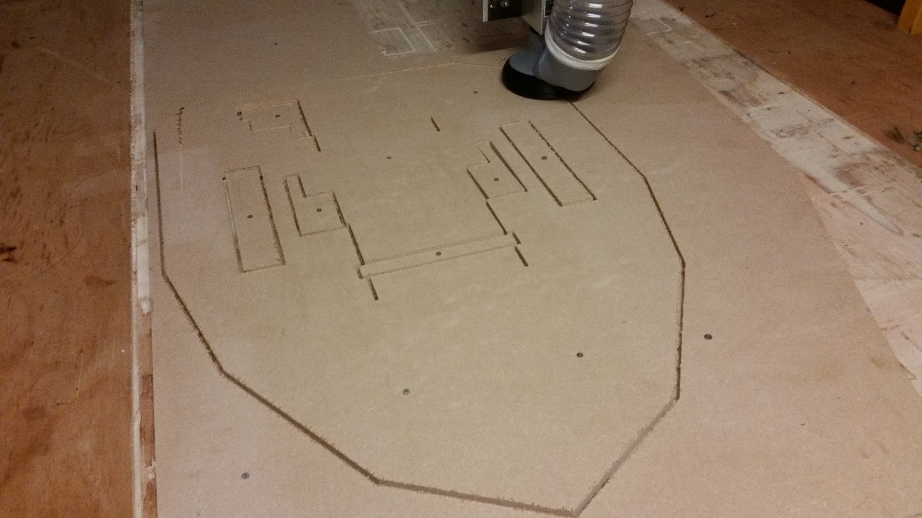

This base panel slots onto some thin metal supports on the wheelchair base and can be lifted off for easy access to the batteries.

## ROS

### Move_base.launch

Any ROS system of reasonable complexity consists of multiple nodes running simultaneously. To aid the launching of multiple nodes, arguments and configuration parameters, ROS launch files are used. A launch file is an xml document which starts with <launch> and ends with </launch>. The move_base.launch file starts the move_base navigation stack which launches its own sub-programmes. The launch file also pulls parameters in for the local and global costmaps, common costmap parameters and the local base planner. The following code is the launch file which was developed to start the navigation stack in the robot.

Code snippet 1 - move_base.launch part 1

<launch>

<master auto=**"start"**/>

<arg name=**"model"** />

<arg name=**"gui"** default=**"False"** />

<param name=**"use_gui"** value=**"$(arg gui)"**/>

<param name=**"robot_description"** textfile=**"$(find slambot_2dnav)/URDF/slambotSonic.urdf"** />

<node name=**"joint_state_publisher"** pkg=**"joint_state_publisher"** type=**"joint_state_publisher"** >

<param name=**"publish_frequency"** value=**"50"**/>

</node>

<node name=**"robot_state_publisher"** pkg=**"robot_state_publisher"** type=**"state_publisher"** >

<param name=**"publish_frequency"** value=**"50"**/>

</node>

<arg name=**"tf_map_scanmatch_transform_frame_name"** default=**"scanmatch_frame"**/>

<arg name=**"base_frame"** default=**"laser"**/>

<arg name=**"odom_frame"** default=**"laser"**/>

<arg name=**"pub_map_odom_transform"** default=**"true"**/>

<arg name=**"scan_subscriber_queue_size"** default=**"5"**/>

<arg name=**"scan_topic"** default=**"scan"**/>

<arg name=**"map_size"** default=**"1024"**/>

<node pkg=**"hector_mapping"** type=**"hector_mapping"** name=**"hector_mapping"** output=**"screen"**>

<!-- Frame names -->

<param name=**"map_frame"** value=**"map"** />

<param name=**"base_frame"** value=**"$(arg base_frame)"** />

<param name=**"odom_frame"** value=**"$(arg odom_frame)"** />

<!-- Tf use -->

<param name=**"use_tf_scan_transformation"** value=**"true"**/>

<param name=**"use_tf_pose_start_estimate"** value=**"false"**/>

<param name=**"pub_map_odom_transform"** value=**"$(arg pub_map_odom_transform)"**/>

<!-- Map size / start point -->

<param name=**"map_resolution"** value=**"0.05"**/>

<param name=**"map_size"** value=**"$(arg map_size)"**/>

<param name=**"map_start_x"** value=**"0.5"**/>

<param name=**"map_start_y"** value=**"0.5"** />

<param name=**"map_multi_res_levels"** value=**"2"** />

Code snippet 2 - move_base.launch part 2

<!-- Map update parameters -->

<param name=**"update_factor_free"** value=**"0.4"**/>

<param name=**"update_factor_occupied"** value=**"0.9"** />

<param name=**"map_update_distance_thresh"** value=**"0.4"**/>

<param name=**"map_update_angle_thresh"** value=**"0.06"** />

<param name=**"laser_z_min_value"** value = **"-1.0"** />

<param name=**"laser_z_max_value"** value = **"1.0"** />

<!-- Advertising config -->

<param name=**"advertise_map_service"** value=**"true"**/>

<param name=**"scan_subscriber_queue_size"** value=**"$(arg scan_subscriber_queue_size)"**/>

<param name=**"scan_topic"** value=**"$(arg scan_topic)"**/>

<!-- Debug parameters -->

<!--

<param name="output_timing" value="false"/>

<param name="pub_drawings" value="false"/>

<param name="pub_debug_output" value="true"/>

-->

<param name=**"tf_map_scanmatch_transform_frame_name"** value=**"$(arg tf_map_scanmatch_transform_frame_name)"** />

</node>

<!--- Run AMCL

<include file="$(find amcl)/examples/amcl_diff.launch" /> -->

<node pkg=**"move_base"** type=**"move_base"** respawn=**"false"** name=**"move_base"** output=**"screen"**>

<rosparam file=**"$(find slambot_2dnav)/costmap_common_params.yaml"** command=**"load"** ns=**"global_costmap"** />

<rosparam file=**"$(find slambot_2dnav)/costmap_common_params.yaml"** command=**"load"** ns=**"local_costmap"** />

<rosparam file=**"$(find slambot_2dnav)/local_costmap_params.yaml"** command=**"load"** />

<rosparam file=**"$(find slambot_2dnav)/global_costmap_params.yaml"** command=**"load"** />

<rosparam file=**"$(find slambot_2dnav)/base_local_planner_params.yaml"** command=**"load"** />

</node>

<node pkg=**"tf"** type=**"static_transform_publisher"** name=**"laser_to_base_broadcaster"** args=**"0 0 0 0 0 0 laser base_link 40"** />

<node pkg=**"tf"** type=**"static_transform_publisher"** name=**"world_to_odom_broadcaster"** args=**"0 0 0 0 0 0 world odom 40"** />

<node pkg=**"tf"** type=**"static_transform_publisher"** name=**"world_to_map_broadcaster"** args=**"0 0 0 0 0 0 world map 40"** />

<!--<node name="arduinoMotorController" pkg="rosserial_python" type="serial_node.py" args="/dev/ttyACM1" />-->

</launch>

## Costmap configuration

### Local_costmap_prarams.yaml

Code snippet 3 - local_costmap_params.yaml

**local_costmap**:

**plugins**:

**- {name**: obstacle_layer, type: 'costmap_2d::ObstacleLayer'}

**- {name**: sonar_layer, type: "range_sensor_layer::RangeSensorLayer"}

**- {name**: inflation_layer, type: 'costmap_2d::InflationLayer'}

**global_frame**: /map

**robot_base_frame**: base_link

**update_frequency**: 2.0

**publish_frequency**: 1.0

**static_map**: **false**

**rolling_window**: **true**

**width**: 6.0

**height**: 6.0

**resolution**: 0.1

**transform_tolerance**: 1

**obstacle_layer**:

**observation_sources**: laser_scan_sensor

**laser_scan_sensor**: {sensor_frame: laser, data_type: LaserScan, topic: scan, marking: true, clearing: true}

### Global_costmap_params.yaml

Code snippet 4 - global_costmap_params.yaml

**global_costmap**:

**plugins**:

**- {name**: static_layer, type: 'costmap_2d::StaticLayer'}

**- {name**: obstacle_layer, type: 'costmap_2d::ObstacleLayer'}

**- {name**: inflation_layer, type: 'costmap_2d::InflationLayer'}

**global_frame**: /map

**robot_base_frame**: /base_link

**resolution**: 0.1

**update_frequency**: 2.0

**static_map**: **true**

### Costmap_common_params.yaml

Code snippet 5 - costmap_common_params.yaml

**obstacle_layer**:

**observation_sources**: laser_scan_sensor

**obstacle_range**: 3

**raytrace_range**: 9

**laser_scan_sensor**: {sensor_frame: laser, data_type: LaserScan, topic: scan, marking: true, clearing: true}

**footprint**: [[-0.45, -0.23], [-0.357, -0.38], [0.083, -0.38], [0.2985, -0.32], [0.514, -0.178], [0.616, 0], [0.514, 0.178], [0.2985, 0.32], [0.083, 0.38], [-0.357, 0.38], [-0.45, 0.23]]

**transform_tolerance**: 1.3

**footprint_padding**: 0.01

**sonar_layer**:

**frame**: ultrasound

**topics**: ["/ultrasound"]

**no_readings_timeout**: 1.0

**clear_on_max_reading**: **true**

**inflation_layer**:

**inflation_radius**: 0.4

## Base planner configuration

### Base_local_planner_params.yaml

Code snippet 6 - base_local_planner_params.yaml

**TrajectoryPlannerROS**:

# max_rotational_vel: 0.68

**max_vel_x**: 0.95

**min_vel_x**: 0.70

**max_vel_theta**: 1.1

**min_vel_theta**: -1.1

**min_in_place_vel_theta**: 0.65

**min_in_place_rotational_vel**: 0.65

**acc_lim_theta**: 0.5

**acc_lim_x**: 0.5

**acc_lim_y**: 0.5

**acc_lim_th**: 0.5

# min_in_place_rotational_vel: -0.49

**xy_goal_tolerance**: 0.35

**yaw_goal_tolerance**: 0.78

**holonomic_robot**: **false**

# meter_scoring: true

**controller_frequency**: 7.0

# sim_time: 0.2

# sim_granularity: 0.09

# angular_sim_granularity: 0.075

# vx_samples: 15

# vtheta_samples: 25

## Ultrasonics

The HY-SR05 was configured to run on one-pin mode. A cpp file and header file were created to manage the ultrasonic sensors and return data to the main code. Code snippets 1 and 2 below show the cpp and header files respectively.

Code snippet 7 - Ultrasonic cpp file

//dalekSonics.cpp

**#**include **"**Arduino.h**"**

float duration;

float distance;

float getRangeSRF**(**byte sensorpin**)**{

//Set pin to output

**pinMode(**sensorpin**,** **OUTPUT)**;

//Drive pin low for 2 microseconds, high for 10 microseconds and then low again (transmitts ultrasonic burst)

**digitalWrite(**sensorpin**,** **LOW)**;

**delayMicroseconds(**2**)**;

**digitalWrite(**sensorpin**,** **HIGH)**;

**delayMicroseconds(**10**)**;

**digitalWrite(**sensorpin**,** **LOW)**;

//Set pin to input so that the returned pulse width can be measured

**pinMode(**sensorpin**,** **INPUT)**;

//measure pulse duration

duration **=** **pulseIn(**sensorpin**,** **HIGH)**;

//Divide by 5800 to convert time-of-flight to distance in meters

distance **=** duration**/**5800;

//Return distance as a float

return distance;

}

//dalekSonics.h

**#**ifndef DALEK_SONIC

**#**define DALEK_SONIC

//Prototype for getRangeSRF found in dalekSonics.cpp

float getRangeSRF**(**byte sensorpin**)**;

**#**endif

Code snippet 8 - Ultrasonic header with function prototype

## PCB

A printed circuit board was designed to hold the Arduino Nano, the LM2902 quad op-amp comparator circuit and the low-pass filters for the motor controller, as well as connectors for the encoders, ultrasonic sensors and some extra pins for future expansion.

The PCB was designed as a schematic in Proteus ISIS before a layout was created in Proteus Ares.

Schematics

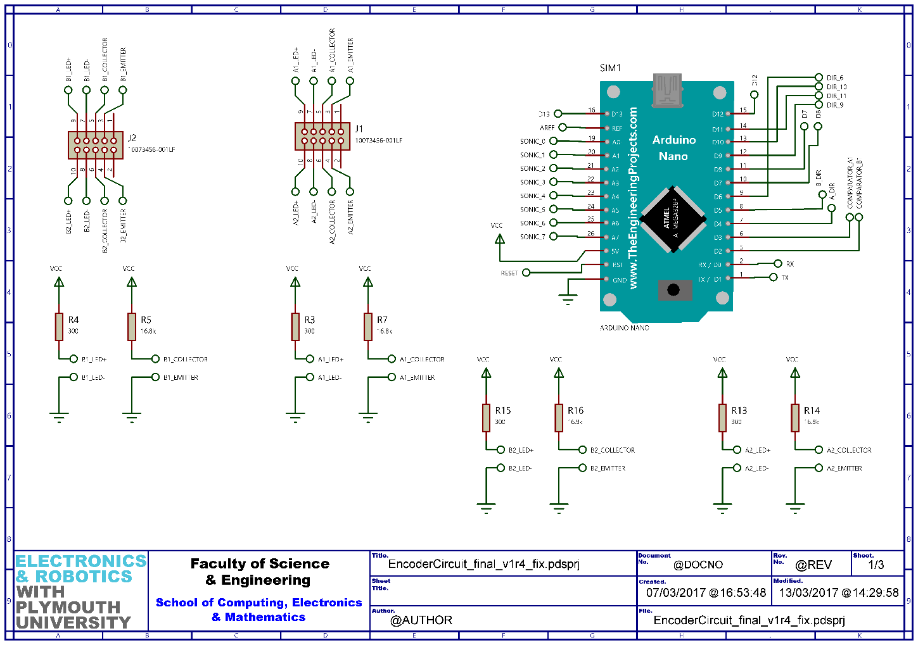

Schematic 2 - Main PCB sheet 1

## 

Schematic 3 - Main PCB sheet 3

Schematic 4 - Main PCB sheet 2

Simulation was not needed for this PCB due to the simplicity of the circuits involved and the manual testing of the low-pass filters on a breadboard. From these schematics, a PCB layout was designed as can be seen in figure 7.

### Board layout

Figure 7 - PCB layout

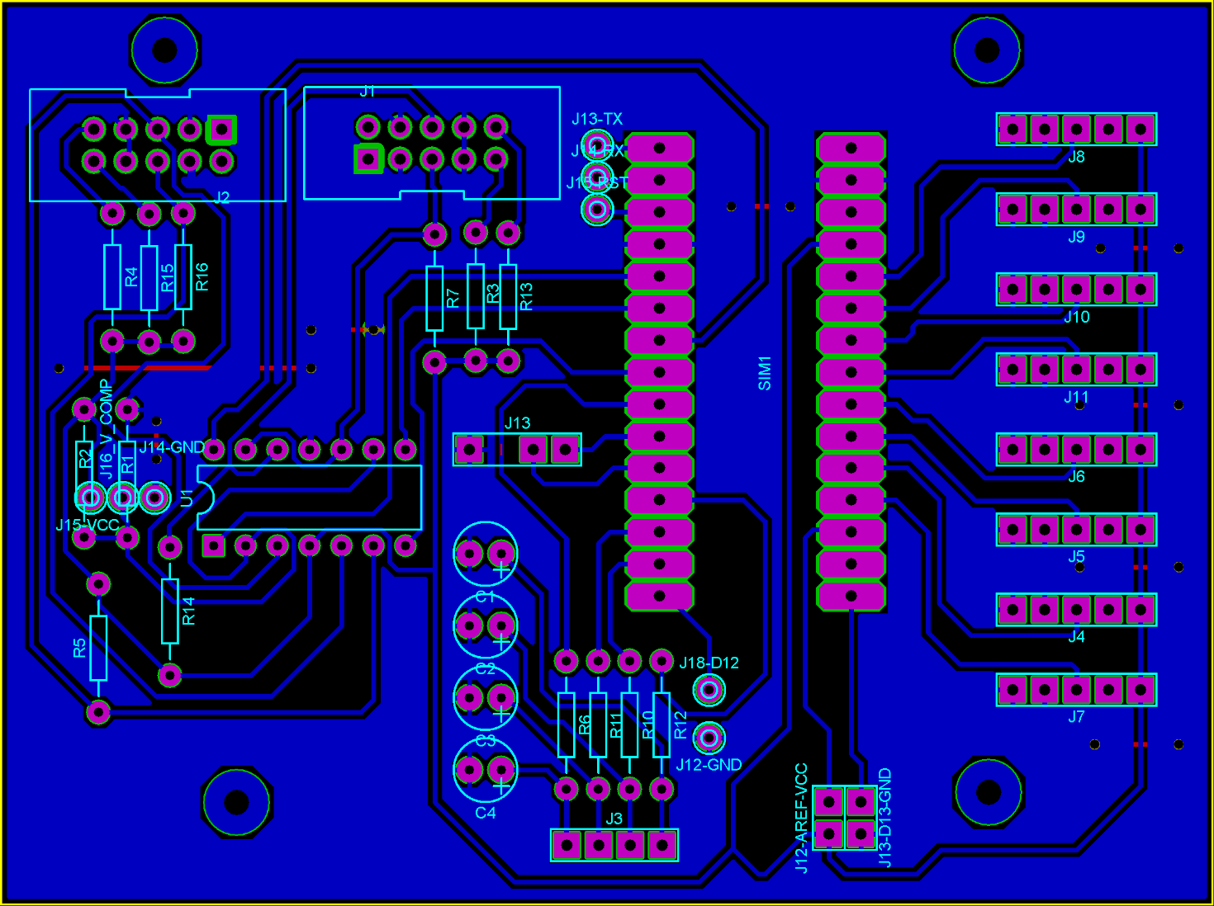

### Arduino Nano Pinout

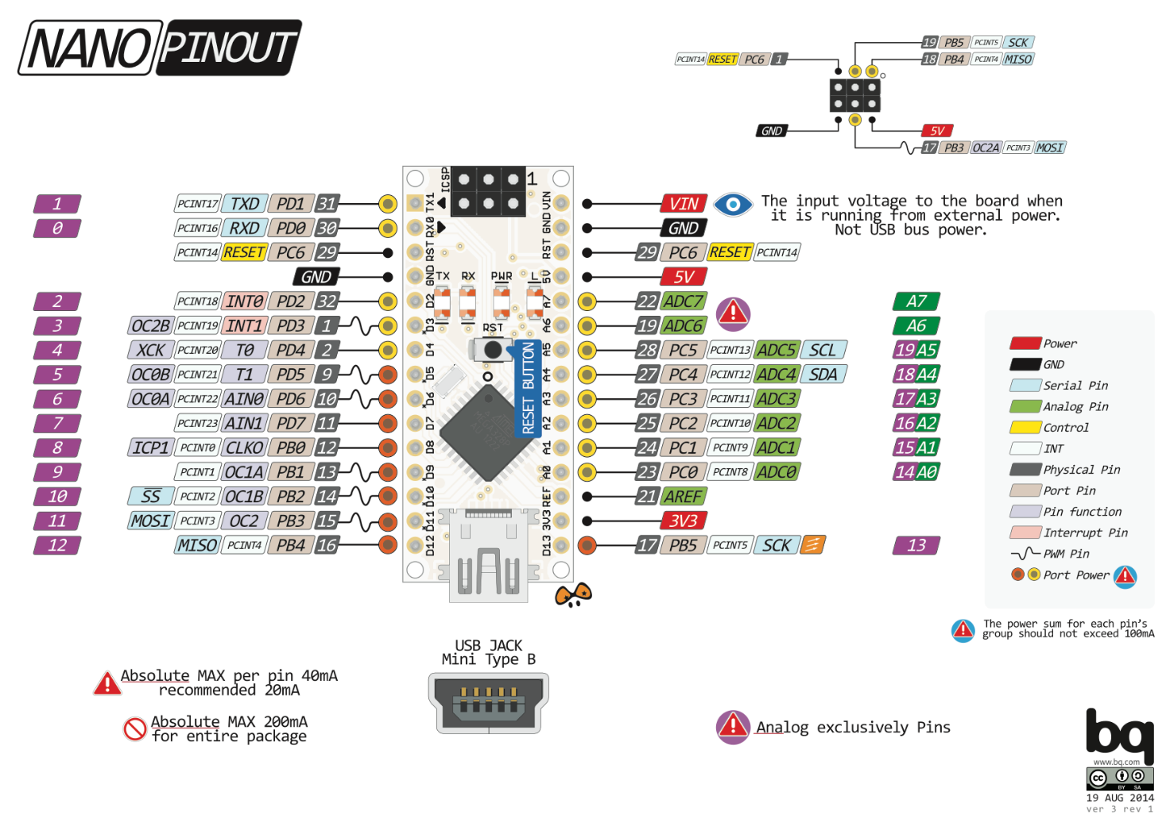

Figure

### Modifications

#### Changing microcontroller

It was later realised that the Arduino Nano did not have enough working memory to transmit and receive all the necessary data. The Arduino Nano was replaced with a Teensy3.2 (figure 9), which had the same pin spacing but different pin mappings.

#### Pin remapping

Pins for the ultrasonic sensors, encoders and motors were remapped in software. Initially the motors would not respond to outputs from the Teensy. It was discovered via oscilloscope that the Teensy3.2 PWM outputs are 3.3V instead of 5V like the Nano.

#### Level shifter

A level shifter circuit was needed. Several methods were considered including: discrete transistors, dedicated ICs and opto-couplers. The chosen solution was a 74HCT08, which is a high-speed CMOS TTL compatible quad 2-input AND gate. This IC was chosen as it could run from a 5V supply, outputted almost its full supply voltage when outputting high and had TTL level inputs where a logic ‘1’ is anything between 2V to supply voltage and a logic ‘0’ is anything between GND and 0.8V. The 74HCT08 was connected in-between the digital output pins and the low-pass filters.

The inputs to each and gate were wired together to provide logic table (table 1). The ICs supply was connected to USB 5V from a pin on the Teensy.

|  |  |
| --- | --- |
| Input | Output |
| 0 | 0 |
| 1 | 1 |

Table - Level shifter logic with 74HCT08

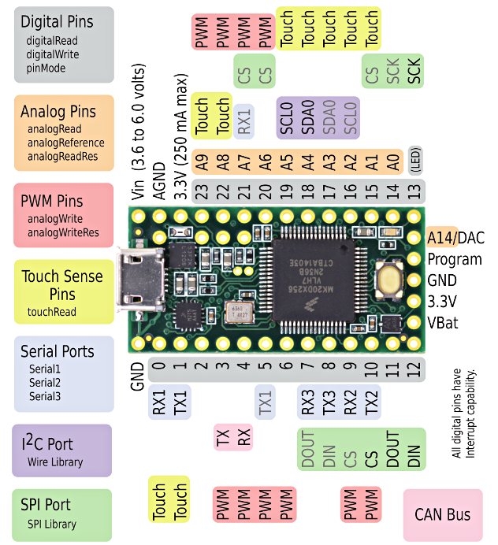

Figure

The level shifter worked as expected and the motor controller could now be driven again.

#### Using wheelchair controllers regulated voltage reference

At this point in the projects development, the robots batteries were broken and it was running from a tethered power supply. Upon moving the robot to a different location and tethering the robot to a different power supply, the motor controller would immediately flash error codes upon being connected to the microcontrollers level shifter circuit. It was hypothesised that this was due to the lack of ground reference between the systems and the increased noise from the new power supply.

In addition, the laptops USB voltage was measured to be 5.14V at one time and 5.08 at another. This is 140mV higher than the 5V supply to the joystick inside the wheelchair controller and varied by at least 70mV. No variance was detected in the 5V output from the controller to the joystick (this was checked periodically in the 10mV range).

The varying USB voltage was supplying the level shifter circuit, and so as the USB voltage changed so would the centre points of the signals going to the controller, leading to intermittent faults depending on uncontrollable variables.

To remedy this, the 5V USB supply to the level shifter was replaced with the highly regulated 5V supply which was supposed to go from the wheelchair controller to the joystick.

#### Voltage level recalibration

The centre voltages of the joystick were measured on an oscilloscope to be 2.52V. A scaling factor was calculated to help convert these voltages to 8-bit values:

$$8_{bit}number= \frac{255}{Vs}*V_{in}$$

$$Scaling factor= \frac{255}{5}=51$$

$$8_{bit}number=51*2.52=128.52$$

This was rounded up to 129. The same process was repeated for the minimum and maximum voltage of all the signal lines. The minimum and maximum for each line was found to be the same.

|  |  |  |
| --- | --- | --- |
|  | Voltage | DAC value |
| Minimum | 1.33V | 68 |
| Maximum | 3.72V | 190 |

Table - Joystick min/max signal voltages and equivalent DAC values

#### Controller enable circuit

A circuit was designed to enable remote disabling and restarting of the wheelchair driver.

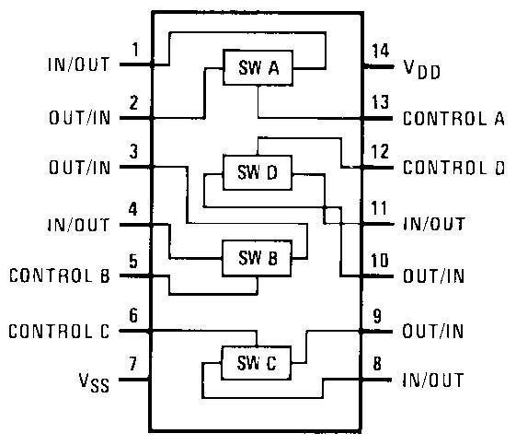Initially a CD4066 CMOS quad bilateral switch was used.

However, it was later found that the signals from the motor controllers keypad were approaching 24V which destroyed the gates in the CD4066 switch.

This lead to the design of a transistor circuit to switch the controller on and off. As the controller required two wires to be connected together and momentarily touched to a third to enable the controller, two BC547 transistors were used. The first connected the two wires together when its base was driven high. The second connected a third wire to the first two momentarily when its base was pulsed for 150mS.

The code in snippet 3 was written to drive these transistors from the remote machine.

void controller_en_cb**(**const std_msgs::Bool& controller_en**)**{

if **(**controller_en.data**)**{

startController**()**;

}

else if **(!**controller_en.data**)**{

stopController**()**;

}

}

ros::Subscriber**<**std_msgs::Bool**>** controller_en_sub**("/**controller_enable**",** controller_en_cb**)**;

void startController**()**{

stopMotors**()**;

**delay(**100**)**;

**digitalWrite(**controllerConstant**,** **HIGH)**;

**delay(**500**)**;

**digitalWrite(**controllerPulse**,** **HIGH)**;

**delay(**150**)**;

**digitalWrite(**controllerPulse**,** **LOW)**;

**delay(**1500**)**;

}

void stopController**()**{

**digitalWrite(**controllerConstant**,** **LOW)**;

}

Code snippet 9 - Remote controller enable/disable

## Odometry

### Rationale

It was decided that, if possible, the wheel odometry data would be calculated on the microcontroller. As previously discussed under ‘issues’ in the encoder section, errors in these types of encoders rapidly accumulate and thus care must be taken to not introduce further errors in software.

If the odometry data were to be calculated on the host computer on the robot, then the microcontroller would have to send serial packets to the host computer informing it of a wheel pulse at a rate dependent on the wheel speed. The code for the microcontroller was written in a way which minimised the time the program spent in a ISR, by setting a flag for the main loop to service on its next run through. This already introduces timing inaccuracies due to the multiple other processes the micro is executing at irregular intervals.

Constructing the serial packet takes time to complete, introducing further latencies. From this point, the packet can be timestamped and further errors minimised (although not eliminated).

All these latencies accumulate and are very difficult to predict due to the numerous other tasks the microcontroller is running. For these reasons, it was decided to calculate odometry information on the microcontroller and send it to the host computer

### Code

The code in snippet 1 shows calculation of the robots forward and rotational velocity from the wheel velocities. The code then integrates these velocities over time. The variables x, y and th store the accumulated integrals, and thus contain the 2D translation and final rotation of the robot relative to where it started. The ‘calculated’ flag is set whenever a wheel velocity is updated.

if **(**calculated && **(millis()** **>** 2000**))**{

//Calculate robots x and theta velocities

vx **=** **(**v_left **+** v_right**)/**2;

vth **=** **(**v_right **-** v_left**)/**wheel_spacing;

lCurrent_time **=** **millis()/**1000;

double dt **=** lCurrent_time **-** lLast_time;

double delta_x **=** **(**vx **\*** **cos(**th**))** **\*** dt;

double delta_y **=** **(**vx **\*** **sin(**th**))** **\*** dt;

double delta_th **=** vth **\*** dt;

x **+=** delta_x;

y **+=** delta_y;

th **+=** delta_th;

//This statement was added to reset the odometry accumulators

// and robot velocities from the host computer or on startup

if **(**clearOdom**)**{

v_left **=** 0;

v_right **=** 0;

vx **=** 0;

vth **=** 0;

delta_x **=** 0;

rightWheelCounter **=** 0;

leftWheelCounter **=** 0;

delta_y **=** 0;

delta_th **=** 0;

//Reset map coordinates (AMCL USE ONLY)

x **=** 25.624998;

y **=** 25.624998;

th **=** 0;

clearOdom **=** false;

}

calculated **=** false;

}

Code snippet 10 - Odometry calculation

The code in snippet 2 was written to publish the calculated odometry. This code was based off code from the ROS tutorials, found here: <http://wiki.ros.org/navigation/Tutorials/RobotSetup/Odom>

//Execute periodically

if **(millis()** **>** pubTime**)**{

geometry_msgs::Quaternion odom_quat **=** tf::createQuaternionFromYaw**(**th**)**;

//first, we'll publish the transform over tf

geometry_msgs::TransformStamped odom_trans;

odom_trans.header.stamp **=** nh.now**()**;

odom_trans.header.frame_id **=** **"**odom**"**;

odom_trans.child_frame_id **=** **"**laser**"**;

odom_trans.transform.translation.x **=** x;

odom_trans.transform.translation.y **=** y;

odom_trans.transform.translation.z **=** 0.0;

odom_trans.transform.rotation **=** odom_quat;

//send the transform

odom_broadcaster.sendTransform**(**odom_trans**)**;

//next, we'll publish the odometry message over ROS

nav_msgs::Odometry odom;

odom.header.stamp **=** nh.now**()**;

odom.header.frame_id **=** **"**odom**"**;

//set the position

odom.pose.pose.position.x **=** x;

odom.pose.pose.position.y **=** y;

odom.pose.pose.position.z **=** 0.0;

odom.pose.pose.orientation **=** odom_quat;

//set the velocity

odom.child_frame_id **=** **"**laser**"**;

odom.twist.twist.linear.x **=** vx;

odom.twist.twist.linear.y **=** 0;

odom.twist.twist.angular.z **=** vth;

//publish the message

// last_time = current_time;

lLast_time **=** lCurrent_time;

serial_odom.publish**(**&odom**)**;

//Execute every 50mS

pubTime **=** **millis()** **+** 50;

}

Code snippet 11 - Odometry calculations

### Results

In trying to publish the odometry message, rosserial began generating time-out errors upon starting, requiring a reset of the microcontroller. This issue went away when the odometry publisher was removed from the code.

Another, very small publisher was added to publish integers over serial to see if the problem lay solely with the odometry and TF packets. Adding this simple publisher also resulted in rosserial timing out.

It turned out that the RAM on the Arduino Nano wasn’t large enough to hold any more publishers or subscribers. It was initially thought that more publishers and subscribers could be avoided, however it quickly became apparent that more were needed to debug and expand the system.

This lead to the decision to change the microcontroller for a Teensy3.2. See section ‘Changing the microcontroller’ for more information on this.

Once the hardware remapping and software porting was complete and the buffers in the ros.h file were increased from 512 bytes to 1024 bytes the odometry packet could be published successfully, and further publishers and subscribers could be added.

After the micro was swapped, code snippets 1 and 2 successfully calculated and published the robots odometry information to the ROS host. Figure 7 evidences this by showing the pose estimates calculated when the v_left variable was hard set to 1m/s and v_right variable was hard set to 0.5m/s and the system was left to run for a while.

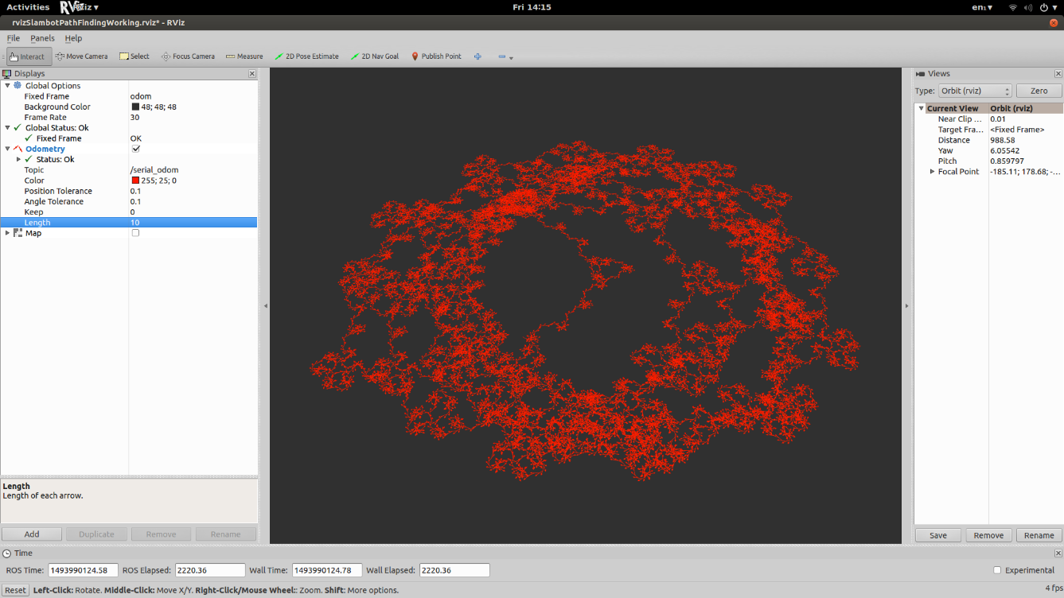

Figure 10 - Encoder patterns

## ROSbag

### Overview

ROSbag is a set of tools for recording from and playing back to ROS topics, with APIs written in both C++ and python. ROSbags can be useful for off-site debugging of robotic systems. For example, the following command:

rosbag record -o myScan.bag /scan

will capture all data published on the /scan topic. If the above command was running whilst the robot was navigating, then the bag file would contain a time-stamped record of all LIDAR data. By setting the following command:

rosparam set use_sim_time true

before playing back the bag file via:

rosbag play myScan.bag --clock

The bag file will replay, and the ROS system time will be synchronised with the time stamps in the bag file. If the rest of the navigation stack was activated, then the host computer would believe that it was actively processing LIDAR data and navigating, and the user would be able to watch the progress of this through Rviz as if the robot was moving around. The robots computer could then be taken away from the robot and no laser scanner connected, and debugging/testing can be performed without the robots hardware.

Aside from debugging and testing off-site, rosbags were utilised in this project to capture, store and replay 2D Nav Goals in waypoint and patrol route mode.

### Code

The following code snippets represent a simplified version of how the smach-based state-machine has been written to create and playback bag files.

First, a subscriber is setup (snippet 5) to catch any 2D Nav Goals set by the user in Rviz. The callback function of this subscriber is triggered whenever data is published to the /move_base_simple/goal topic. This data is latched into a global variable and is overwritten when the next location is received.

#Create location object to hold and latch 2D Nav Goal

location **=** PoseStamped**()**

**def** locationHolder**(**data**):**

**global** location

location **=** data

#Create subscriber to 2D Nav Goals, callback to function 'locationHolder()'

locationSubscriber **=** rospy**.**Subscriber**(**'/move_base_simple/goal'**,** PoseStamped**,** locationHolder**)**

Code snippet 12

A user-activated function is defined (snippet 6) to read the global variable ‘location’ and save it to a bag file in the root directory of the GUI. This function is activated via the ‘Create bag’ button in the GUI. The essence of how this button is created is in code snippet 7.

Code snippet 13

fileNumber **=** 0

**def** locationBagger**():**

#Global variables for file number and location to be saved

**global** fileNumber

**global** location

#Convert file number to string so that it can be appended to the filename

sFileNumber **=** str**(**fileNumber**)**

#Create bag containing location

bag **=** rosbag**.**Bag**(**'location' **+** sFileNumber**,** 'w'**)**

**print** **(**"Saving location"**)**

**print(**location**)**

**print** **(**"in bag file"**)**

**print(**bag**)**

#Increment bag counter so that a new file is created when the function is #next called

fileNumber **+=** 1

**try:**

#Write location to bagfile and timestamp

bag**.**write**(**'move_base_simple/goal'**,** location**,** location**.**header**.**stamp**)**

**finally:**

#Close bag and return

**print(**"Location bagging finished, closing bag.."**)**

bag**.**close**()**

**print(**"Bag closed"**)**

#the below function is an extract from the class object oop which has been written #to create the GUI on start-up

**def** _locationFrameSetup**(**self**):**

#Create new sub-frame to hold waypoint/patrol buttons

self**.**locationFrame **=** ttk**.**Frame**(**self**.**buttonFrame**)**

#Set where to place this sub-frame and how it should resize with

#its parent window

self**.**locationFrame**.**grid**(**column**=**1**,** row**=**3**,** columnspan**=**2**,** sticky**=(**N**,** W**,** S**,** E**))**

self**.**locationFrame**.**columnconfigure**(**0**,** weight**=**1**,** minsize**=**185**)**

self**.**locationFrame**.**columnconfigure**(**1**,** weight**=**1**,** minsize**=**120**)**

self**.**locationFrame**.**columnconfigure**(**2**,** weight**=**1**,** minsize**=**100**)**

#Create button to activate 'locationBagger()' function when pressed

ttk**.**Button**(**self**.**locationFrame**,** text**=**"Create bag"**,** command**=**locationBagger**).**grid**(**column**=**0**,** row**=**0**,**sticky**=(**N**,** W**))**

#This button does not exist within this function in the code but has been

#placed here to aid the readers understanding

ttk**.**Button**(**self**.**buttonFrame**,** text**=**"Leave wait-state"**,** command**=**leaveWaitState**).**grid**(**column**=**1**,** row**=**0**,** sticky**=(**N**,** W**))**

Code snippet 14

The above code snippets (5 and 6) describe how the dalek_controllerv1.6.py program saves the current objective as a bag file when a user clicks a button (snippet 7). Code snippets in the next section ‘Smach’ (subsection ‘Code’) will show how the state machine extracts data from the first bag file, publishes it, waits for the contained goal to be reached and then publishes the next bag file.

## Smach

The code for the developed executive control state-machine is extensive and heavily interlinked, and contains the full code for the tkinter GUI. Because of this, most code snippets will make little sense out of context. Care has been taken to extract key elements of the program and adjust them to make more sense outside of the main program, but the full code listing should be viewed for a greater understanding of the state-machine and GUI. A full code listing can be found in the appendix and will also be submitted as a separate file with this report.

This subsystem was designed to be expanded upon. Whilst the current functionality of the smach code includes little more than waypoint and patrol route modes, the framework has been written to allow more complex, higher level tasks to be developed on and executed by the robot. Some of the key elements of the state machine will be described below. Figure 8 shows a diagram of the implemented state-machine.

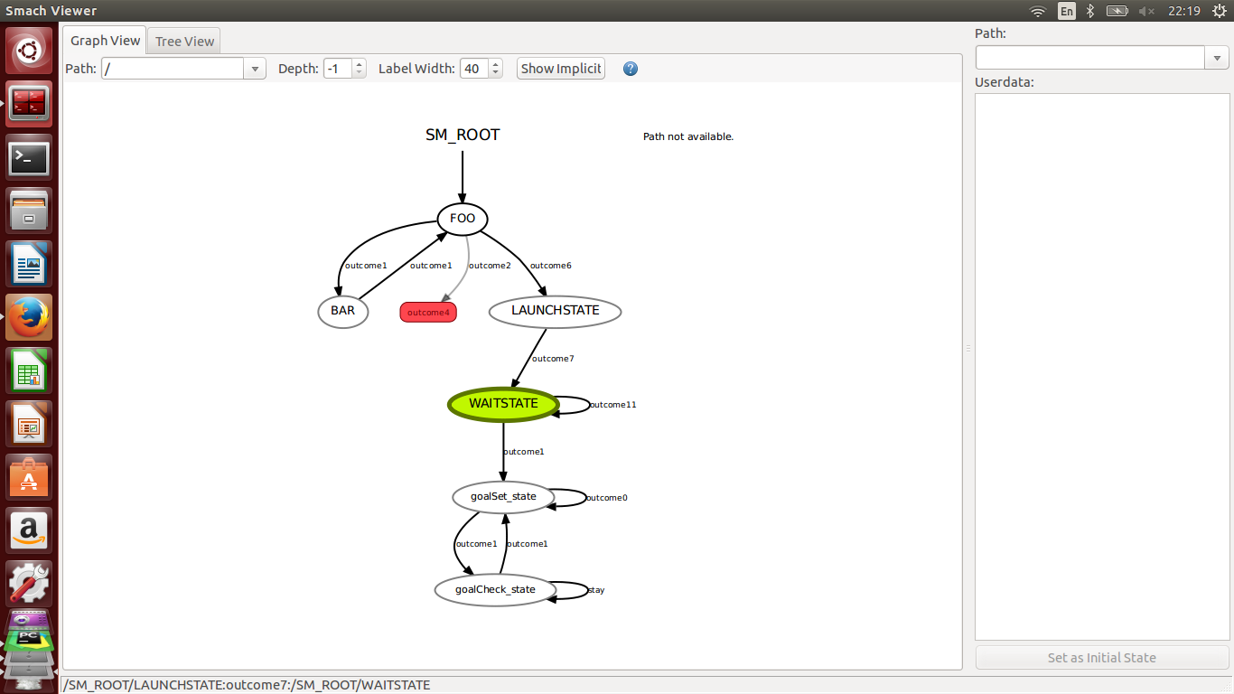

Figure 11 - Executive state-machine

### States implemented

#### Foo and Bar

These two states were initially a ‘hello world’ style introduction to smach. However, they provided a useful method of checking that everything was running correctly and provide samples of how to write states and link them together if other people end up developing this project further. Foo increments a counter each time it is entered and then returns to Bar. Bar logs the counter and then returns too Foo. Once the counter in Foo reaches 3, outcome6 is activated and the Launch-State is entered.

#### Launch-State

This state handles the setup of the robot. The launch state logs that it has been activated, before configuring the lidar depending on which lidar has been selected. The launch state then starts the smach viewer application which displays a live flowchart of the status of the state machine, and also starts the tkinter GUI application which has been written as the robots main control panel.

#### Wait-state

Here the program stops and waits for user input. To reduce CPU usage, the wait state contains a sleep timer of three seconds to prevent it from repeatedly executing. The button to leave the wait state is latched, so the user does not have to hold the button to leave the state. Whilst in the wait state it is recommended that the user configure any waypoints or patrol routes if desired.

The process of creating waypoints and patrol routes via the GUI is outlined in the ‘waypoints and patrol routes’ section of ‘how to use the robot’.

Once any navigation planning has been entered into the GUI by the user and the user is ready for the robot to start moving, the ‘Leave wait state’ button should be pressed. The program will then move on to the goalSet_state.

#### Goal set state

This state is where the next objective is sent to the robots navigation stack. Upon entering, the goal set state logs that it has been entered and that a goal is being set. It the calls the set_goal() function. This function retrieves the bag file containing the first goal and publishes it to the move_base_simple/goal topic. This is the same topic that is published to by Rviz when a 2D Nav Goal is set. Once the goal has been published, the bag file is closed and the goal check state is entered.

#### Goal check state

The purpose of this state is to check whether the robot has reached its current objective. It does this by checking a global flag every three seconds. This flag is set via a subscriber callback to the move_base/status topic. The messages in this topic form a status list. By checking the status variable in the first element of the status list we can determine whether the robot has reached its objective. If the goal has not been reached yet, the state sleeps for three seconds before checking again. If the goal has been reached, the bag file counter is incremented and the program returns to the goal set state. If the bag file counter is at its maximum (the robot is at its last waypoint), the goal check state reads the ‘Tick to loop’ checkbox. If this box has been checked, then the counter resets and the first waypoint is set as the new goal. If this box is not checked, then the robot waits for further user input.

### Code

The below code snippets are extracts from the smach state machine, describing the goal-set state and the goal-check state. The snippets focus around the class definitions of these states as methods within these classes are where the most active parts of the waypoint process lie.

**class** **goalSet_state(**smach**.**State**):**

**def** __init__**(**self**):**

smach**.**State**.**__init__**(**self**,**

outcomes**=[**'outcome1'**,** 'outcome0'**],**

input_keys**=[**'flag'**])**

**def** execute**(**self**,** userdata**):**

**while** **not** rospy**.**is_shutdown**():**

rospy**.**loginfo**(**'goalSet_state entered, setting goal'**)**

set_goal**()**

**return** 'outcome1'

Code snippet 15

Code snippet 8 shows the definition of the goal set state. It is entered when the user clicks the ‘Leave wait state’ button on the GUI and is returned to if another objective is to be set. This state calls the set_goal function which is described in snippet 9.

**def** set_goal**():**

**print** **(**"Setting goal"**)**

**try:**

#If the user has specified a particular waypoint to move to, then

#retrieve this waypoint number

fileAppend **=** oop**.**numberOut**.**get**()**

**print(**'location'**+**str**(**fileAppend**))**

#Open a bag file corresponding to the waypoint number requested

bag **=** rosbag**.**Bag**(**'location'**+**str**(**fileAppend**),** 'r'**)**

**except:**

**print(**"The bag file you have selected probably doesn't exist"**)**

#Iterate through the bag file and publish any locations using the

#talker() function

**for** topic**,** msg**,** t **in** bag**.**read_messages**(**topics**=[**'move_base_simple/goal'**]):**

#Uncomment below to print this data to the GUI

#print (msg)

talker**(**msg**)**

#Close the bag

bag**.**close**()**

**print** **(**"Goal set"**)**

#Sleep for three seconds to reduce CPU load

time**.**sleep**(**3**)**

Code snippet 16

Code snippet 10 shows the definition of the functions called by the goal check state. Goal_feed() is the callback from the subscriber created in goal_listener(). It extracts the success status of the goal from the move_base/result topic and stores it in a global variable.

#Subscriber to check for goal success

**def** goal_listener**():**

l **=** rospy**.**Subscriber**(**'move_base/result'**,** MoveBaseActionResult**,** goal_feed**)**

**return** l

goalSuccess **=** 0

**def** goal_feed**(**result_data**):**

#print "goal success!"

**global** goalSuccess

q **=** result_data

goalSuccess **=** q**.**status_list**[**0**].**status

**def** check_goal**():**

**print** **(**"Waiting for goal to be reached"**)**

**global** goalSuccess

**if** goalSuccess **==** 3**:**

**print(**"Goal success!"**)**

**return** 1

**else:**

**print(**"Not there yet"**)**

**return** 0

#Publishes goals

**def** talker**(**data**):**

pub **=** rospy**.**Publisher**(**'move_base_simple/goal'**,** PoseStamped**,** queue_size**=**10**)**

pub**.**publish**(**data**)**

Code snippet 17

Check_goal() is called by the goal check state and returns ‘1’ if the goal has been reached and ‘0’ if it has not. This exists in its own function to tidy up the goal check state and to allow for future development to request more than just ‘success’/’failed’ parameters from the move_base/status topic.

Now that the required functions have been defined, the goal_check state class can be created (snippet 11).

**class** **goalCheck_state(**smach**.**State**):**

**def** __init__**(**self**):**

#Declare outcomes

smach**.**State**.**__init__**(**self**,**

outcomes**=[**'outcome1'**,**'stay'**],**

input_keys**=[**'flag'**])**

**def** execute**(**self**,** userdata**):**

**while** **not** rospy**.**is_shutdown**():**

rospy**.**loginfo**(**'goalCheck_state entered, waiting for goal to be reached'**)**

#Global variable fileNumber is used to retrieve the bag file counter

**global** fileNumber

#Location 55 is used by the user to tell the robot to wait for further #input at its next goal (This should be replaced with a button)

**if** oop**.**numberOut**.**get**()** **==** 55**:**

time**.**sleep**(**3**)**

**return** 'stay'

#sleep to reduce CPU and network load

time**.**sleep**(**4**)**

#Check goal success

**if** check_goal**()** **==** 1**:**

**print(**"We're at the goal, success!"**)**

#If the 'sequence goals' box is checked in the GUI, then

#increment the bag counter and load the next objective

**if** oop**.**sequenceEN**.**get**()** **==** 1**:**

**print(**"incrimenting..."**)**

#Increment bag counter

oop**.**numberOut**.**set**(**oop**.**numberOut**.**get**()+**1**)**

#if we have reached the last bag file

**if** oop**.**numberOut**.**get**()** **==** **(**fileNumber **+** 1**)** **:**

#If the loop box is checked, then reset the bag #counter

**if** oop**.**looperEN**.**get**()** **==** 1**:**

oop**.**numberOut**.**set**(**0**)**

#If we have reached the last bag file and the loop #box is not checked, then wait for user input

**else:**

time**.**sleep**(**3**)**

**return** 'stay'

#If goal has been reached, return to goal_set state

**return** 'outcome1'

**else:**

#If the goal has not been reached, then check again in three seconds

time**.**sleep**(**3**)**

**return** 'stay'

Code snippet 18

The states have been defined, but for the code to work a state machine container must be created. The state machine container can be called as a state in a larger state-machine program. Once the container is created, the states defined in snippets 8 and 11 will be added and transitions will be defined and potentially remapped.

Code snippet 19 - Cut-down version of dalek_controllerv1.6.py main showing state machine container definition, adding states to the container and multi-threading

**def** main**():**

start_roscore**()**

#the anonymous argument tells rospy to rename the node if

#another of the same name exists

rospy**.**init_node**(**'dalek_state_machine'**,** anonymous**=True)**

# Create a SMACH state machine

sm **=** smach**.**StateMachine**(**outcomes**=[**'outcome4'**])**

sm**.**userdata**.**sm_counter **=** 0

# Create and start the introspection server

sis **=** smach_ros**.**IntrospectionServer**(**'server_name'**,** sm**,** '/SM_ROOT'**)**

sis**.**start**()**

# Open the container

**with** sm**:**

# Add states to the container

smach**.**StateMachine**.**add**(**'goalSet_state'**,** goalSet_state**(),**

transitions**={**'outcome1'**:**'goalCheck_state'**,**

'outcome0'**:**'goalSet_state'**})**

smach**.**StateMachine**.**add**(**'goalCheck_state'**,** goalCheck_state**(),**

transitions**={**'outcome1'**:**'goalSet_state'**,**

'stay'**:**'goalCheck_state'**})**

# Execute SMACH plan

**def** executeSmach**():**

outcome **=** sm**.**execute**()**

#Thread the state-machine to prevent blocking of the GUI

smachThread **=** threading**.**Thread**(**target**=**executeSmach**)**

smachThread**.**daemon **=** **True**

smachThread**.**start**()**

**print(**"Executing smach"**)**

**if** __name__ **==** '__main__'**:**

main**()**

The line ‘outcome = sm.execute()’ in code snippet 12 activates the state machine which will then begin processing the states. This line has been started in its own thread, as both smach and tkinter like to have their own looping functions to do their respective jobs. The state-machine will function if this command is not defined in its own thread, but the tkinter GUI will lock up.

## Motor control

In its most basic mode, the microcontroller received motor commands from ROS and turned them into signals for the motor controller. To achieve this, a cpp and header file were written to contain the motor control functions. Code snippet 3 contains this cpp file, and snippet 4 contains the header file with the function prototypes.

//dalekMotors.cpp

**#**include **"**Arduino.h**"**

**#**define forwardPin 9

**#**define reversePin 11

**#**define rightPin 6

**#**define leftPin 10

//Define analog ranges and centre value

**#**define analogRangeMin 100

**#**define analogRangeMax 190

**#**define centre 136

//Function to stop motors by emulating a cantered joystick

void stopMotors**(**void**)**{

**analogWrite(**forwardPin**,** centre**)**;

**analogWrite(**reversePin**,** centre**)**;

**analogWrite(**leftPin**,** centre**)**;

**analogWrite(**rightPin**,** centre**)**;

}

int xmag**,** zmag;

int iStickF**,** iStickB**,** iStickL**,** iStickR;

void xz_updateStick**(**float x1**,** float z1**)**{

xmag **=** x1**\***100;

zmag **=** z1**\***100;

//Stop motors if commands are zero

if **((**xmag **==** 0**)** && **(**zmag **==** 0**))**{

stopMotors**()**;

}

else {

//Scale to controller range

iStickF **=** **map(**xmag**,** -100**,** 100**,** analogRangeMin**,** analogRangeMax**)**;

iStickB **=** **map(**xmag**,** -100**,** 100**,** analogRangeMax**,** analogRangeMin**)**;

iStickR **=** **map(**zmag**,** -100**,** 100**,** analogRangeMin**,** analogRangeMax**)**;

iStickL **=** **map(**zmag**,** -100**,** 100**,** analogRangeMax**,** analogRangeMin**)**;

//Output motor commands

**analogWrite(**forwardPin**,** iStickF**)**;

**analogWrite(**reversePin**,** iStickB**)**;

**analogWrite(**leftPin**,** iStickL**)**;

**analogWrite(**rightPin**,** iStickR**)**;

}

}

Code snippet 20 - dalekMotors.cpp

Code snippet 21 - dalekMotors.h

//dalekMotors.h

**#**ifndef DALEK_MOTOR_OUTPUT

**#**define DALEK_MOTOR_OUTPUT

//Prototype for xz_updateStick found in dalekMotors.cpp

void xz_updateStick**(**float x1**,** float z1**)**;

**#**endif

**#**ifndef DALEK_MOTOR_STOP

**#**define DALEK_MOTOR_STOP

//Prototype for stopMotors found in dalekMotors.cpp

void stopMotors**(**void**)**;

**#**endif

## Encoders

### Sensor box

The encoders were initially imagined to be two boxes attached to the frame so that they lined up with any number of slots plus half a slot. First, the RPR-220 sensor was modelled (figure 7) from the drawings in the datasheet (figure 8). Over 50 files were generated as the encoder boxes were iteratively designed, encompassing at least 30 iterations. The key stages in the development of the box will be listed below. The rest of the files are available on request.

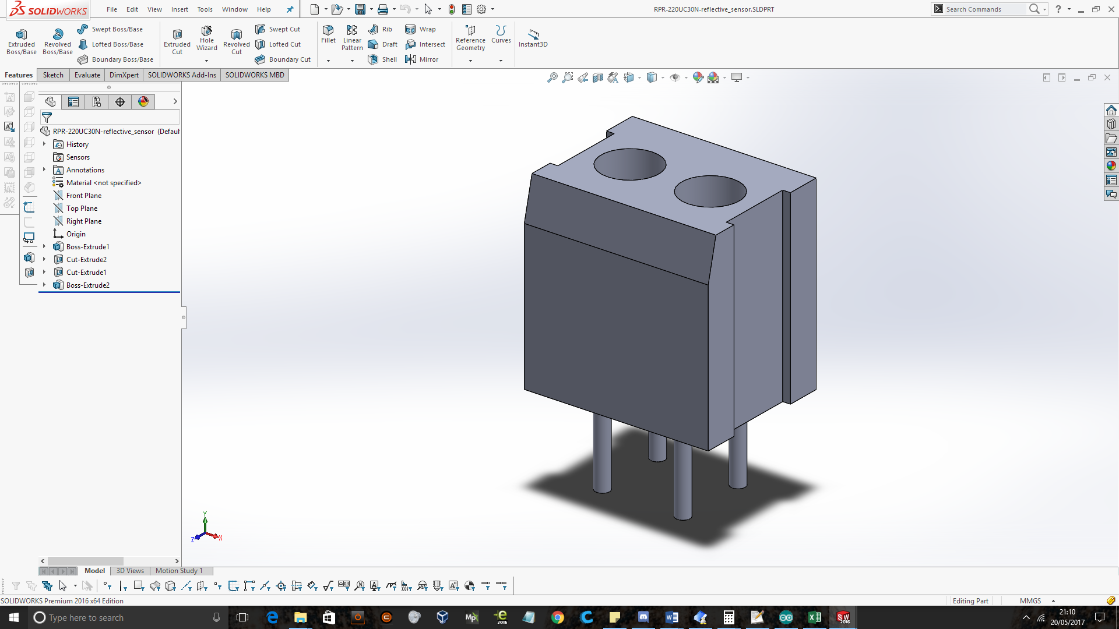

Figure 12 - Modelled RPR-220

Figure 13 - RPR-220 drawings from datasheet

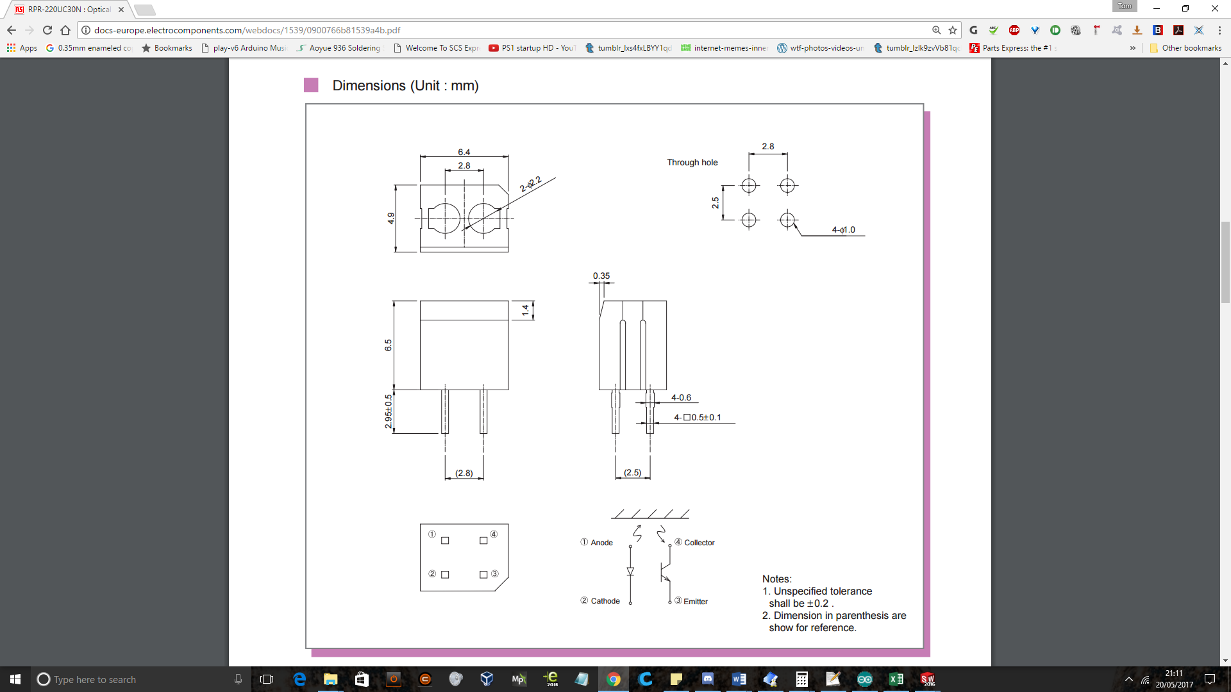

Using the model of the RPR-220 sensor, a fitting was designed to hold the sensor via a friction fit (figure 9).

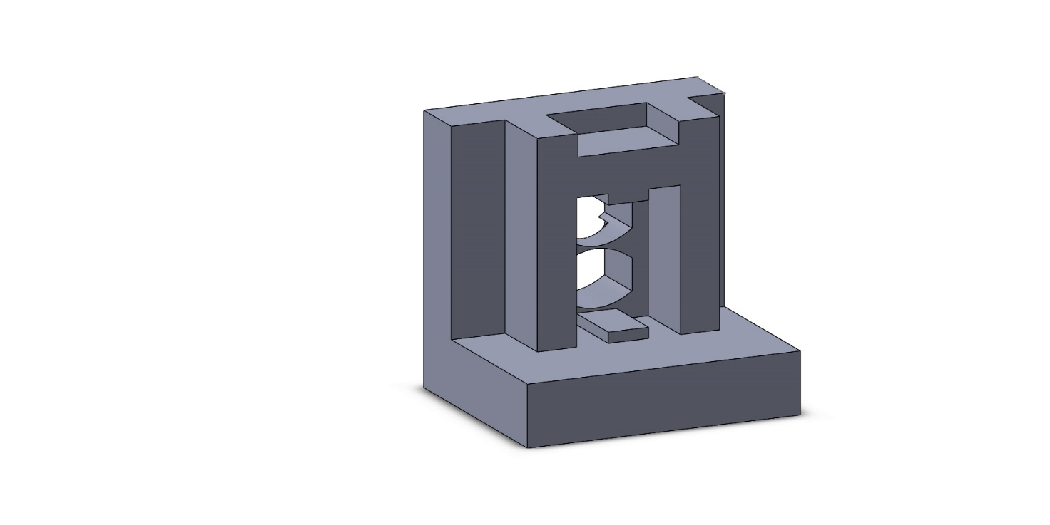

Figure - RPR-220 sensor fitting

By designing the sensor fitting separately, it was possible to iteratively print sensor fittings with minor adjustments to ensure a snug and secure fit. Multicore wires were soldered onto the sensor pins and heat-shrink tubing was applied (figure 10).

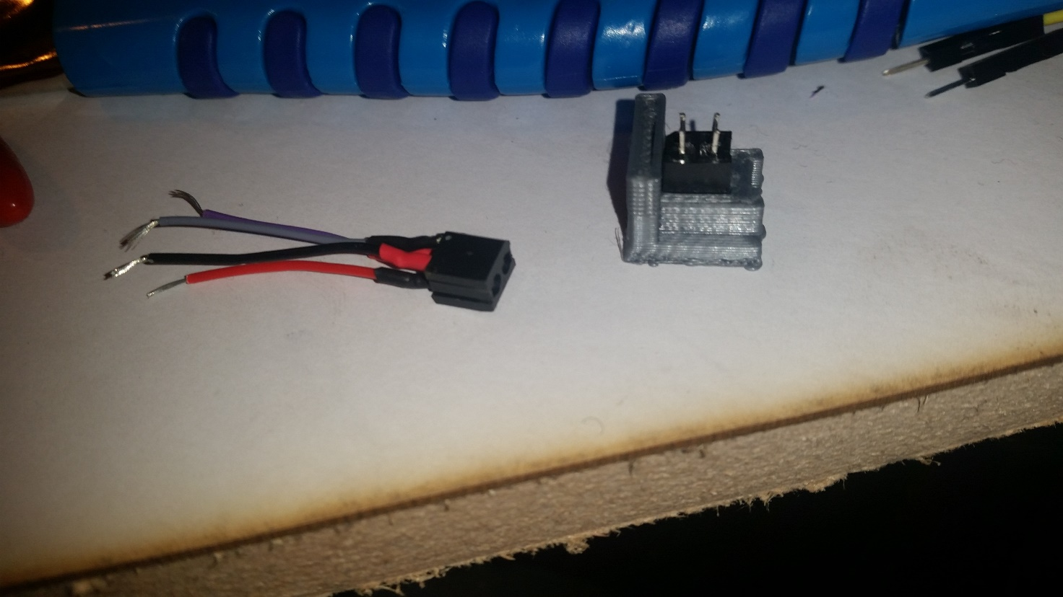

Figure - Test fitting RPR-220

Once the sensor fitting was tuned to the fit the sensor, the rest of the box was designed (figure 11).

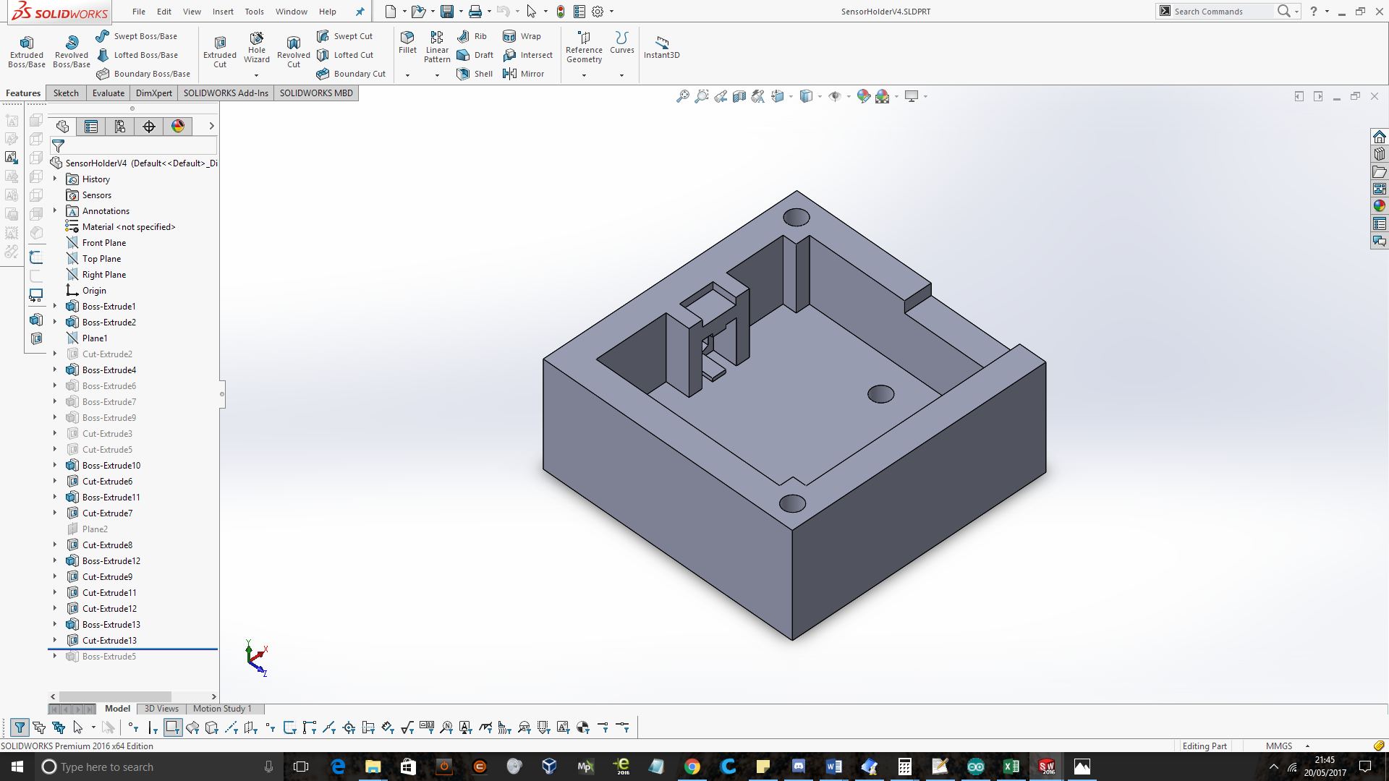

Figure - Single sensor holder box

It was quickly realised that these sensors could be any distance apart, as long as one was n+(1/2) slots away from the other. From this, a single box was designed and reshaped so that it would fit in the narrow gap available between the chassis and the wheel. Two boxes were to be produced, one for each wheel. Each box was to contain two sensors.

A sketch of the encoder disk was constructed and overlaid with the encoder box to aid positioning of the two sensors inside a single box (figure 12).

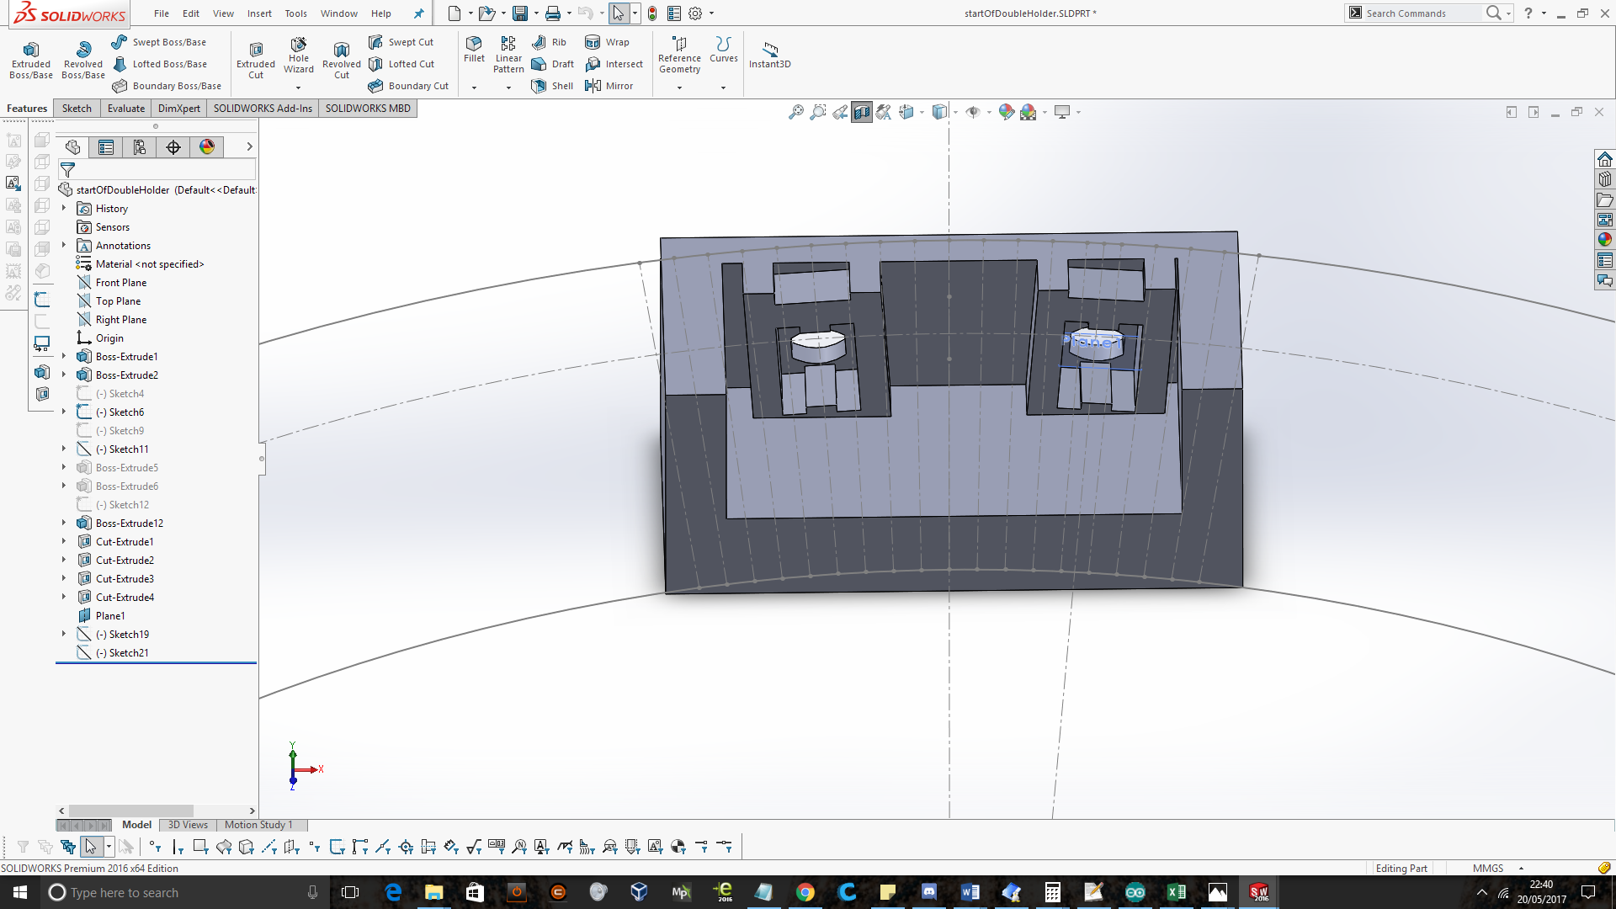

Figure - First dual sensor prototype

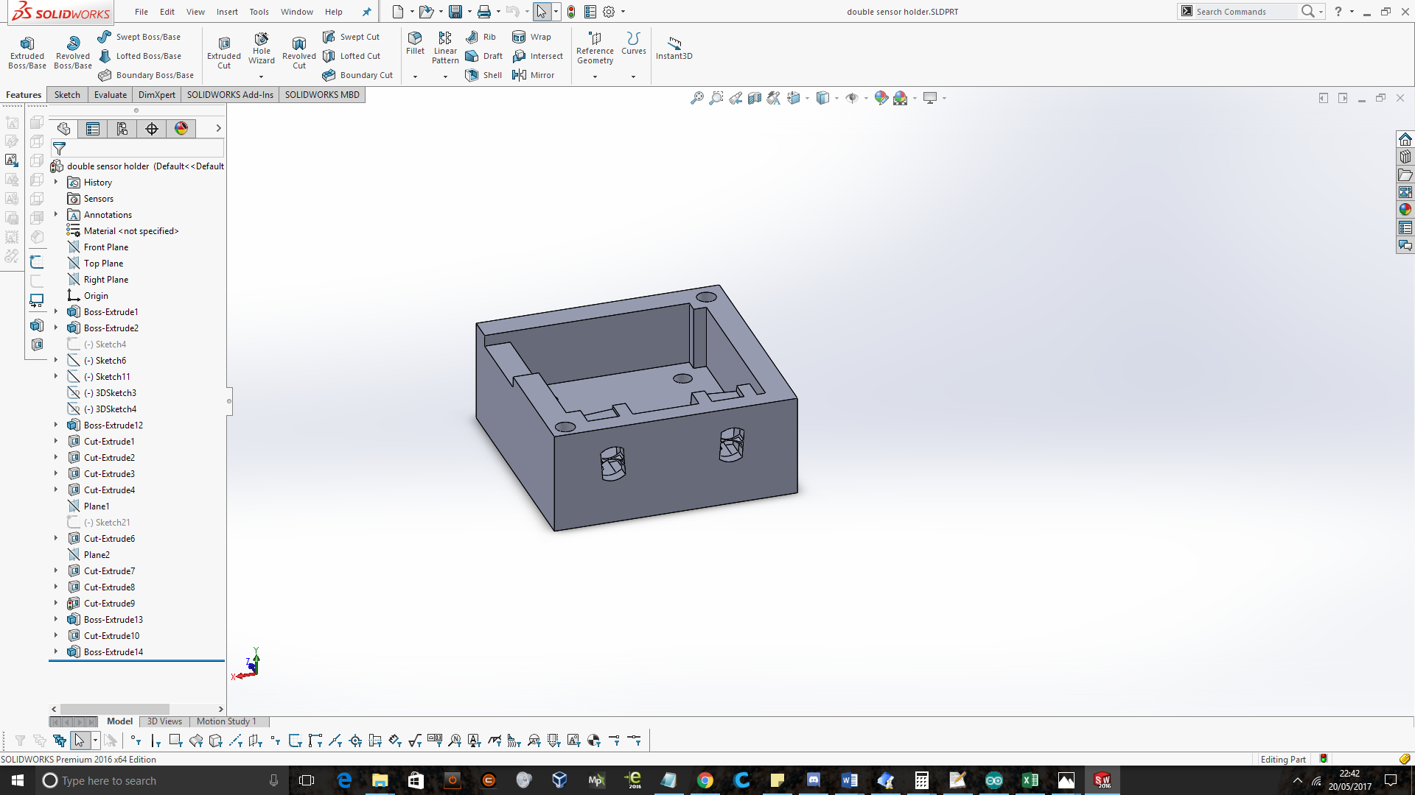

Figure - Second dual sensor prototype

The RPR-220 reflective sensors had to be at least 6mm away from the surface to be sensed in order to detect a large enough difference in contrast. The size of the gap which the sensor was to fit inside was 49.8mm. The width of the PCB was 36.2mm and the sensor was 6mm. Including the 6mm gap required for the sensor to function, only 1.6mm was left for the walls of the box (assuming the sensor, PCB and box walls were pushed up against eachother). This lead to many boxes being printed with very slight variations in size in order to find a solution to satisfy the criteria.

A middle section and lid were designed initially as separate parts (figure 14).

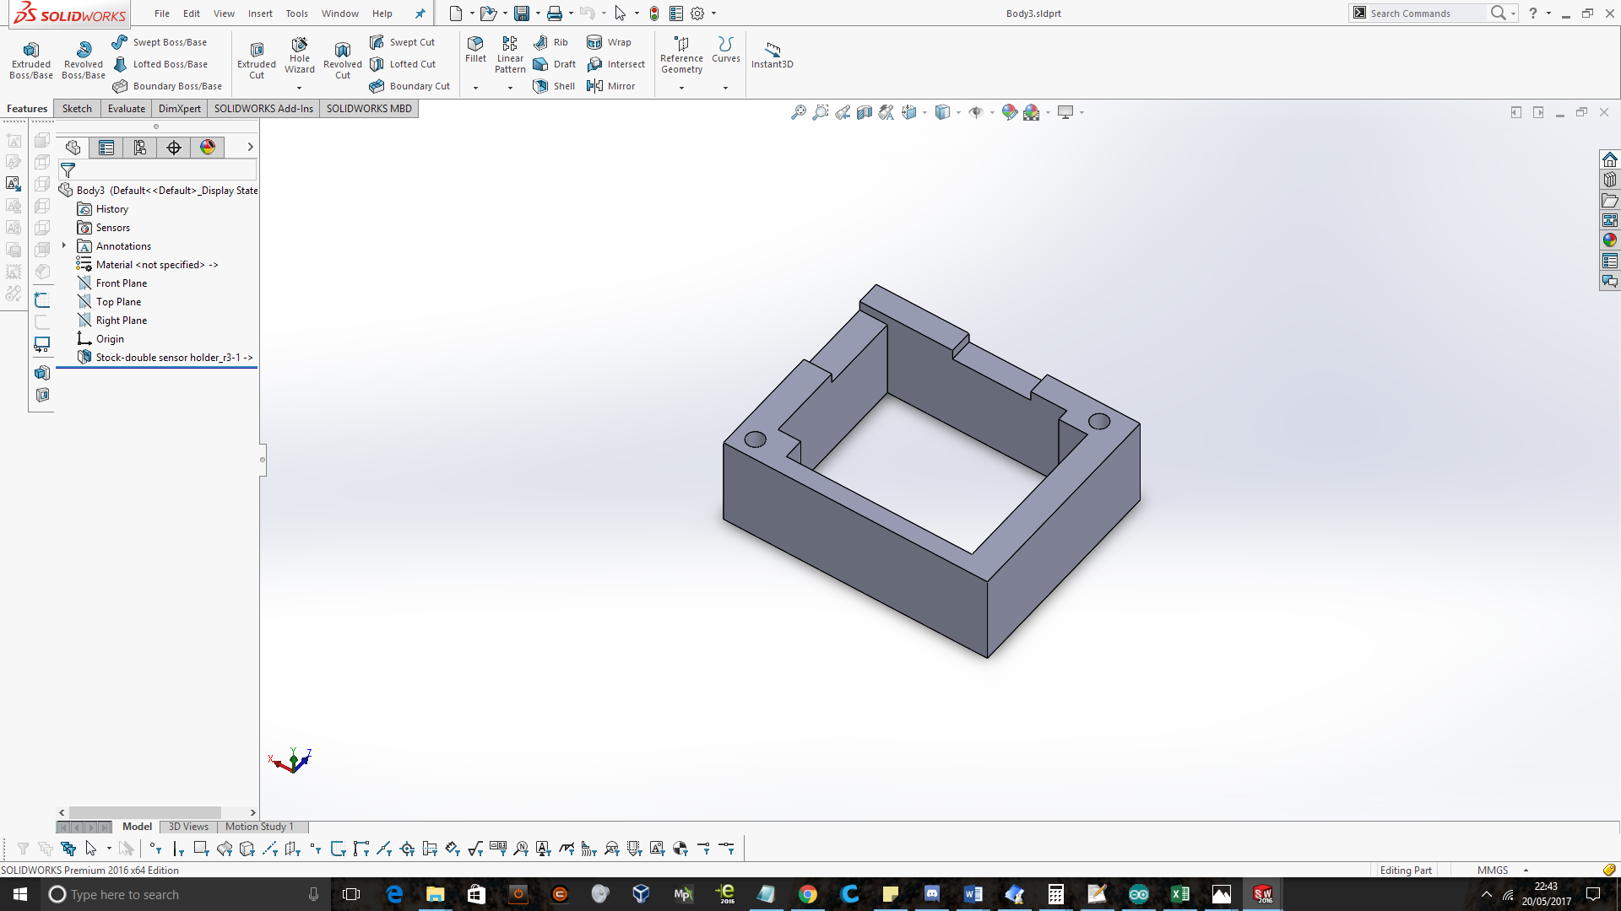

Figure - Mid section 1

However, as the box was constantly being adjusted, it was discovered that these components could be made as a single part and then cut into separate parts. Changes in one part would then automatically be applied to the other part. As a PCB was being made for the connection between the 10-way ribbon cable and the sensors, this was exported from proteus as a CAD file and imported into solidworks to ensure correct fitting and alignment (figure 15).

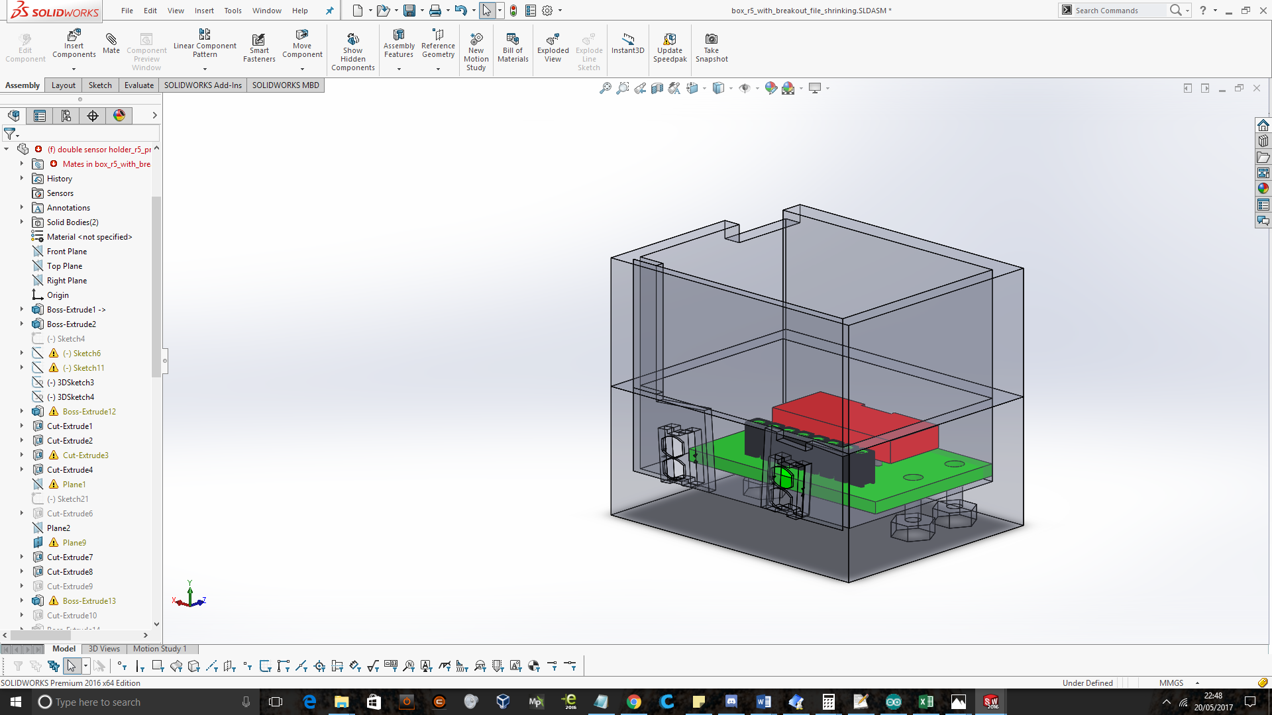

Figure - Double sensor holder with mid-section and breakout PCB

Mounting points were then added to the underside of the box (figure 16).

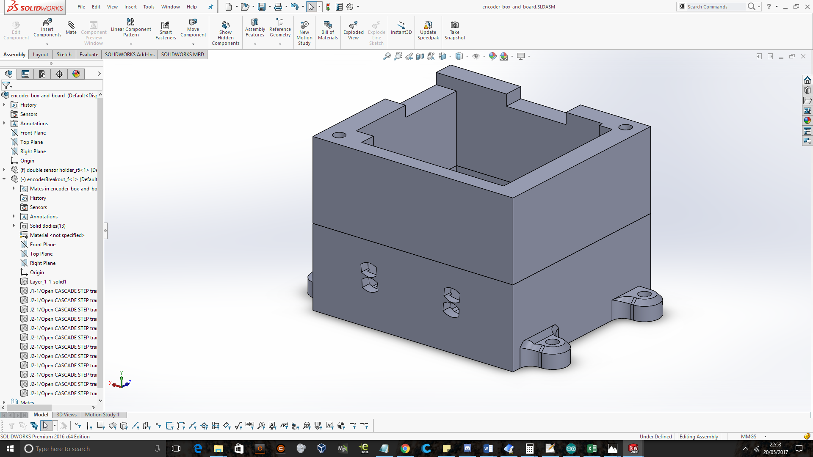

Figure - Mounting points

It was realised, as the box would be attached to the underside of the chassis, that the sensors should be rotated in the other direction. Also, as the majority of these iterations were to get the sensor to fit into a very small gap, the size of the box needed to be further reduced. This lead to the decision to move the internal screw fixings to the outside of the box (figure 17).

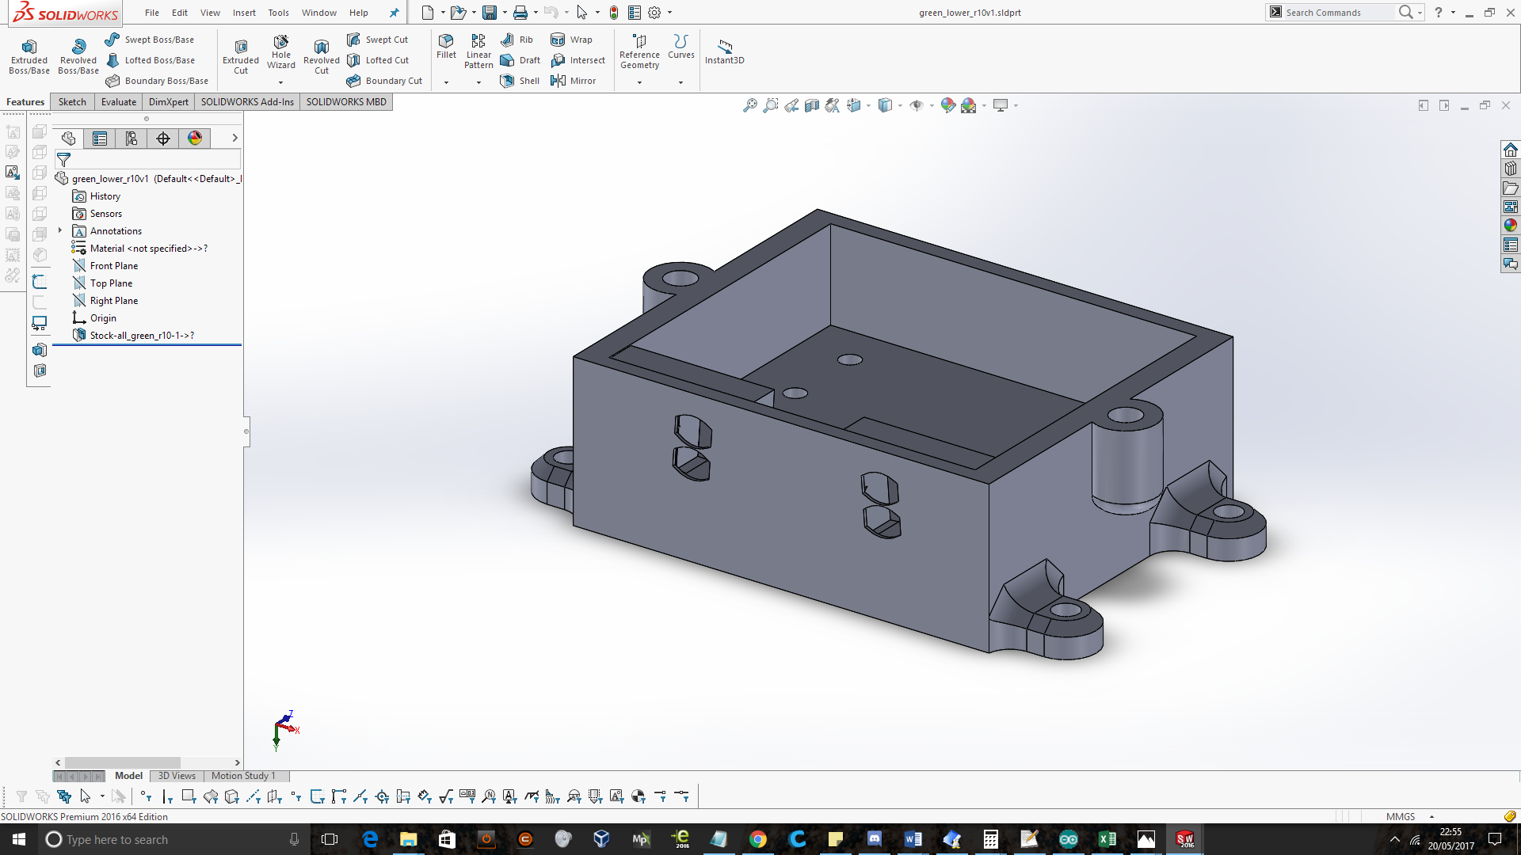

Figure - Rotated front and external screw fixings

This box was just about small enough to fit in the gap and satisfied all the other design requirements. However, it turns out that the tyre on the robots wheel was deflated during this design process. Re-inflating the tyre reduced the size of the gap by two millimetres, preventing the latest design from working.

The decision was then made to move the encoder to the other side of the wheel. The encoder disc and sensor were transferred to the other side of the wheel. The sensor box was temporarily attached with a sticky pad until its positioning was finalised.

### Encoder wheel

A solidworks sketch was created with the same resolution as the paper test wheels (figure 18).

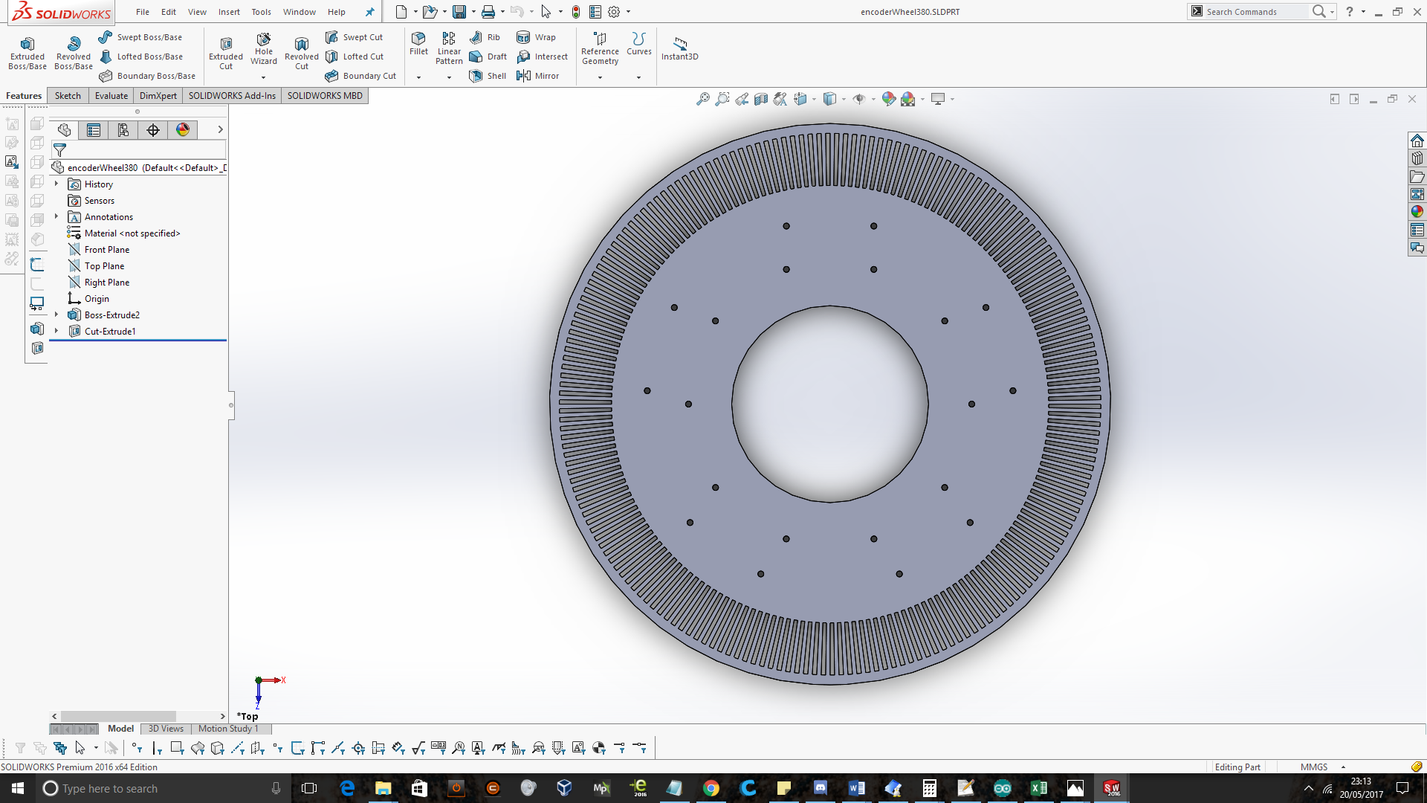

Figure - Encoder wheel - 190 slots – solidworks

This disc was laser-cut out of 3mm MDF (figure 19).

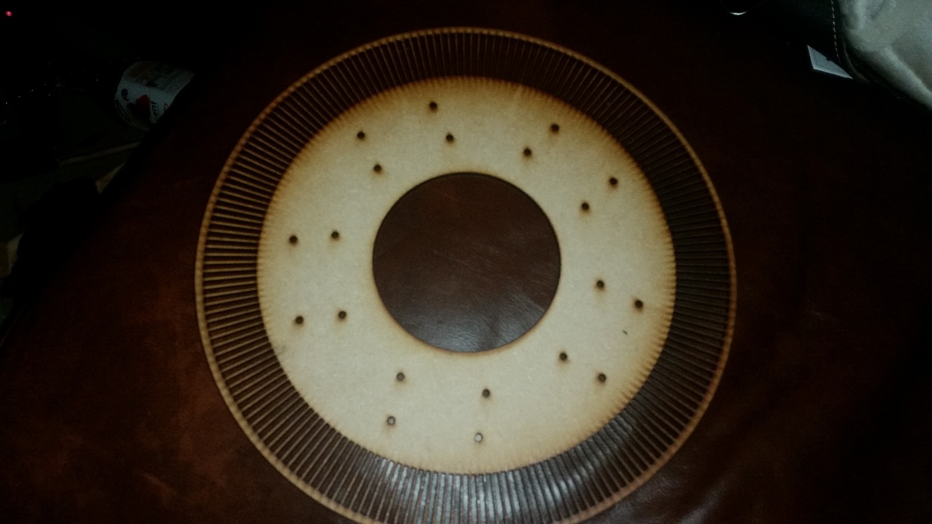

Figure - MDF encoder disc

The disc was also cut out of engineering card. The MDF was to provide support and the white card was to provide a higher contrast than the wood alone. However, the laser cut card had browned edges from the cutting process. This significantly reduced the reflectivity of the white card, leading to up to half of the slots being misread as they moved past the sensor. Upon closer inspection with an oscilloscope, the peak to peak voltage from the collectors was approximately 1V, and the DC offset of this signal varied by more than 1V. This meant that there was no single voltage which, when crossed, could be set to trigger an interrupt on the microcontroller.

To remedy the low reflectivity of the engineering card, white primer and gloss spray paint were purchased. The wooden encoder discs were taken to a spray-booth and coated with several layers of white primer and then several layers of white gloss. Once the paint had dried, a halo of black card was cut out and placed between the robots wheel and the MDF encoder disc (figures 20 and 21).

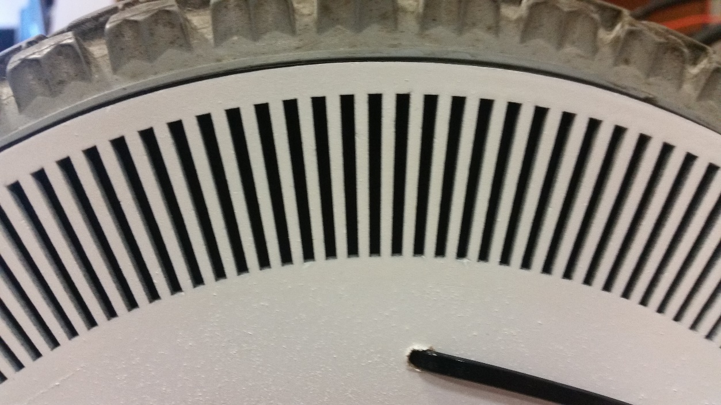

Figure 25 - Encoder disc close up

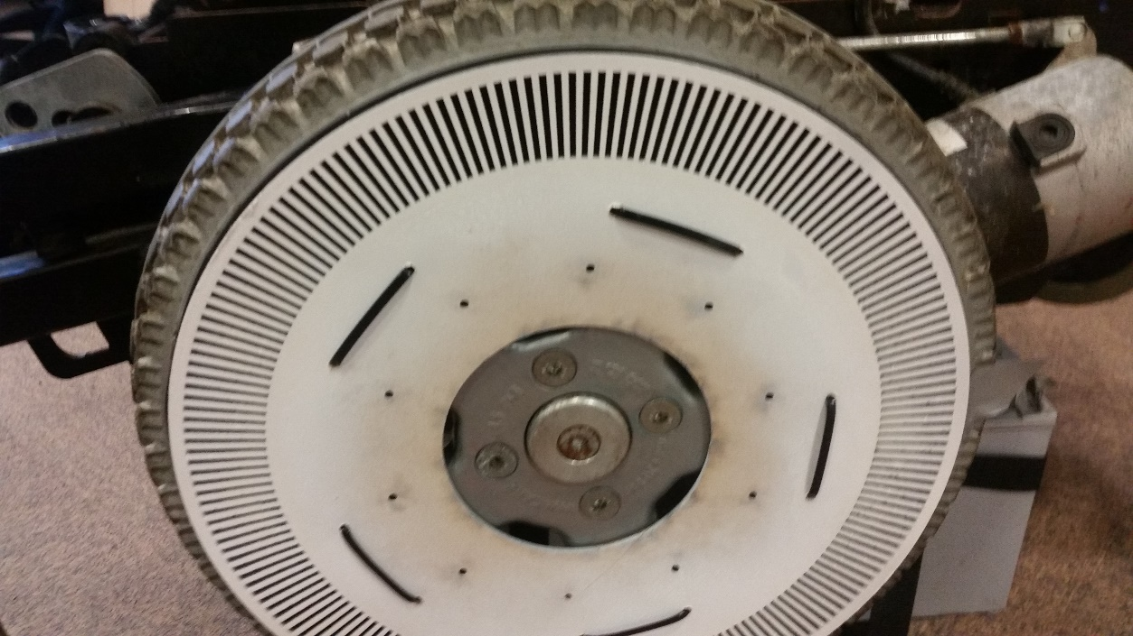

Figure 26 - Encoder disc on wheel

This provided a very high contrast for the sensor, bringing the collector voltage swing between 2.4V and 2.8V. The DC offset of this signal was still approximately 1V, so a comparator voltage could now be chosen.

Even though the 190 slot test encoder disc was readable at every point, mechanically fixing the quadrature sensor to the frame of the robot and attaching the wooden encoder disc to the wheel resulted in some pulses being missed. The system was designed with the highest resolution detectable so the margin of error was very small.

At one point the robot was manually driven into an alcove where one of the encoder discs collided with a sharp, heavy metal object, tearing through multiple slots on the encoder disc. As another disc then had to be fabricated, the decision was made to reduce the resolution of this disc from 190 slots to 128 slots to increase reliability.

The microcontroller was only triggered to activate on the rising edge of a comparator output.

### Circuit

The encoder pulses (measured at the collector of the phototransistor) formed a sine wave as the encoder disc moved past the sensor due to the sensor size being similar to the slot size. The sine wave had a peak to peak voltage of 2.4V to 2.8V, and a varying DC offset of 1.1V. This varying offset was because of a slight misalignment of each wheel on its axel, coupled with a very small buckling of the wheel. This lead to a variance in the distance between the wheel and the sensor of a few millimetres over one rotation of the wheel. It was possible to set a single voltage which when crossed could trigger a microcontroller to increment the wheel counter, however problems arose when attempting to check the other half of the quadrature encoder pair. Whilst it was possible to get a sensor to trigger on every slot, it was not possible to read the state of the other sensor to consistently determine the direction of the wheel due to the varying offset of the sine wave.

To detect relative motion and direction, the state of two sensors must be read. When one sensor crosses a voltage threshold, the state of the other sensor (high or low) determines the wheel direction. Whilst, for clockwise rotation, sensor A always triggered before sensor B and for anti-clockwise motion, sensor B always triggered before sensor A, the absolute voltage level of sensor B was not a reliable way to determine wheel direction.

This lead to the design of a comparator circuit. The circuit used two op-amps per wheel. The first compared sensor A against a reference voltage, outputting high if the sensor was above this voltage and low if the sensor was below it.

The second comparator compared sensor B against sensor A, outputting high if B > A and low if B < A. These two outputs fed into digital inputs on a microcontroller. A rising edge of the first output triggered an interrupt service routine (ISR). Inside this ISR, the state of the second comparator was read. This proved to be a robust method of determining wheel direction.

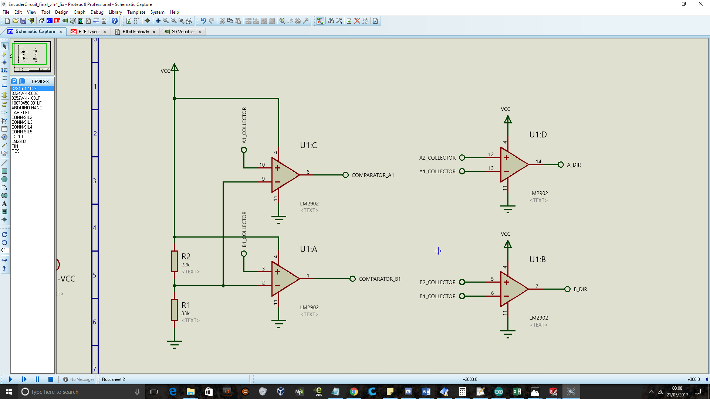

Schematic - Encoder comparator circuit

A quad op-amp, the LM2902, was chosen for its four amplifiers and wide supply voltage tolerance.

For future development, an analogue circuit to track the encoder position between pulses could be designed which could increase the resolution from 190 pulses per revolution to closer to 50,000 pulses per revolution.

### Code

The code snippet in Code Snippet 1 shows the ISR that was written to read one wheel. This function is repeated for the other wheel. Code snippet 2 shows how the main loop of the program uses this information to track the wheel position and calculate velocity.

//Attach the ISR 'leftTrigger' to activate when 'leftInterruptPin' //changes from low to high

**attachInterrupt(**leftInterruptPin**,** leftTrigger**,** **RISING)**;

void leftTrigger**()** **{**

//Teensy3.2 recommends that global interrupts are disabled at the start //of the ISR (cli();) and reenabled at the end (sei();)

cli**()**;

**if** **(**digitalRead**(**leftStatusPin**)** **==** 1**){**

//A flag is set for the main loop to know which direction to count

lFlag **=** 1**;**

**}**

**else** **if** **(**digitalRead**(**leftStatusPin**)** **==** 0**){**

lFlag **=** **-**1**;**

**}**

//Another flag is set to tell the main loop to count

leftTriggered **=** **true;**

sei**();**

**}**

Code snippet 22 - Left Wheel ISR

The above code snippets calculated the velocity of the left wheel.

//If the ISR has triggered, the debounce timer has been exceeded and

//the system has been active for at least two seconds..

if **((**leftTriggered**)** && **(millis()** **>=** lTime**)**&& **(micros()** **>** 2000000**))**{

//Inline statement to set the LED to turn on when the wheel is

//rotating one way, and off it its rotating the other

lFlag **==** 1 ? **digitalWrite(**13**,** **HIGH)** : **digitalWrite(**13**,** **LOW)**;

//Increments or decrements a counter depending on direction each pulse

lFlag **==** -1 ? leftWheelCounter **+=** 1 : leftWheelCounter **-=** 1;

//convert pulses to millimeters of robot motion

lLeftWheelDistance **=** long**(**leftWheelCounter**\***1037L**)**;

leftWheelDistance **=** lLeftWheelDistance **/** wheelSlots;

//Publish accumulated distance to ROS host

int_msg.data **=** leftWheelDistance;

leftWheel.publish**(** &int_msg**)**;

//Calculate velocity from change in position over change in time

//old_v_left = v_left; // Uncomment this and the commented line below

//to average velocity over two measurements

newposition **=** leftWheelDistance;

newtime **=** **millis()**;

v_left **=** **(**newposition**-**oldposition**)/(**newtime**-**oldtime**)**;

oldposition **=** newposition;

oldtime **=** newtime;

//v_left = (v_left + old_v_left)/2; // Also uncomment this to enable

//averaging of velocity over two measurements

//Publish left wheel velocity to ROS host

float32_msg.data **=** v_left;

v_left_pub.publish**(** &float32_msg**)**;

//Debounce timer

lTime **=** **millis()** **+** 10;

//Flag to enter 'calculated' function

calculated **=** true;

//Don't re-enter until ISR is triggered again

leftTriggered **=** false;

}

Code snippet 23 - Left wheel processing - Main loop

### Issues

There are inherent problems with quadrature encoders. The two main methods of detecting encoder pulses are:

* Code is executed at fixed time intervals (Constant Δ time) and position is calculated
* Code is triggered by changes in encoder position (constant Δ position) and time is calculated

There are problems with both of these approaches. The first approach requires polling the encoder sensor and so blocks up the rest of the code. Even if this was not the case, other problems arise which apply to both methods.

The second approach initially seems like a good way of measuring wheel speed, and for a fixed velocity wheel it can work quite well. One issue is that the faster the wheel moves and the higher the resolution, the higher the CPU load. Although this won’t provide any problems with this robot as it cannot move that quickly.

Another issue with the constant Δ position approach is that it only gives us an average speed between pulses, changes in wheel speed between the pulses are ignored. This error is small, but quickly accumulates as a robot moves around the room.

The main issue with the constant Δ position approach is that the robots velocity can never reach zero, as can be seen in figure 22.

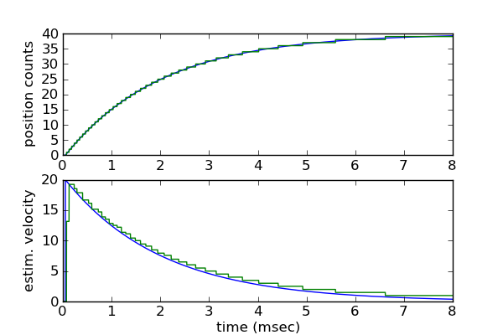

Figure - Quadrature encoders can never read zero velocity

As can be seen in figure 22, the velocity equation can only look back in time. When a change in position is detected, the velocity is calculated a priori. For the velocity to read zero, the next encoder pulse would have to arrive at $t= ∞$ which can obviously never happen.

If the robot is told to stop moving the microcontroller will read the last known velocity indefinitely. Over time the integral error of the PID control accumulates. If the robot was moving forwards before it stopped then the integral error will grow in such a way as to drive the robot forwards, although it will never execute as the code requires the host machine to be sending velocity commands to the robot before any movement can happen. If the robot is then asked to reverse after being stationary for a few minutes, the accumulated integral error term will drive the robot forwards instead. These phenomena are explored further in the PID subsection of the build section of this report.

### Result

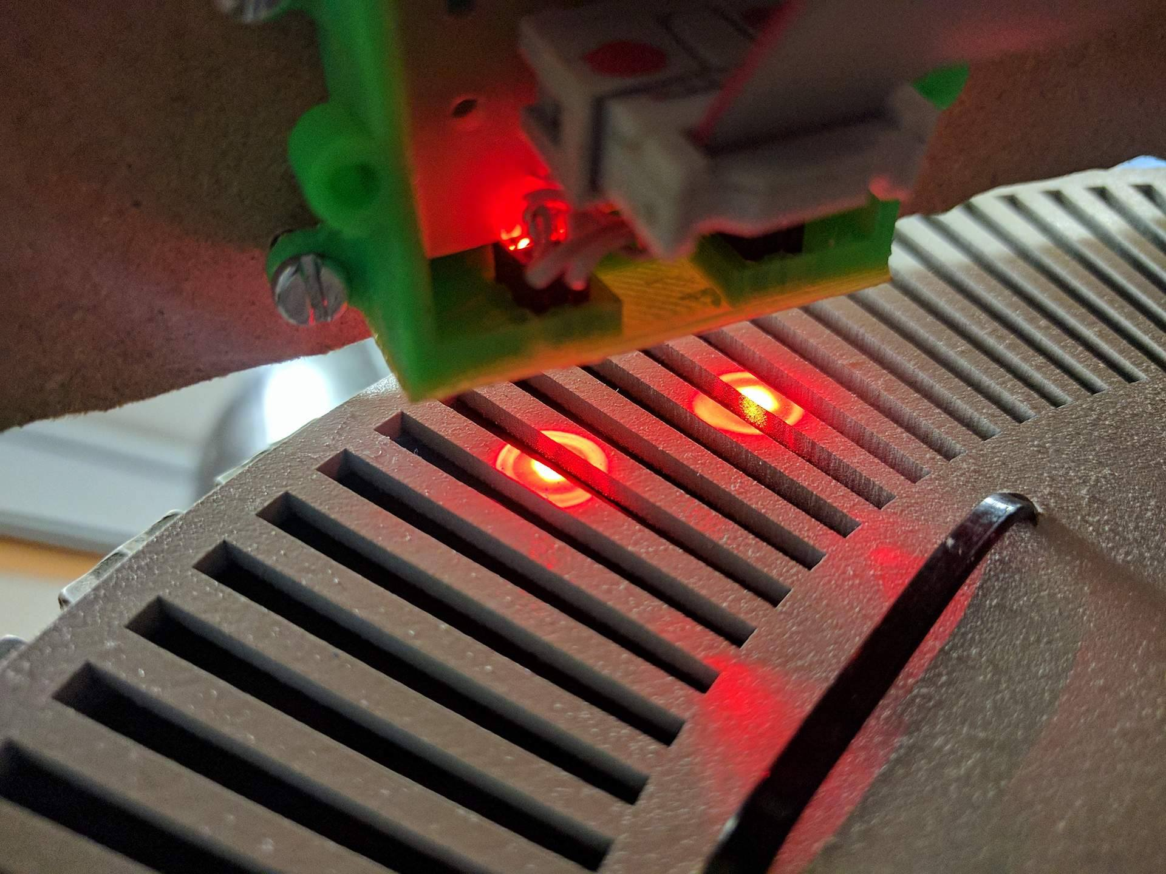

## PID

### Rationale

Even though many SLAM systems have higher computational requirements; HectorSLAM is still a relatively computationally intensive program. In addition, the RPLIDAR would only rotate at a maximum rate of 4.5Hz (more on this in the LIDAR modifications section). HectorSLAM relies on successive scan-matching to calculate the robots changing position. Experimentally, it was found that HectorSLAM required scan updates within 6cm of robot movement to be able to correctly track the robots position. With a LIDAR scan rate of 4.5Hz, this translates to a maximum robot speed of 0.22m/s (assuming the computer isn’t being loaded with too many other tasks). If the computer slowed down, the robots localisation loop would slow down and the robot would rapidly lose track of its position. Due to lack of loop-closure in HectorSLAM, this meant that the robot would not be able to recover its location once this occurred.

The Invacare wheelchair base had a minimum velocity which varied depending on the orientation of its dolly wheels.

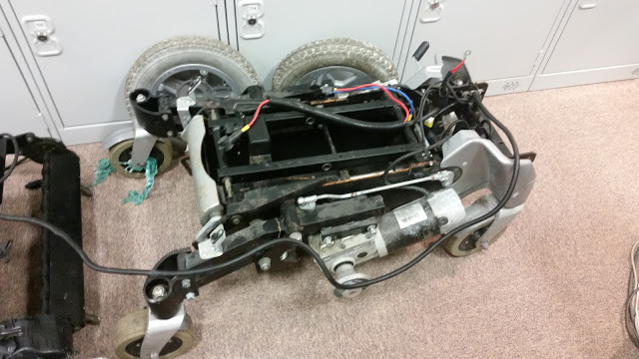

Passive Dolly Wheels

Figure 28 - Chassis Dolly Wheels

As can be seen from figure 22, the base chassis has four passive dolly wheels. Each wheel uses two bearings; one for the rotation of the wheel about its axel and another for the rotation of the entire wheel unit orthogonal to the wheels axel. The chassis utilises suspension to account for uneven terrain and to allow the wheel chair to climb small curbs onto pavements. The rear dolly wheels are rigidly attached to the bulk of the frame. The driven wheels can be raised a few inches due to the suspension and the front dolly wheels can be raised by about an inch.

As the driven wheels are in the centre of the length of the base, the dolly wheels 360o orthogonal bearing allows the wheelchair base to rotate about its centre without exhibiting any translational motion. Whilst this functionality is very useful in a robotic platform it does introduce open-loop control issues, where the control signals required to start moving the base must be greater than those required to maintain a constant low speed.

For example, if the wheel chair bas has been rotating about its centre its dolly wheels will all be perpendicular to the length of the robot. As the base is then driven forwards, the dolly wheels will passively rotate to become parallel with the length of the chassis. During this passive rotation phase, larger control signals are required.

If the last command given to the robot base was to rotate by 90o then the dolly wheels will be perpendicular to the length of the robot base. If we then ask the robot base to move forwards at its minimum speed (approximately 0.18m/s) the base will not move. This is because the minimum power to the motors does not provide enough torque to overcome the extra energy required to re-align the passive wheels. If the control signals to the motor are increased to 0.30m/s, the passive wheel will align and the base will start moving forwards at a speed of 0.30m/s. This is too fast for HectorSLAM to keep track of and the localisation will fail.

It was thought that a solution to this problem would be PID control. By implementing a control system with an accumulating integral term, the robot should be able to move at a constant slower speed. If the robot is asked to move at 0.2m/s but cannot overcome the stiction in the orthogonal wheel bearings then the integral term of the PID equation will grow and thus the commands to the motor driver will steadily increase. Once the wheels start moving the integral term will shrink again and the robot will move at a constant velocity. If the robot ever attempts to move faster than the target velocity, then the proportional term of the PID equation will slow the wheel down before the LIDAR misses any measurements.

It is primarily for these reasons that the wheels were encoded and control systems were designed. Two control systems were implemented as are described below.

### Controlling robots rotation and forward velocity

linear:

x: 0.32

y: 0.0

z: 0.0

angular:

x: 0.0

y: 0.0

z: 0.47

---

The cmd_vel messages from the ROS navigation stack take the following form:

As the chassis is differential drive, its instantaneous motion can be described in polar form with an x velocity and an angular velocity. This is the same form as the joystick commands to the wheel chair base. Deflecting the joystick forwards and backwards is equivalent to setting the ‘linear x’ variable in the above message and deflecting the joystick left and right is equivalent to setting the ‘angular z’ variable in the above message.

A control system was designed to provide correction signals for these parameters, as can be seen in figure 23.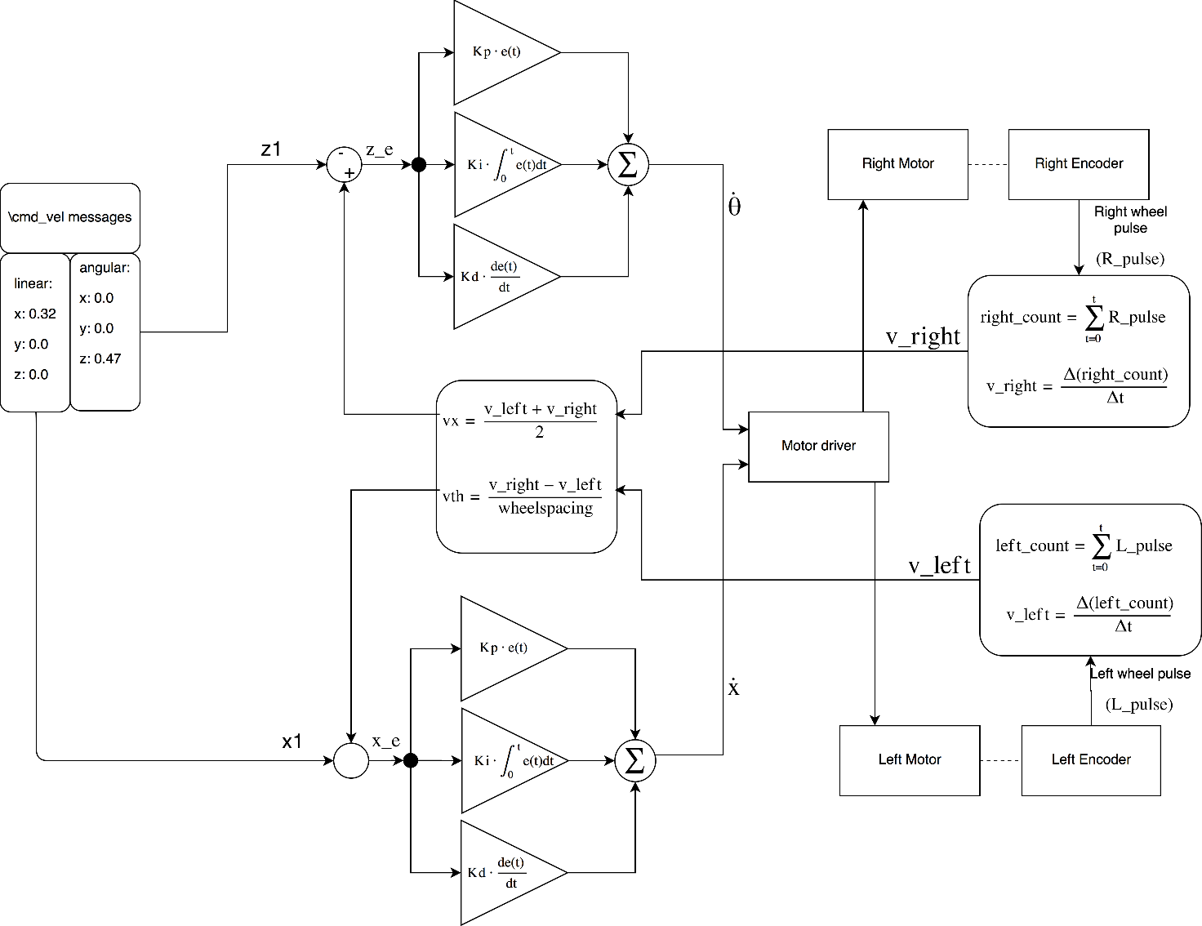

Figure - Controlling x and theta

Code snippet 3 shows how this control system was implemented. Left and right wheel velocities are calculated in the same way as they are in code snippets 1 & 2.

//Set x PID tunings

float xKp **=** 5.0;

float xKi **=** 0.2;

float xKd **=** 0.4;

//Set z PID tunings

float zKp **=** 5.0;

float zKi **=** 0.2;

float zKd **=** 0.4;

//These are called once on setup to create the PIDx and PIDz objects

PID myPIDx**(**&xInput**,** &xOutput**,** &xSetpoint**,**xKp**,**xKi**,**xKd**,** DIRECT**)**;

PID myPIDz**(**&zInput**,** &zOutput**,** &zSetpoint**,**zKp**,**zKi**,**zKd**,** DIRECT**)**;

//Only run when the velocities are updated

if **(**calculated**)**{

vx **=** **(**v_left **+** v_right**)/**2;

vth **=** **(**v_right **-** v_left**)/**wheel_spacing;

calculated **=** false;

}

//Only run if desired velocities are not zero

if **((**x1 **!=** 0**)** **||** **(**z1 **!=** 0**))** {

//Set calculated x and theta velocities to be the PID inputs

xInput **=** vx;

zInput **=** vth;

//Set the desired velocities as setpoints

xSetpoint **=** x1;

zSetpoint **=** z1;

//Calculate PID

myPIDx.Compute**()**;

myPIDz.Compute**()**;

//Output to motor driver

xz_updateStick**(**xOutput**,** zOutput**)**;

}

else {

stopMotors**()**;

}

Code snippet 24 - X and Theta control code

The robot was propped up so that the driven wheels couldn’t touch the ground and the PID tuning process started. Tuning the PID required reprogramming the microcontroller and it was not intuitive to base the tunings from variables being sent through the serial port. Because of this a live PID tuning system was developed.

The code in snippet 4 shows the initial function developed to send PID gain values to the system as it was running.

**#**include **<**std_msgs**/**Float32.h**>**

**#**include **<**ros.h**>**

//Create node handle

ros::NodeHandle nh;

//Default tunings

float xKp **=** 1.4;

float xKi **=** 0.14;

float xKd **=** 0.01;

//Create PID object

PID myPIDx**(**&xInput**,** &xOutput**,** &xSetpoint**,**xKp**,**xKi**,**xKd**,** DIRECT**)**;

//Callback for PID subscriber

void pidCb**(** const std_msgs::Float32& data**)**{

myPIDx.SetTunings**(**data.data**,** xKi**,** xKd**)**;

}

//Create PID subscriber

ros::Subscriber**<**std_msgs::Float32**>** tuner**("**pid_p**",** &pidCb**)**;

void **setup** **()**

{

//Initialise as ROS node

nh.initNode**()**;

//Subscribe to "pid_p" topic

nh.subscribe**(**tuner**)**;

}

Code snippet 25 - Proportional tuner

The following command was entered into a terminal to set the proportional gain:

rostopic pub /tune std_msgs/Float32 "data: 1.4"

Code snippet 4 shows how a single tuning parameter was set. The PID tuning system was expanded to cover all variables as can be seen in code snippet 5.

To set the PID values, a geometry_msgs/Pose message was used as it was floating point and contained enough data fields for all the values. For future development, a bespoke ROS message should be defined. To set all the PID gains remotely, the following command was entered into the terminal:

Code snippet 26 - PID tune all subscriber

**#**include **<**ros.h**>**

**#**include **<**geometry_msgs**/**Pose.h**>**

//Create node handle

ros::NodeHandle nh;

//Initialise default values

float lKp **=** 1.4;

float lKi **=** 0.14;

float lKd **=** 0.01;

float rKp **=** 1.4;

float rKi **=** 0.14;

float rKd **=** 0.01;

//Create PID objects

PID myPIDx**(**&xInput**,** &xOutput**,** &xSetpoint**,**xKp**,**xKi**,**xKd**,** DIRECT**)**;

PID myPIDz**(**&zInput**,** &zOutput**,** &zSetpoint**,**zKp**,**zKi**,**zKd**,** DIRECT**)**;

geometry_msgs::Pose pid_all;

void pid_all_cb**(**const geometry_msgs::Pose& pid_all**)**{

xKp **=** pid_all.position.x;

xKi **=** pid_all.position.y;

xKd **=** pid_all.position.z;

zKp **=** pid_all.orientation.x;

zKi **=** pid_all.orientation.y;

zKd **=** pid_all.orientation.z;

PIDen **=** boolean**(**pid_all.orientation.w**)**;

myPIDx.SetTunings**(**xKp**,** xKi**,** xKd**)**;

myPIDz.SetTunings**(**zKp**,** zKi**,** zKd**)**;

}

//Create PID_tune_sub subscriber

ros::Subscriber**<**geometry_msgs::Pose**>** PID_tune_sub**("**PID_tuneAll**",** pid_all_cb**)**;

void **setup** **()**

{

//Initialise as ROS node

nh.initNode**()**;

//Subscribe to "pid_p" topic

nh.subscribe**(**PID_tune_sub**)**;

}

rostopic pub /pidTune geometry_msgs/Pose "position:

x: 1.4

y: 0.14

z: 0.01

orientation:

x: 1.4

y: 0.14

z: 0.01

w: 1.0"

Where the ‘position’ variables are the forward/reverse loop gains and ‘orientation’ variables are the rotation loop gains. The x, y and z variables are for proportional, integral and derivative respectively.

The fourth orientation variable was typecast to a Boolean once it reached the microcontroller. This Boolean variable was used to enable or disable the PID control.

By utilizing the rqt_plot program in ROS to graph the variables live it was possible to see how tunings affected the system while it was running. Figure 24 shows the live tuning of the X PID loop.

To make this process easier, sliders and text entry boxes were implimented in the GUI to provide a graphical interface to the PID tuning process. A ‘reset to defaults’ button was also added.

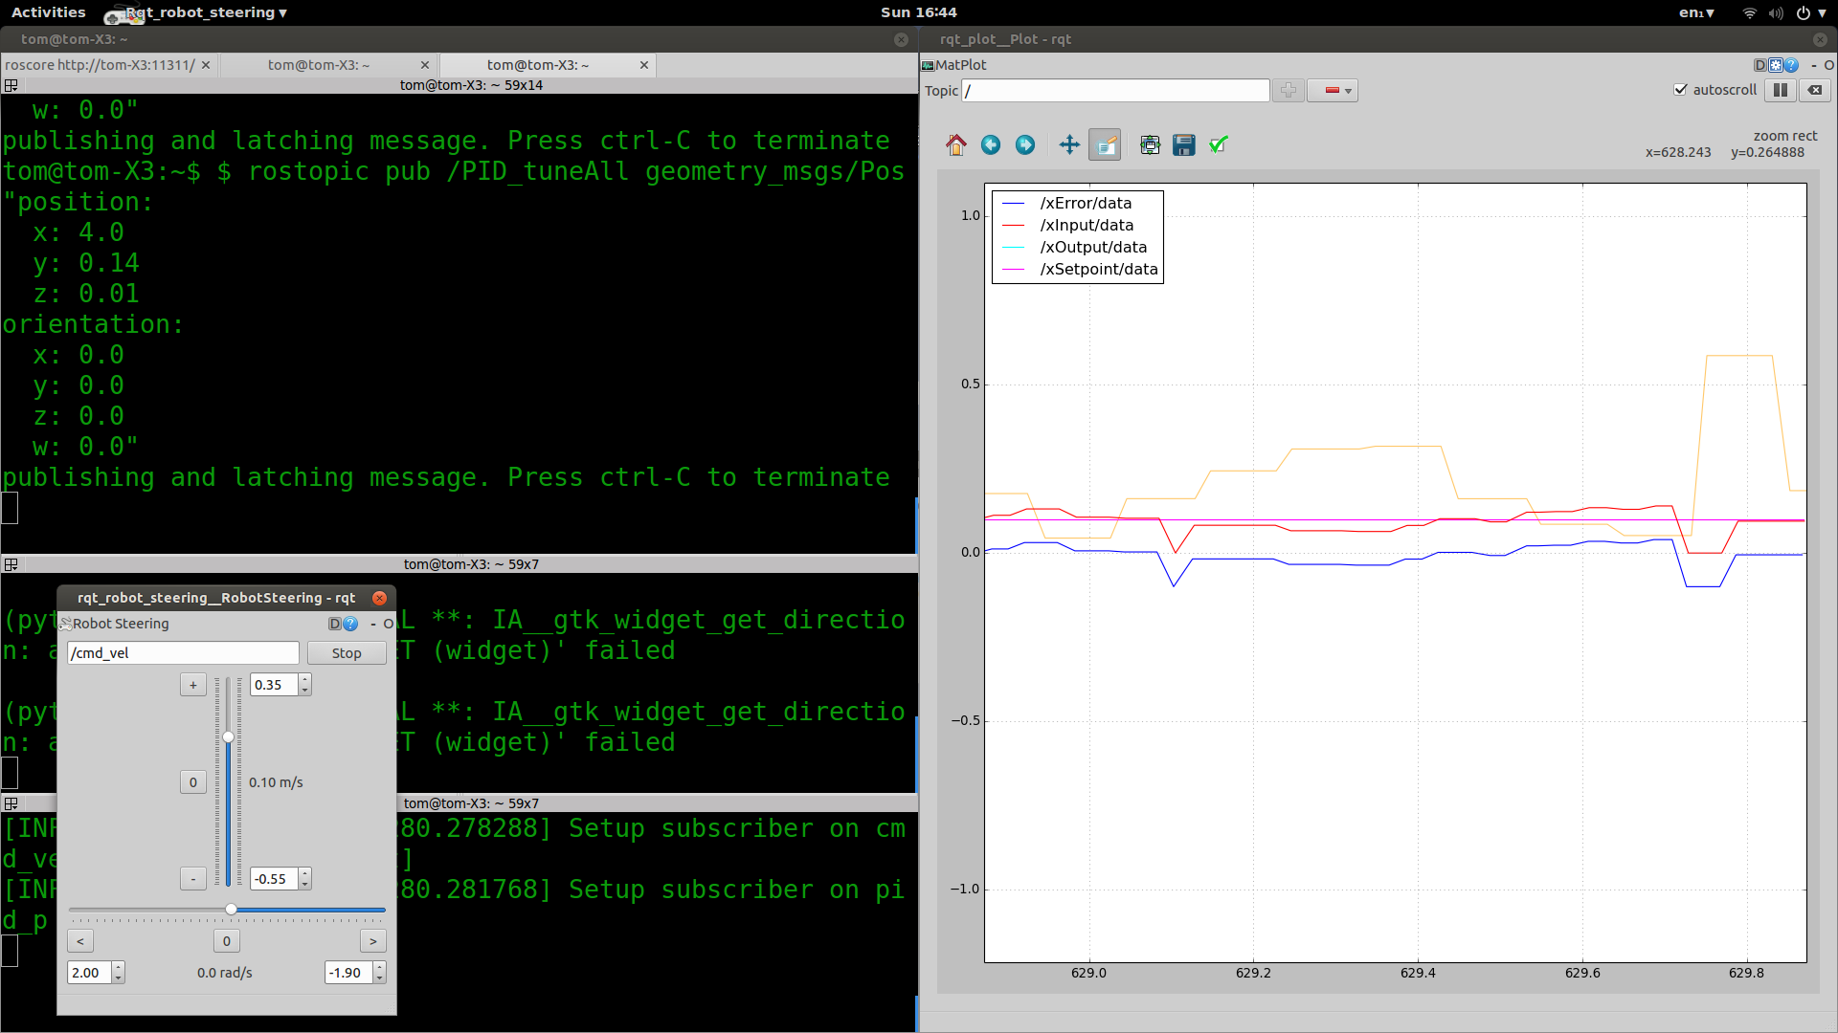

Figure - Live tuning the X loop

#### Results

As introduced under Research > Encoders > Issues, there are problems with accumulating integral error with quadrature encoders. By using the above control system, when propped up, the robots minimum speed dropped to 0.1m/s. Some oscillations in velocity occurred, but once the PID values were further dialled in the robots wheels could move at a steady 0.1m/s.

The robot was then removed from its props, placed on the floor and manually asked to move forwards at a slow, constant speed. After a few seconds the integral term accumulated and the robot began moving. Whilst the robot was moving, the manual controls were altered to ask the robot to start turning left, but the robot did not turn. The robot was asked to turn right and reverse too, but none of these commands changed the robots trajectory. The accumulated integral term in the robots forward velocity control loop completely overrode further control inputs.

Further tuning of the PID gains was attempted. It was possible to remove this behaviour by removing the integral term, but this returned the robot to the initial problem of its minimum speed being too high and not constant. For these reasons, a second control system was designed to remedy this.

### Controlling robots left and right wheels

As the x and theta PID loops integral terms overwrote each other it was decided to try and control the wheels instead of the robots forward and rotational velocity. To do this, new equations had to be derived from the differential drive robot equations to extract the robots left and right wheel commands from the x and theta velocity control signals. The motor driver for the wheelchair has the same mathematical problem to solve and so it is hypothesised that the motor driver implements similar equations.

$$Differential drive equations:$$

$$x_{velocity}= \frac{v_{left}+v_{right}}{2}$$

$$θ_{velocity}= \frac{v_{right}-v_{left}}{wheel spacing}$$

$$x= \frac{v_{l}+v_{r}}{2}$$

$$θ=\frac{v_{r}-v_{l}}{w}$$

First, we will derive the equation for $v_{l}$ in terms of $x$ and $v_{r}$:

$$2.x=v_{r}+v_{l}$$

$$2.x-v_{r}=v_{l}$$

Now we will derive $v_{l}$ in terms of $θ$ and $w$:

$$w.θ=v_{r}-v_{l}$$

$$v_{r}- w.θ=v_{l}$$

Equating the two and solving for $v_{r}$:

$$2.x-v_{r}=v_{r}-w.θ$$

$$2.x+w.θ=2.v_{r}$$

$$x+ \frac{w.θ}{2}=v_{r}$$

Now we repeat the process for $v_{l}:$

$$2.x=v_{r}+v_{l}$$

$$2.x-v_{l}=v_{r}$$

$$w.θ=v_{r}-v_{l}$$

$$w.θ+v_{l}=v_{r}$$

Equating:

$$2.x-v_{l}=w.θ+v_{l}$$

$$2.x-w.θ=2.v_{l}$$

$$x-\frac{w.θ}{2}=v_{l}$$

We now have two equations which will convert the polar cmd_vel messages to left and right wheel velocities. This gives us a target velocity for each wheel which we can control with two new PID loops. Figure 26 shows the control diagram for the new control system.

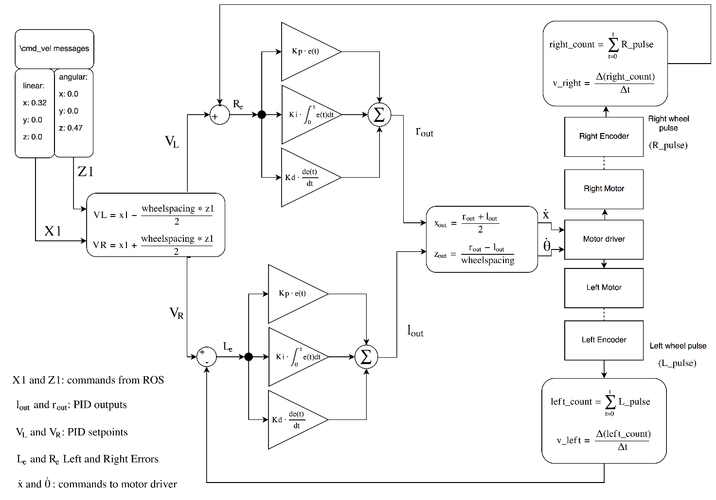

Figure - Diagram for controlling left and right wheels

if **((**x1 **!=** 0**)** **||** **(**z1 **!=** 0**))** {

//Setpoints from extracted left and right components of x1 and z1

VL **=** x1 **-** **((**z1**\***wheel_spacing**)/**2**)**;

VR **=** x1 **+** **((**z1**\***wheel_spacing**)/**2**)**;

lSetpoint **=** VL;

rSetpoint **=** VR;

//Inputs are measured wheel velocities

lInput **=** v_left;

rInput **=** v_right;

if **(**v_left **>** 0.15**)**{

lSetpoint **=** speedLimit;

}

if **(**v_right **>** 0.15**)**{

rSetpoint **=** speedLimit;

}

//Publishers to graph PID variables

float32_msg.data **=** lInput;

lInputP.publish**(** &float32_msg**)**;

float32_msg.data **=** lSetpoint;

lSetpointP.publish**(** &float32_msg**)**;

float32_msg.data **=** rInput;

rInputP.publish**(** &float32_msg**)**;

float32_msg.data **=** rSetpoint;

rSetpointP.publish**(** &float32_msg**)**;

//Clears integral accumulator once the robot is moving

if **((**v_left **>** 0.08**)** **||** **(**v_right **>** 0.08**))**{

leftPID.Compute**(**true**)**;

rightPID.Compute**(**true**)**;

}

else {

leftPID.Compute**(**false**)**;

rightPID.Compute**(**false**)**;

}

//Publishers for PID output

float32_msg.data **=** rOutput;

rOutputP.publish**(** &float32_msg**)**;

float32_msg.data **=** lOutput;

lOutputP.publish**(** &float32_msg**)**;

//Recombine left and right wheel control into differential drive commands

xout **=** **(**rOutput **+** lOutput**)/**2;

zout **=** **(**rOutput **-** lOutput**)/**2;

//Output motor commands

xz_updateStick**(**xout**,** zout**)**;

}

Code snippet 27 - PID control of left and right wheels

Code snippet 6 shows the main points of how this was implemented in the Arduino. The PID values for this were tuned in the same way as the previous control loop. Figure 27 shows the live tuning of the left and right PID loops. In the background you can see the four encoder collectors on an oscilloscope. The combination of rqt_plot and the oscilloscope proved to be instrumental in correctly positioning the encoders.

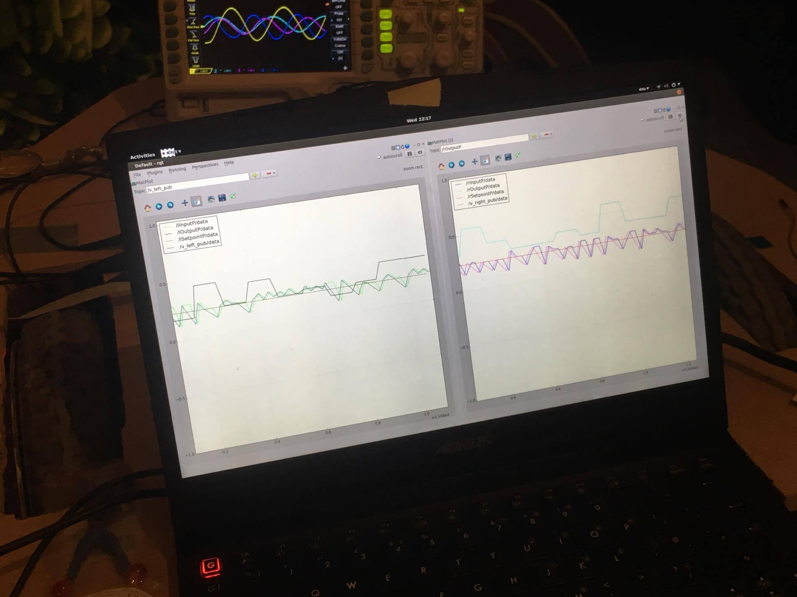

Figure - Live tuning left and right PID loops

#### Results

This system worked significantly better than the last. The robot would overcome the stiction in its orthogonal wheel bearings due to the build-up of the integral error, and would still respond to different velocity commands. Manually controlling the robot felt a little sluggish.

When the robot was released back into the lab and asked to navigate to an objective it would sometimes bump into things. Remotely viewing the cmd_vel messages provided no insight to this. Bringing up the rqt_graph on a remote machine showed that the integral term was still accumulating too much, potentially due to the latency between the microcontroller and the motors via the motor driver. Some time was spent adjusting the PID gains but a balance could not be found between the robots minimum velocity and the robots responsiveness. This lead to the decision to implement a third type of control.

### Velocity limit control

As the main control problem was overcoming the robots starting stiction and inertia (and because PID was causing so many problems) it was decided to remove the PID code and design a system to limit the robots velocity. This way ROS could be configured to output larger control signals than the desired robot speed, and the microcontroller could limit the speed of the wheels to prevent the robot moving too quickly. Code snippet 7 shows how this was implemented.

Code snippet 28 - Velocity limit control

if **((abs(**v_left**)** **>** limitThreshold**)** **||** **(abs(**v_right**)** **<** limitThreshold**))**{

if **(**x1 **>** x1Lim**)** x1 **=** x1Lim;

if **(**x1 **<** x1LimNeg**)** x1 **=** x1LimNeg;

if **(**z1 **>** z1Lim**)** z1 **=** z1Lim;

if **(**z1 **<** z1LimNeg**)** z1 **=** z1LimNeg;

}

//Speed boost for reversing (requires more power for the same speed compared to forwards)

if **(**x1 **<** 0**)**{

x1 **=** **-**0.45;

}

xz_updateStick**(**x1**,** z1**)**;

The speed limits could be altered remotely in the same way as the PID tuning parameters. Additional sliders and entry boxes were added to the GUI to facilitate this.

#### Testing

This system performed better than the previous two control implementations. The forward, reverse, left and right velocities of the robot base could be set from the GUI which allowed the robots speed to be fine-tuned as it was navigating. Once the RPLIDAR had been modified and its scan frequency tripled, the robot could approach 0.8m/s before it began to lose track of itself.

The velocity limit control was also useful in that it required only a few clicks on the GUI in order to change the speed of the robot if manual control was taking place.

## RPLIDAR modifications

The RPLIDAR is advertised as having a user-configurable scanning frequency of up to 10Hz. The RPLIDAR ROS node contained no such settings and forum posts resulted in no information on how to set the scanning frequency. The default scanning frequency ranged between 4.5Hz and 5.2Hz on the robot.

Upon closer examination of one of the datasheets for the RPLIDAR, it was discovered that the RPLIDARs motor voltage could be increased from USB voltage (5V) to 9V.

The motor in the RPLIDAR is powered open-loop from USB voltage. The rotating scanner on top of the lidar is encoded and so varying or unstable motor speed is not a problem.

A LM317 3-pin adjustable voltage regulator in a TO-220 package was constructed on breadboard. Figure 29 shows the schematic and pinout of the IC.

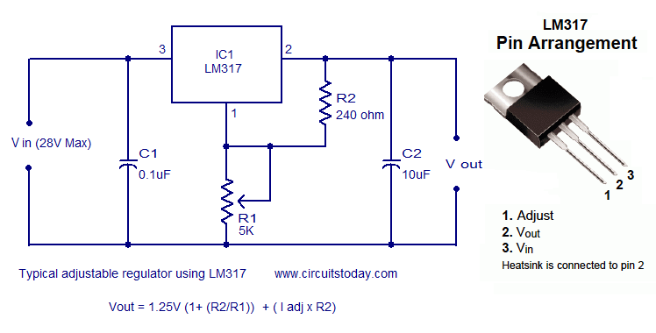

Figure - LM317 Circuit and pinout

The ‘I adj’ term in the vout equation in figure 29 is very small and so wasn’t considered in this application.

The maximum rated voltage of the RPLIDARS motor in the datasheet is 9V, so the regulator will be configured to output approximately 8.5V.

$$v_{out}=1.25*\left(1+\frac{R2}{R1}\right)=1.25*\left(1+\frac{2200}{370}\right)=8.68V$$

$$R1=370Ω$$

$$R2=2.2kΩ$$

The RPLIDAR datasheet states that the motor will draw 100mA max at 5V. As the motor will be provided with up to 9V, it was decided to increase this current rating to 150mA to be safe.

$$Power=V_{in}-V_{out}*I=\left(28-9\right)*0.15=2.8 watts$$

$$Max heatsink thermal resistance \left(LM317\right)=\frac{(T_{max}-T_{Ambient})}{Power}=\frac{60-25}{2.8}={12.2}^{o}C/W$$

A heatsink was chosen from the store with a thermal resistance of 8oC/W.

### Testing

After connecting the 9V regulator to the motors voltage input pin the motor enable pin, the RPLIDAR was powered up and connected to the robot. The driver was started and the scan frequency was found to be 13Hz, which is more than three times the default speed.

The robot was released back into the lab once more and the internal speed limits were adjusted as it navigated its way to objectives. It was found that the robots speed could be increased from 0.22m/s to 0.75m/s before it began to lose track of itself. This lead to the hypothesis that the main limiting factor of the robots navigation speed was the scan frequency of the LIDAR, and that a faster LIDAR module could perhaps achieve similar or better performance on a platform with decreased computational power.

## Tkinter

### Overview

Tkinter is a GUI (graphical user interface) for python. A GUI was developed to be the general-purpose controller for the robot with the aim of reducing the number of simultaneous terminal windows required for both remote and local operation, and to enable untrained persons to operate it.

Tkinter GUIs based on the grid manager generally consist of nested frames to aid organisation. A root window is created in which sits the main frame. This main frame can be divided into as many columns and rows as desired. Within any cell of a frame, another frame can be created, each with its own grid system.

Resizing parameters are set by weighting each column and row. If a window has two columns, the first with a weighting of 1 and the second a weighting of two, then the second column will expand/contract twice as much as the first when the window is resized.

### Specifications

* All PID parameters tuneable via both sliders for coarse tuning and text entry boxes for fine tuning
* PID parameters can be reset to default with a single click
* All speed limit parameters are tuneable with both sliders and text entry boxes
* std_in and std_err redirected to GUI from subprocesses for easier debugging
* Waypoints and patrol routes can be configured and activated without having to type anything
* Commonly used ROS tools can be started, stopped and restarted from the GUI, such as:
  + Rviz
  + RPLIDAR driver
  + Navigation stack
  + Manual robot steering
* Console output of smach state-machine status printed directly to the GUI
* Topics can be published to straight from the GUI
* Cmd_vel instructions are displayed on the GUI whether the GUI is running locally or remotely
* Automated bag file creation and unbagging available without having to type

Figure 30 shows the GUI in operation.

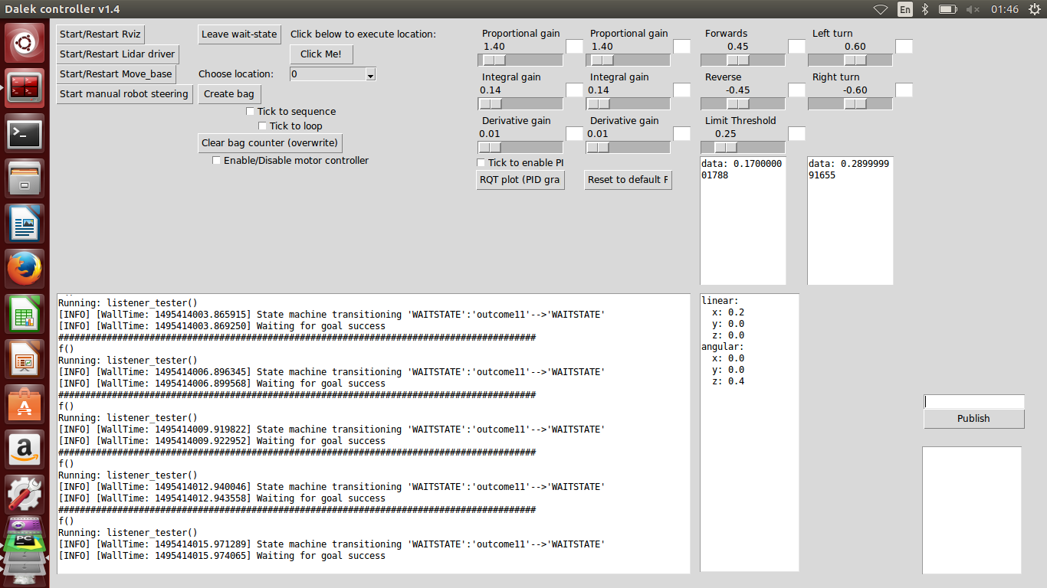

Figure 34 - Tkinter GUI

# How to use the Robot

## ROS network setup

The robot is controlled via a remote computer. This remote computer and the one on the robot must be connected to the same wireless network. It is recommended to setup a new local network between the machines, as routing through pre-existing university networks (EDUROAM) often causes issues. To make setup easier it is also recommended to set the machines to the same subnet. Internet access is not required for the network to function. Static IP addresses will make the system robust against the DHCP server assigning new addresses and will prevent the need for later reconfiguration, however dynamic IPs were used in the development of this robot and didn’t cause any issues.

Once the network has been setup and both machines are connected, the ROS IP addresses must be configured. These can be entered into each terminal session, however it is recommended to add the configuration settings to the bottom of each machines .bashrc file so that they are automatically called at each new terminal session.

For ease of understanding, during the rest of this document the computer on the robot will be referred to as the host and the remote computer will be referred to as the client.

The IP address of each computer must be known. To find out the IP address of a machine, type “ip addr show” into a terminal window. Find the information returned under the network adapter that you are using to connect to the network (e.g. wlan0). Within this text, next to the word “inet” will be a string of numbers, generally resembling the form 192.168.xxx.xxx. This is the IP address of the computer. Repeat this process for both the host and the client and record their IP addresses.

To tell ROS that it should run over a network, some environmental variables need to be set. The ROS_MASTER_URI tells the computer where on the network the host machine is.

It is highly recommended to make a backup of the .bashrc file on each machine before continuing. To do this, type the following command into a terminal on both the host and the client:

cp ~/.bashrc ~/.bashrc.original

And if ever you need to restore this backup, type the following:

cp ~/.bashrc.orignal ~/.bashrc

Then, on both the host and the client computers, type the following into a terminal but replace 192.168.43.128 with the IP address of the HOST computer:

echo ‘export ROS_MASTER_URI=http://192.168.43.128:11311’ >> ~/.bashrc

The above command adds a line to the computers .bashrc file telling it to add the ROS_MASTER_URI to the systems environmental variables. If you believe that you may have mistyped or later wish to edit this information, the following command will let you make changes to the file:

sudo nano ~/.bashrc

Then on the host computer, the ROS_IP and ROS_HOSTNAME need to be set. To do this type the following, but again replacing the IP address with the one from your HOST computer:

echo ‘export ROS_IP=192.168.43.128’ >> ~/.bashrc

echo ‘export ROS_HOSTNAME=192.168.43.128’ >> ~/.bashrc

To check that you have done this correctly, check the output of the following command:

cat ~/.bashrc

The last three lines should read:

export ROS_MASTER_URI=http://192.168.xxx.xxx:11311

export ROS_IP=192.168.xxx.xxx

export ROS_HOSTNAME=192.168.xxx.xxx

Now the ROS_IP and ROS_HOSTNAME must be set on the client machine. To do this, on the client machine, type the following but replace the IP address with that of the client machine:

echo ‘export ROS_IP=192.168.43.223’ >> ~/.bashrc

echo ‘export ROS_HOSTNAME=192.168.43.223’ >> ~/.bashrc

The ROS network should now be setup. To test this, close all previous terminals and open a new one on both the client and host machines. On the host, type:

roscore

And on the client, type:

rostopic list

The client terminal should return the following:

/rosout

/rosout_agg

If it returns one or both then everything is probably okay. If not, double check your network configuration.

## Robot setup

Now that the network is setup, the robots software stack can be started. The setup process has been simplified through use of launch files, however all processes have not been consolidated into a single launch file as often processes need to be started and stopped individually without restarting the entire navigation system. It is recommended to install Terminator to help with this process as it supports tiled terminal windows. To install terminator, type:

sudo apt-get install terminator

The following steps will be described for both the host and client machines. However, once you are comfortable with the setup process you may wish to start all nodes from the client computer, using SSH to start nodes remotely on the host machine.

Ensure that the LIDAR is connected and powered on, as well as the microcontroller and the wheelchair controller.

On the host machine (physically or via SSH), type the following:

roslaunch rplidar_ros rplidar.launch

This will start the LIDAR driver. If this fails and states that it cannot bind to the specified serial port, then the serial port may have to be changed. To do this, disconnect everything but the LIDAR and type:

ls /dev/ttyUSB*

This should return:

/dev/ttyUSBx

Where ‘x’ is replaced by a number. This represents the port the LIDAR is connected to. Then type:

roscd rplidar_ros/launch

sudo nano rplidar.launch

And under <param name=”serial_port” type=”string” value=”/dev/ttyUSB0”/>

replace /dev/ttyUSB0 with the USB port number found above.

Re-running the roslaunch command above should now result in the lidar driver scanning correctly. To check that data is being streamed into ROS, type:

rostopic echo /scan

You should see large matrices of numbers rapidly filling the terminal window. Press Ctrl+C to stop this.

Now the navigation stack must be started. To do this open a new terminal (or split the window in terminator) and type:

roslaunch slambot_2dnav move_base.launch

This will start the navigation stack, containing the SLAM system, trajectory generator, costmaps and some TF publishers.

Now the serial link to the motor controller has to be started. To do this type:

rosrun rosserial_python serial_node.py /dev/ttyACM*

This covers setup on the host machine, the robot should now be operational and waiting for objectives.

To send the robot objectives you must switch to the client computer. On the client, open a new terminal and start the GUI. This is recommended to be started from the PyCharm IDE, but can also be started directly with:

~/smachGUI/Dalek_controllerv1.6.py

From the GUI, check and then uncheck the box marked ‘Tick to enable PID’, then click ‘Start/Restart Rviz’ and ‘Start manual robot steering’. Manual robot steering allows the forward and rotational velocities of the robot to be manually set. This is a useful test to see that the network is functioning correctly and that the microcontroller / wheelchair controller is responding. Now, switch to RVIZ. You should be presented with a map of the robots environment with the robots footprint in the centre of the map and a large red arrow pointing in the direction of the robots heading. Assuming everything has been setup correctly, clicking ‘2D Nav Goal’ and then placing a goal on the map should result in the robot autonomously navigating towards the goal.

## Waypoints and patrol routes

The process of setting up waypoints or patrol routes has been automated for the user via the GUI. It is recommended that the GUI is started from the PyCharm IDE, but it should work if ran as a python script in the terminal.

Start the GUI, either via PyCharm:

~/pycharm-2017.1.2/bin/pycharm.sh

And click the ‘Play’ button. Or, to start the GUI and state-machine directly:

~/smachGUI/dalek_controllerv1.6.py

The GUI and state-machine will now start.

To plan and activate waypoints or patrol routes, first switch to the GUI entitled “Dalek controller v1.6”. Ensure that the ‘Enable/Disable motor controller’ button is unchecked. Click ‘Start/Restart Rviz’. Once Rviz has opened, the user will be presented with a map of the robots environment. Place a 2D Nav Goal as if you were giving the robot an objective. Then switch back to the GUI and click ‘Create Bag’. Then return to Rviz, create another goal and click ‘Create Bag’ again. If the user wishes to start over they can click the ‘Clear bag counter’ button. Once all the goals have been set, return to Rviz and place a goal at the robots current location. This will prevent the robot from moving before the patrol route or waypoints are activated.

To prime the robot for movement the defined patrol route, return to the GUI. Check the ‘Enable/Disable motor controller’ check box. If the last 2D Nav goal is not approximately on top of the robot, the robot will start moving, so be careful.

To enable multi-waypoint mode, check the ‘Tick to sequence’ box. To have the robot repeat the waypoints and thus follow a patrol route, check the ‘Tick to loop’ box. To have the robot move to a particular waypoint and then stop, uncheck these two boxes, select a waypoint from the ‘Choose location’ combo box and press the ‘Click Me’ button.

The robot is now ready to execute the actions which have just been defined. To start the robot moving, click the ‘Leave wait-state’ button. The robot will now execute the plan the user has just entered. If a patrol route has been configured, the robot will loop through goals indefinitely.

To halt at the next goal, select location ‘55’ from the combo box and press the ‘Click Me’ button. The robot will now halt at the next goal.

# Conclusion

The autonomous robot platform designed and build in this report can autonomously navigate through an unknown environment as can be seen on the following youtube playlist: <https://www.youtube.com/playlist?list=PLShpoMUW8Rj9yidoXEcSqX7xUTcHpAVGT> . The maps generated by the robot are of high quality and the robot doesn’t lose track of its location. The waypoint and patrol route system functions well, but work could be done to make the GUI more intuitive.

The project met its goal of producing a stable, autonomous navigation platform. Factoring in the price of the wheelchair, both the laptop computers and the LIDAR, this robotic system was developed for less than 1% of the price of the PR2 robotic platform.

# References

https://developer.microsoft.com/en-us/windows/kinect/hardware (Microsoft, 2017)

# Bibliography

CAN In Automation (CIA). (2017). *History of CAN technology*. Retrieved from CAN In Automation (CIA): https://www.can-cia.org/can-knowledge/can/can-history/

Hamed Sarbolandi, D. L. (2015). Kinect range sensing: Structured-light versus Time-of-Flight Kinect. *Computer Vision and Image Understanding*, 1.

Microsoft. (2017). *Kinect Hardware*. Retrieved from Microsoft Developer: https://developer.microsoft.com/en-us/windows/kinect/hardware

MOSHE KAM, X. Z. (1997). Sensor Fusion for Mobile Robot Navigation. *Proceedings of the IEEE, Volume 85*, Abstract.

*Odometry*. (2017). Retrieved from Wikipedia.

ROS. (2017). *Catkin conceptual overview*. Retrieved from ROS wiki: http://wiki.ros.org/catkin/conceptual_overview

ROS. (2017). *Understanding Nodes*. Retrieved from ROS Wiki: http://wiki.ros.org/ROS/Tutorials/UnderstandingNodes

ROS wiki. (2017). *TF*. Retrieved from ROS wiki: http://wiki.ros.org/tf

Santo, D. (2016, July 7th). Retrieved from EE Times: http://www.eetimes.com/author.asp?section_id=36&doc_id=1330069

Teddy N. Yap, J. a. (2009). SLAM in Large Indoor Environments with Low-Cost, Noisy, and. *IEEE International Conference on Robotics and Automation*.

# Appendix 1 – Arduino main code

**#**include **<**NewPing.h**>**

//#include <ArduinoHardware.h>

**#**include **<**ros.h**>**

**#**include **<**geometry_msgs**/**Twist.h**>**

**#**include **<**nav_msgs**/**Odometry.h**>**

**#**include **<**std_msgs**/**Int16.h**>**

**#**include **<**ros**/**time.h**>**

**#**include **<**tf**/**tf.h**>**

//#include <rosproxy_msgs/Odometry.h>

**#**include **<**tf**/**transform_broadcaster.h**>**

**#**include **<**std_msgs**/**String.h**>**

**#**include **<**sensor_msgs**/**Range.h**>**

**#**include **"**dalekMotors.h**"**

**#**include **"**dalekSonics.h**"**

//#include "PID.h"

**#**include **<**PID_v1.h**>**

//#define HWSERIAL Serial1 // change for available pins

//#include <std_msgs/Float32MultiArray.h>

**#**include **<**geometry_msgs**/**Pose.h**>**

**#**include **<**geometry_msgs**/**PoseArray.h**>**

**#**include **<**std_msgs**/**Int16.h**>**

**#**include **<**std_msgs**/**Float32.h**>**

**#**include **<**std_msgs**/**Bool.h**>**

**#**define wheel_spacing 0.505

**#**define speedLimit 0.15

**#**define debug_leftEncoder

//#define doubleResolution

**#**define sonic2 19

NewPing sonar**(**A4**,** A4**,** 300**)**;

NewPing sonar2**(**A5**,** A5**,** 300**)**;

**#**define controllerConstant 6

**#**define controllerPulse 5

**#**define wheelSlots 128

**#**define controllerConstant 6

**#**define controllerPulse 5

ros::NodeHandle nh;

float tKp **=** 400;

float tKi **=** 4000;

**char** frameid**[]** **=** **"/**ultrasound**"**;

nav_msgs::Odometry nav_msgs_odom;

//ros::Publisher odom_pub = nh.advertise<nav_msgs::Odometry>("odom", 50);

ros::Publisher serial_odom**("**serial_odom**",** &nav_msgs_odom**)**;

// odom_pub.publish(odom);

tf::TransformBroadcaster odom_broadcaster;

//left and right wheel counter publishers

std_msgs::Int16 int_msg;

ros::Publisher rightWheel**("**rightWheel**",** &int_msg**)**;

ros::Publisher leftWheel**("**leftWheel**",** &int_msg**)**;

ros::Publisher iDebug**("**iDebug**",** &int_msg**)**;

std_msgs::Float32 float32_msg;

ros::Publisher fDebug**("**fDebug**",** &float32_msg**)**;

//publishers for v_left and v_right

ros::Publisher v_left_pub**("**v_left_pub**",** &float32_msg**)**;

ros::Publisher v_right_pub**("**v_right_pub**",** &float32_msg**)**;

ros::Publisher x_out_sub**("**x_out_sub**",** &float32_msg**)**;

ros::Publisher z_out_sub**("**z_out_sub**",** &float32_msg**)**;

//Left wheel PId input, output and setpoints

ros::Publisher lInputP**("**lInputP**",** &float32_msg**)**;

ros::Publisher lOutputP**("**lOutputP**",** &float32_msg**)**;

ros::Publisher lSetpointP**("**lSetpointP**",** &float32_msg**)**;

//Right wheel PId input, output and setpoints

ros::Publisher rInputP**("**rInputP**",** &float32_msg**)**;

ros::Publisher rOutputP**("**rOutputP**",** &float32_msg**)**;

ros::Publisher rSetpointP**("**rSetpointP**",** &float32_msg**)**;

//general chatter for debug

std_msgs::String str_msg_main;

ros::Publisher chatter**("**chatter**",** &str_msg_main**)**;

//ultrasound publishers

sensor_msgs::Range range_msg;

ros::Publisher pub_range**(** **"/**ultrasound**",** &range_msg**)**;

ros::Publisher pub_range2**(** **"/**ultrasound2**",** &range_msg**)**;

float x1**,** z1;

void messageCb**(** const geometry_msgs::Twist& winner**)**{

x1 **=** winner.linear.x;

z1 **=** winner.angular.z;

}

ros::Subscriber**<**geometry_msgs::Twist**>** cmd_vel_subscriber**("**cmd_vel**",** &messageCb**)**;

unsigned long lTime**,** rTime **=** 0;

const byte leftInterruptPin **=** 0; //int 0, pin 2

const byte rightInterruptPin **=** 1; //int 1, pin 3

const byte leftStatusPin **=** 3; //d5

const byte rightStatusPin **=** 2;

volatile int lFlag **=** 0;

volatile int rFlag **=** 0;

float leftWheelDistance **=** 0.00;

float rightWheelDistance **=** 0.00;

long lLeftWheelDistance **=** 0L;

long lRightWheelDistance **=** 0L;

boolean leftTriggered **=** true;

boolean rightTriggered **=** true;

int leftWheelCounter **=** 0;

int rightWheelCounter **=** 0;

int newposition;

boolean calculated **=** false;

float v_left**,** v_right**,** old_v_left;

//[-25.624998, -25.624998, 0.000000]

//double x = 25.624998;

//double y = 25.624998;

double x **=** 0.0;

double y **=** 0.0;

double th **=** 0;

double vx **=** 0;

double vth **=** 0;

//ros::Time Llast_time, Rlast_time, current_time, last_time;

long lCurrent_time**,** lLast_time;

//long current_time, last_time;

float lKp **=** 1.4;

float lKi **=** 0.14;

float lKd **=** 0.01;//.5;

float rKp **=** 1.4;

float rKi **=** 0.14;

float rKd **=** 0.01;//.5;

double lSetpoint**,** lInput**,** lOutput;

double rSetpoint**,** rInput**,** rOutput;

double xout**,** zout**,** VL**,** VR;

double lError;

PID leftPID**(**&lInput**,** &lOutput**,** &lSetpoint**,**lKp**,**lKi**,**lKd**,** DIRECT**)**;

PID rightPID**(**&rInput**,** &rOutput**,** &rSetpoint**,**rKp**,**rKi**,**rKd**,** DIRECT**)**;

long timeout;

boolean PIDen **=** false;

long pubTime **=** 0;

/*void PIDtoggle(pidEnable){

PIDen = PIDenable ? true : false;

}

*/

double x1Lim **=** 0.55;

double x1LimNeg **=** **-**0.55;

double z1Lim **=** 0.65;

double z1LimNeg **=** **-**0.65;

double limitThreshold **=** 0.25;

geometry_msgs::Pose speed_all;

void speed_all_cb**(**const geometry_msgs::Pose& speed_all**)**{

x1Lim **=** speed_all.orientation.x;

x1LimNeg **=** speed_all.orientation.y;

z1Lim **=** speed_all.orientation.z;

z1LimNeg **=** speed_all.orientation.w;

limitThreshold **=** speed_all.position.x;

}

boolean clearOdom **=** true;

geometry_msgs::Pose pid_all;

void pid_all_cb**(**const geometry_msgs::Pose& pid_all**)**{

lKp **=** pid_all.position.x;

lKi **=** pid_all.position.y;

lKd **=** pid_all.position.z;

rKp **=** pid_all.orientation.x;

rKi **=** pid_all.orientation.y;

rKd **=** pid_all.orientation.z;

PIDen **=** boolean**(**pid_all.orientation.w**)**;

leftPID.SetTunings**(**lKp**,** lKi**,** lKd**)**;

rightPID.SetTunings**(**rKp**,** rKi**,** rKd**)**;

}

void settings_cb**(**const geometry_msgs::Pose& settings**)**{

clearOdom **=** boolean**(**settings.position.x**)**;

}

void controller_en_cb**(**const std_msgs::Bool& controller_en**)**{

if **(**controller_en.data**)**{

startController**()**;

}

else if **(!**controller_en.data**)**{

stopController**()**;

}

}

ros::Subscriber**<**geometry_msgs::Pose**>** PID_tune_sub**("**PID_tuneAll**",** pid_all_cb**)**;

ros::Subscriber**<**geometry_msgs::Pose**>** speed_set_sub**("**speed_all**",** speed_all_cb**)**;

ros::Subscriber**<**std_msgs::Bool**>** controller_en_sub**("/**controller_enable**",** controller_en_cb**)**;

boolean debugFlag **=** true;

void startController**()**{

stopMotors**()**;

**delay(**100**)**;

**digitalWrite(**controllerConstant**,** **HIGH)**;

**delay(**500**)**;

**digitalWrite(**controllerPulse**,** **HIGH)**;

**delay(**150**)**;

**digitalWrite(**controllerPulse**,** **LOW)**;

**delay(**1500**)**;

}

void stopController**()**{

**digitalWrite(**controllerConstant**,** **LOW)**;

}

void restartController**()**{

stopController**()**;

**delay(**500**)**;

startController**()**;

}

void controllerTest**()**{

**pinMode(**controllerConstant**,** **OUTPUT)**;

**pinMode(**controllerPulse**,** **OUTPUT)**;

**digitalWrite(**controllerPulse**,** **LOW)**;

**digitalWrite(**controllerConstant**,** **LOW)**;

**delay(**500**)**;

**digitalWrite(**controllerPulse**,** **HIGH)**;

**digitalWrite(**controllerConstant**,** **HIGH)**;

**delay(**500**)**;

**digitalWrite(**controllerPulse**,** **LOW)**;

**digitalWrite(**controllerConstant**,** **LOW)**;

**delay(**500**)**;

**digitalWrite(**controllerPulse**,** **HIGH)**;

**digitalWrite(**controllerConstant**,** **HIGH)**;

**delay(**500**)**;

}

void **setup** **()**

{

// HWSERIAL.begin(9600);

//For motors

stopMotors**()**;

nh.initNode**()**;

// broadcaster.init(nh);

// odom_broadcaster.init(nh);

// nh.advertise(odom_broadcaster);

nh.subscribe**(**PID_tune_sub**)**;

nh.subscribe**(**cmd_vel_subscriber**)**;

nh.subscribe**(**speed_set_sub**)**;

// nh.advertise(theta);

// nh.advertise(vtheta);

nh.advertise**(**fDebug**)**;

nh.advertise**(**iDebug**)**;

nh.advertise**(**z_out_sub**)**;

nh.advertise**(**x_out_sub**)**;

nh.advertise**(**rightWheel**)**;

nh.advertise**(**leftWheel**)**;

nh.advertise**(**v_left_pub**)**;

nh.advertise**(**v_right_pub**)**;

nh.advertise**(**lInputP**)**;

nh.advertise**(**lOutputP**)**;

nh.advertise**(**lSetpointP**)**;

nh.advertise**(**rInputP**)**;

nh.advertise**(**rOutputP**)**;

nh.advertise**(**rSetpointP**)**;

// nh.advertise(serial_odom);

nh.advertise**(**chatter**)**;

//For sonar

nh.advertise**(**pub_range**)**;

nh.advertise**(**pub_range2**)**;

range_msg.radiation_type **=** sensor_msgs::Range::ULTRASOUND;

range_msg.header.frame_id **=** frameid;

range_msg.field_of_view **=** 0.1; // fake

range_msg.min_range **=** 0.03;

range_msg.max_range **=** 3.00;

// range_msg.max_range = 2.01;

leftPID.SetMode**(**AUTOMATIC**)**;

rightPID.SetMode**(**AUTOMATIC**)**;

leftPID.SetOutputLimits**(**-1**,** 1**)**;

rightPID.SetOutputLimits**(**-1**,** 1**)**;

//stopMotors();

//Arduino LED, set as output

**pinMode(**13**,** **OUTPUT)**;

**pinMode(**2**,** **INPUT)**;

**pinMode(**5**,** **INPUT)**;

//Setup interrupts

**pinMode(**leftInterruptPin**,** **INPUT)**;

**pinMode(**leftStatusPin**,** **INPUT)**;

**pinMode(**rightInterruptPin**,** **INPUT)**;

**pinMode(**rightStatusPin**,** **INPUT)**;

/*

#if defined(doubleResolution)

attachInterrupt(leftInterruptPin, leftTrigger, CHANGE);

attachInterrupt(rightInterruptPin, rightTrigger, CHANGE);

#else

*/

**attachInterrupt(**leftInterruptPin**,** leftTrigger**,** **RISING)**;

**attachInterrupt(**rightInterruptPin**,** rightTrigger**,** **RISING)**;

//#endif

//current_time = micros();

//last_time = micros();

// current_time = nh.now();

// last_time = current_time;

lCurrent_time **=** **millis()/**1000;

lLast_time **=** lCurrent_time;

// digitalWrite(controllerConstant, LOW);

// digitalWrite(controllerPulse, LOW);

**pinMode(**controllerConstant**,** **OUTPUT)**;

**pinMode(**controllerPulse**,** **OUTPUT)**;

**digitalWrite(**controllerConstant**,** **LOW)**;

**digitalWrite(**controllerPulse**,** **LOW)**;

// digitalWrite(controllerConstant, HIGH);

//delay(1000);

**digitalWrite(**controllerPulse**,** **LOW)**;

startController**()**;

// controllerTest();

/*

digitalWrite(controllerPulse, LOW);

delay(100);

digitalWrite(controllerPulse, HIGH);

delay(900);

digitalWrite(controllerPulse, LOW);

delay(100);

digitalWrite(controllerPulse, HIGH);

delay(900);*/

//deomSeed(734);

} // end of setup

//This runs if an ISR is called, which doesn't exist. Prevents the micro resetting on a bad ISR

float oldposition**,** Roldposition**,** Rnewposition;

int newtime**,** Roldtime**,** Rnewtime;

int oldtime;

float vel;

long range_time**,** range_time2**,** range_time3;

//int currentTime;

int duration2**,** distance2;

boolean on **=** true;

boolean lCalc**,** rCalc **=** true;

float old_v_right;

float rnewposition**,** roldposition;

int rnewtime;

int roldtime;

double theta **=** 0;

int millCheck **=** 0;

int millCheck2 **=** 0;

//char base_link[] = "/base_link2";

//char odom[] = "/odom_serial";

boolean restartFlag **=** false;

void **loop** **()**

{

//[-25.624998, -25.624998, 0.000000]

//double x = 25.624998;

//double y = 25.624998;

if **((millis()** **>** 5000**)** && **(**restartFlag**))**{

// stopController();

//delay(2000);

//startController();

restartController**()**;

restartFlag **=** false;

}

if **((**leftTriggered**)** && **(millis()** **>=** lTime**)**&& **(micros()** **>** 2000000**))**{

lFlag **==** 1 ? **digitalWrite(**13**,** **HIGH)** : **digitalWrite(**13**,** **LOW)**;

lFlag **==** -1 ? leftWheelCounter **+=** 1 : leftWheelCounter **-=** 1;

//convert pulses to millimeters

lLeftWheelDistance **=** long**(**leftWheelCounter**\***1037L**)**;

leftWheelDistance **=** lLeftWheelDistance **/** wheelSlots;

int_msg.data **=** leftWheelDistance;

leftWheel.publish**(** &int_msg**)**;

old_v_left **=** v_left;

newposition **=** leftWheelDistance;

newtime **=** **millis()**;

v_left **=** **(**newposition**-**oldposition**)/(**newtime**-**oldtime**)**;

oldposition **=** newposition;

oldtime **=** newtime;

// v_left = (v_left + old_v_left)/2;

float32_msg.data **=** v_left;

v_left_pub.publish**(** &float32_msg**)**;

lTime **=** **millis()** **+** 10;

lCalc **=** calculated **=** true;

leftTriggered **=** false;

}

if **(**lTime **<** **millis()** **+** 150**)**{

v_left **=** 0;

}

/* if ((millis() > lTime +10) ){

newposition = leftWheelDistance;

newtime = millis();

v_left = (newposition-oldposition)/(newtime-(lTime-1000));

oldposition = newposition;

oldtime = newtime;

}

*/

// digitalRead(rightInterruptPin) == 1 ? digitalWrite(13, HIGH) : digitalWrite(13, LOW);

if **((**rightTriggered**)** && **(millis()** **>=** rTime**)** && **(micros()** **>** 2000000**))**{

rFlag **==** -1 ? rightWheelCounter **=** rightWheelCounter **+** 1 : rightWheelCounter **=** rightWheelCounter **-** 1;

//convert pulses to millimeters

lRightWheelDistance **=** long**(**rightWheelCounter**\***1037L**)**;

rightWheelDistance **=** lRightWheelDistance **/** wheelSlots;

//convert millimeters to meters

// rightWheelDistance = rightWheelDistance / 1000;

int_msg.data **=** rightWheelDistance;

rightWheel.publish**(** &int_msg**)**;

old_v_right **=** v_right;

rnewposition **=** rightWheelDistance;

rnewtime **=** **millis()**;

v_right **=** **(**rnewposition**-**roldposition**)/(**rnewtime**-**roldtime**)**;

roldposition **=** rnewposition;

roldtime **=** rnewtime;

// v_right = (v_right + old_v_right)/2;

float32_msg.data **=** v_right;

v_right_pub.publish**(** &float32_msg**)**;

rTime **=** **millis()** **+** 10;

rCalc **=** calculated **=** true;

rightTriggered **=** false;

}

if **(**rTime **<** **millis()** **+** 150**)**{

v_right **=** 0;

}

/* if ((millis() > rTime +2) ){

newposition = rightWheelDistance;

newtime = millis();

v_right = (newposition-roldposition)/(newtime-(rTime-1000));

roldposition = newposition;

roldtime = newtime;

}

*/

if **(**calculated && **(millis()** **>** 2000**))**{

//compute odometry in a typical way given the velocities of the robot

// tempTime = ;

vx **=** **(**v_left **+** v_right**)/**2;

vth **=** **(**v_right **-** v_left**)/**wheel_spacing;

// current_time = nh.now();

lCurrent_time **=** **millis()/**1000;

//compute odometry in a typical way given the velocities of the robot

// double dt = (current_time.toSec() - last_time.toSec());

double dt **=** lCurrent_time **-** lLast_time;

double delta_x **=** **(**vx **\*** **cos(**th**))** **\*** dt;

double delta_y **=** **(**vx **\*** **sin(**th**))** **\*** dt;

double delta_th **=** vth **\*** dt;

x **+=** delta_x;

y **+=** delta_y;

th **+=** delta_th;

if **(**clearOdom**)**{

v_left **=** 0;

v_right **=** 0;

vx **=** 0;

vth **=** 0;

delta_x **=** 0;

rightWheelCounter **=** 0;

leftWheelCounter **=** 0;

delta_y **=** 0;

delta_th **=** 0;

x **=** 25.624998;

y **=** 25.624998;

th **=** 0;

clearOdom **=** false;

}

calculated **=** false;

}

// float32_msg.data = x;

// fDebug.publish( &float32_msg);

//since all odometry is 6DOF we'll need a quaternion created from yaw

// geometry_msgs::Quaternion odom_quat = tf::createQuaternionMsgFromYaw(th);

/* if (millis() > pubTime){

geometry_msgs::Quaternion odom_quat = tf::createQuaternionFromYaw(th);

//first, we'll publish the transform over tf

geometry_msgs::TransformStamped odom_trans;

odom_trans.header.stamp = nh.now();

odom_trans.header.frame_id = "odom";

odom_trans.child_frame_id = "laser";

odom_trans.transform.translation.x = x;

odom_trans.transform.translation.y = y;

odom_trans.transform.translation.z = 0.0;

odom_trans.transform.rotation = odom_quat;

//send the transform

odom_broadcaster.sendTransform(odom_trans);

//next, we'll publish the odometry message over ROS

nav_msgs::Odometry odom;

odom.header.stamp = nh.now();

odom.header.frame_id = "odom";

//set the position

odom.pose.pose.position.x = x;

odom.pose.pose.position.y = y;

odom.pose.pose.position.z = 0.0;

odom.pose.pose.orientation = odom_quat;

//set the velocity

odom.child_frame_id = "laser";

odom.twist.twist.linear.x = vx;

odom.twist.twist.linear.y = 0;

odom.twist.twist.angular.z = vth;

//publish the message

// last_time = current_time;

lLast_time = lCurrent_time;

serial_odom.publish(&odom);

// pub_range.publish(&range_msg);

//##############################################################################################################################

//##############################################################################################################################

//##############################################################################################################################

pubTime = millis() + 50;

}

*/

if **(abs(**x1**)** **<** 0.01**)**{

x1 **=** 0;

}

if **(abs(**z1**)** **<** 0.01**)**{

z1 **=** 0;

}

if **((**x1 **!=** 0**)** **||** **(**z1 **!=** 0**))** {

// HWSERIAL.print("x1 at start of loop: ");

// HWSERIAL.println(x1);

/*

if (PIDen){

map(z1, -1, 100, analogRangeMin, analogRangeMax);

*/

VL **=** x1 **-** **((**z1**\***wheel_spacing**)/**2**)**;

VR **=** x1 **+** **((**z1**\***wheel_spacing**)/**2**)**;

lInput **=** v_left;

rInput **=** v_right;

lSetpoint **=** VL;

rSetpoint **=** VR;

if **(**v_left **>** 0.15**)**{

lSetpoint **=** speedLimit;

}

if **(**v_right **>** 0.15**)**{

rSetpoint **=** speedLimit;

}

// delay(10);

float32_msg.data **=** lInput;

lInputP.publish**(** &float32_msg**)**;

float32_msg.data **=** lSetpoint;

lSetpointP.publish**(** &float32_msg**)**;

float32_msg.data **=** rInput;

rInputP.publish**(** &float32_msg**)**;

float32_msg.data **=** rSetpoint;

rSetpointP.publish**(** &float32_msg**)**;

if **((**v_left **>** 0.08**)** **||** **(**v_right **>** 0.08**))**{

leftPID.Compute**(**true**)**;

rightPID.Compute**(**true**)**;

}

else {

leftPID.Compute**(**false**)**;

rightPID.Compute**(**false**)**;

}

float32_msg.data **=** rOutput;

rOutputP.publish**(** &float32_msg**)**;

float32_msg.data **=** lOutput;

lOutputP.publish**(** &float32_msg**)**;

xout **=** **(**rOutput **+** lOutput**)/**2;

zout **=** **(**rOutput **-** lOutput**)/**2;

// HWSERIAL.print("x1 before PIDEN");

// HWSERIAL.println(x1);

if **(**PIDen**)**{

//xz_updateStick(xout, zout);

}

else {

if **((abs(**v_left**)** **>** limitThreshold**)** **||** **(abs(**v_right**)** **<** limitThreshold**))**{

/* if ((x1 == 0) && (z1 != 0)){

z1 = z1 20;

}*/

if **(**x1 **>** x1Lim**)** x1 **=** x1Lim;

if **(**x1 **<** x1LimNeg**)** x1 **=** x1LimNeg;

if **(**z1 **>** z1Lim**)** z1 **=** z1Lim;

if **(**z1 **<** z1LimNeg**)** z1 **=** z1LimNeg;

/*

if (x1 > 0.55){

x1 = 0.55;

}

else if (x1 < -0.50){

x1 = -0.50;

}

if (z1 > 0.85){

z1 = 0.85;

}

else if (z1 < -0.85){

z1 = -0.85;

}

*/

}

if **(**x1 **<** 0**)**{

x1 **=** **-**0.45;

}

xz_updateStick**(**x1**,** z1**)**;

}

//Publish values going into and out of PID equation

float32_msg.data **=** xout;

x_out_sub.publish**(** &float32_msg**)**;

float32_msg.data **=** zout;

z_out_sub.publish**(** &float32_msg**)**;

**delay(**10**)**;

timeout **=** **millis()**;

}

else {

stopMotors**()**;

}

millCheck2 **=** **millis()**;

int_msg.data **=** millCheck2 **-** millCheck;

// iDebug.publish( &int_msg);

if **(** **millis()** **>=** range_time **)**{

// while(1){

/* range_msg.range = getRangeSRF(A4);

range_msg.header.stamp = nh.now();

pub_range.publish(&range_msg);

delay(10);

range_msg.range = getRangeSRF(A5);

range_msg.header.stamp = nh.now();

pub_range2.publish(&range_msg);

delay(10);

range_time = millis() + 200;

nh.spinOnce();

range_msg.range = sonar.ping_cm() / 100.0;

range_msg.header.stamp = nh.now();

pub_range.publish(&range_msg);

*/

// range_msg.range = getRangeSRF(A4);

//range_msg.header.stamp = nh.now();

//pub_range.publish(&range_msg);

range_msg.range **=** sonar2.ping_cm**()** **/** 100.0;

range_msg.header.stamp **=** nh.now**()**;

pub_range2.publish**(**&range_msg**)**;

range_msg.range **=** sonar.ping_cm**()** **/** 100.0;

range_msg.header.stamp **=** nh.now**()**;

pub_range.publish**(**&range_msg**)**;

range_time **=** **millis()** **+** 250;

// nh.spinOnce();

// delay(1);

}

// int tempPing = sonar.ping_cm();

// float tempPing2 = sonar.ping_cm() / 100.0;

/* if ((millis() >= range_time2 ) && (millis() > range_time - 150)){

range_msg.range = getRangeSRF(A5);

// range_msg.range = getRangeSRF(A4);

range_msg.header.stamp = nh.now();

pub_range.publish(&range_msg);

range_time2 = millis() + 200;

}*/

/* range_msg.range = sonar.ping_cm() / 100.0;

range_msg.header.stamp = nh.now();

pub_range.publish(&range_msg);

range_time2 = millis() + 100;

*/

millCheck **=** **millis()**;

/*

if ( millis() >= range_time3 ) && (debugFlag)){

lFlag = -1;

leftTriggered = true;

range_time3 = millis() + 75;

}

if (( millis() >= range_time2 ) && (debugFlag)){

rFlag = 1;

debugFlag = false;

rightTriggered = true;

range_time2 = millis() + 75;

}

*/

nh.spinOnce**()**;

} // end of loop

/*

#if defined(doubleResolution)

void leftTrigger() {

cli();

if (digitalRead(leftInterruptPin) == 1){

if (digitalRead(leftStatusPin) == 1){

lFlag = 1;

}

else if (digitalRead(leftStatusPin) == 0){

lFlag = -1;

}

}

else if (digitalRead(leftInterruptPin) == 0){

if (digitalRead(leftStatusPin) == 1){

lFlag = -1;

}

else if (digitalRead(leftStatusPin) == 0){

lFlag = 1;

}

}

leftTriggered = true;

sei();

}

void rightTrigger() {

cli();

if (digitalRead(rightInterruptPin) == 1){

if (digitalRead(rightStatusPin) == 1){

rFlag = 1;

}

else if (digitalRead(rightStatusPin) == 0){

rFlag = -1;

}

}

else if (digitalRead(rightInterruptPin) == 0){

if (digitalRead(rightStatusPin) == 1){

rFlag = -1;

}

else if (digitalRead(rightStatusPin) == 0){

rFlag = 1;

}

}

rightTriggered = true;

sei();

}

#else

*/

void leftTrigger**()** {

cli**()**;

if **(digitalRead(**leftStatusPin**)** **==** 1**)**{

lFlag **=** 1;

}

else if **(digitalRead(**leftStatusPin**)** **==** 0**)**{

lFlag **=** **-**1;

}

leftTriggered **=** true;

sei**()**;

}

void rightTrigger**()** {

cli**()**;

if **(digitalRead(**rightStatusPin**)** **==** 1**)**{

rFlag **=** 1;

}

else if **(digitalRead(**rightStatusPin**)** **==** 0**)**{

rFlag **=** **-**1;

}

rightTriggered **=** true;

sei**()**;

}

# Appendix 2 – dalekMotors.cpp

//dalekMotors.cpp

**#**include **"**Arduino.h**"**

**#**include **<**ros.h**>**

**#**include **<**std_msgs**/**Int16.h**>**

//#include <PID_v1.h>

**#**define forwardPin 23

**#**define reversePin 21

**#**define rightPin 20

**#**define leftPin 22

//for full range of the joystick and to have the map centering at the correct point, use a min of 60 and a max of 200

**#**define analogRangeMin 68

**#**define analogRangeMax 190

//#define analogRangeMin 100

//#define analogRangeMax 190

//#define centre 136

// #define centre 134

**#**define centre 129

//#define debug_motors

**#**if defined**(**debug_motors**)**

std_msgs::Int16 str_msg;

ros::Publisher chatter_motors**("**chatter_motors**",** &str_msg**)**;

**#**endif

void stopMotors**(**void**)**{

**analogWrite(**forwardPin**,** centre**)**;

**analogWrite(**reversePin**,** centre**)**;

**analogWrite(**leftPin**,** centre**)**;

**analogWrite(**rightPin**,** centre**)**;

}

int xmag**,** zmag;

int iStickF**,** iStickB**,** iStickL**,** iStickR;

void xz_updateStick**(**float x1**,** float z1**)**{

xmag **=** x1**\***100 ;//*100;

zmag **=** z1**\***100;

if **(**xmag **>** 100**)**{

xmag **=** 100;

}

else if **(**xmag **<** -100**)**{

xmag **=** **-**100;

}

if **(**zmag **>** 100**)**{

zmag **=** 100;

}

else if **(**zmag **<** -100**)**{

zmag **=** 100;

}

if **((**xmag **==** 0**)** && **(**zmag **==** 0**))**{

stopMotors**()**;

}

else {

iStickF **=** **map(**xmag**,** -100**,** 100**,** analogRangeMin**,** analogRangeMax**)**;

iStickB **=** **map(**xmag**,** -100**,** 100**,** analogRangeMax**,** analogRangeMin**)**;

iStickR **=** **map(**zmag**,** -100**,** 100**,** analogRangeMin**,** analogRangeMax**)**;

iStickL **=** **map(**zmag**,** -100**,** 100**,** analogRangeMax**,** analogRangeMin**)**;

**analogWrite(**forwardPin**,** iStickF**)**;

**analogWrite(**reversePin**,** iStickB**)**;

**analogWrite(**leftPin**,** iStickL**)**;

**analogWrite(**rightPin**,** iStickR**)**;

**#**if defined**(**debug_motors**)**

str_msg.data **=** 1;

chatter_motors.publish**(** &str_msg **)**;

str_msg.data **=** iStickF;

chatter_motors.publish**(** &str_msg **)**;

str_msg.data **=** 2;

chatter_motors.publish**(** &str_msg **)**;

str_msg.data **=** iStickB;

chatter_motors.publish**(** &str_msg **)**;

str_msg.data **=** 3;

chatter_motors.publish**(** &str_msg **)**;

str_msg.data **=** iStickL;

chatter_motors.publish**(** &str_msg **)**;

str_msg.data **=** 4;

chatter_motors.publish**(** &str_msg **)**;

str_msg.data **=** iStickR;

chatter_motors.publish**(** &str_msg **)**;

**#**endif

}

}

# Appendix 3 – dalekMotors.h

//dalekMotors.h

**#**ifndef DALEK_MOTOR_OUTPUT

**#**define DALEK_MOTOR_OUTPUT

//Prototype for xz_updateStick found in dalekMotors.cpp

void xz_updateStick**(**float x1**,** float z1**)**;

**#**endif

**#**ifndef DALEK_MOTOR_STOP

**#**define DALEK_MOTOR_STOP

//Prototype for stopMotors found in dalekMotors.cpp

void stopMotors**(**void**)**;

**#**endif

# Appendix 4 – dalekSonics.cpp

//dalekSonics.cpp

**#**include **"**Arduino.h**"**

float duration;

float distance;

float getRangeSRF**(**byte sensorpin**)**{

//Set pin to output

**pinMode(**sensorpin**,** **OUTPUT)**;

//Drive pin low for 2 microseconds, high for 10 microseconds and then low again (transmitts ultrasonic burst)

**digitalWrite(**sensorpin**,** **LOW)**;

**delayMicroseconds(**2**)**;

**digitalWrite(**sensorpin**,** **HIGH)**;

**delayMicroseconds(**10**)**;

**digitalWrite(**sensorpin**,** **LOW)**;

//Set pin to input so that the returned pulse width can be measured

**pinMode(**sensorpin**,** **INPUT)**;

//measure pulse duration

duration **=** **pulseIn(**sensorpin**,** **HIGH)**;

//Divide by 5800 to convert time-of-flight to distance in meters

distance **=** duration**/**5800;

//Return distance as a float

return distance;

}

# Appendix 5 – dalekSonics.h

//dalekSonics.h

**#**ifndef DALEK_SONIC

**#**define DALEK_SONIC

//Prototype for getRangeSRF found in dalekSonics.cpp

float getRangeSRF**(**byte sensorpin**)**;

**#**endif

# Appendix 6 – Modified ros.h

/*

* Software License Agreement (BSD License)

*

* Copyright (c) 2011, Willow Garage, Inc.

* All rights reserved.

*

* Redistribution and use in source and binary forms, with or without

* modification, are permitted provided that the following conditions

* are met:

*

* * Redistributions of source code must retain the above copyright

* notice, this list of conditions and the following disclaimer.

* * Redistributions in binary form must reproduce the above

* copyright notice, this list of conditions and the following

* disclaimer in the documentation and/or other materials provided

* with the distribution.

* * Neither the name of Willow Garage, Inc. nor the names of its

* contributors may be used to endorse or promote prducts derived

* from this software without specific prior written permission.

*

* THIS SOFTWARE IS PROVIDED BY THE COPYRIGHT HOLDERS AND CONTRIBUTORS

* "AS IS" AND ANY EXPRESS OR IMPLIED WARRANTIES, INCLUDING, BUT NOT

* LIMITED TO, THE IMPLIED WARRANTIES OF MERCHANTABILITY AND FITNESS

* FOR A PARTICULAR PURPOSE ARE DISCLAIMED. IN NO EVENT SHALL THE

* COPYRIGHT OWNER OR CONTRIBUTORS BE LIABLE FOR ANY DIRECT, INDIRECT,

* INCIDENTAL, SPECIAL, EXEMPLARY, OR CONSEQUENTIAL DAMAGES (INCLUDING,

* BUT NOT LIMITED TO, PROCUREMENT OF SUBSTITUTE GOODS OR SERVICES;

* LOSS OF USE, DATA, OR PROFITS; OR BUSINESS INTERRUPTION) HOWEVER

* CAUSED AND ON ANY THEORY OF LIABILITY, WHETHER IN CONTRACT, STRICT

* LIABILITY, OR TORT (INCLUDING NEGLIGENCE OR OTHERWISE) ARISING IN

* ANY WAY OUT OF THE USE OF THIS SOFTWARE, EVEN IF ADVISED OF THE

* POSSIBILITY OF SUCH DAMAGE.

*/

**#**ifndef _ROS_H_

**#**define _ROS_H_

**#**include **"**ros**/**node_handle.h**"**

**#**include **"**ArduinoHardware.h**"**

**namespace** ros

{

**#**if defined**(**__AVR_ATmega8__**)** **||** defined**(**__AVR_ATmega168__**)**

/* downsize our buffers */

**typedef** NodeHandle_**<**ArduinoHardware**,** 6**,** 6**,** 150**,** 150**>** NodeHandle;

**#**elif defined**(**__AVR_ATmega328P__**)**

**typedef** NodeHandle_**<**ArduinoHardware**,** 25**,** 25**,** 1024**,** 1024**>** NodeHandle;

**#**else

**typedef** NodeHandle_**<**ArduinoHardware**>** NodeHandle;

**#**endif

}

**#**endif

# Appendix 7 – Full tkinter GUI and smach state machine

#!/usr/bin/env python

#Plan:

#Executive functions

#Start roscore, sensor drivers, rosserial

#start navigation stack

#feed first coordinate

#Wait until goal success

#Possibly disable navigation, possibly not

#Start interactive functions

####Kinect drivers

####Gesture stuff

####Voice api

####wait for voice command

####close interactive functions

#Restart nav stack

#load objective (possibly voice dependant)

#wait for goal success

**import** sys

**import** roslib**;** roslib**.**load_manifest**(**'smach_tutorials'**)**

**import** sys

**from** mtTkinter **import** **\***

#from Tkinter import messagebox as tm

#import messagebox as tm

**import** tkMessageBox **as** tm

**import** ttk

**import** rospy

**import** rosbag

**import** smach

**import** subprocess

#from sys import executable

#from subprocess import Popen, CREATE_NEW_CONSOLE

**import** smach_ros

**import** time

**import** threading

**import** actionlib

#actionlib_msgs / GoalStatusArray

#import utils

**from** actionlib_msgs**.**msg **import** GoalStatusArray

**from** std_msgs**.**msg **import** String**,** Int32**,** Float32**,** Bool

**from** geometry_msgs**.**msg **import** PoseStamped**,** Pose**,** Twist

**from** move_base_msgs**.**msg **import** MoveBaseAction**,** MoveBaseGoal**,** MoveBaseActionResult

mySettings **=** 0

#lidar = "rp" #choose between rp and hokuyo

lidar **=** "0" #choose between rp and hokuyo

#ui stuff

#import pygame, sys

#import pygame.locals()

#import msvcrt

**class** **goal_success(** object **):**

**def** __init__**(** self **):**

self**.**public_value **=** 'foo'

**def** __call__**(** self **):**

**return** self**.**public_value

##setup switch case statements, C styley

**class** **switch(**object**):**

**def** __init__**(**self**,** value**):**

self**.**value **=** value

self**.**fall **=** **False**

**def** __iter__**(**self**):**

"""Return the match method once, then stop"""

**yield** self**.**match

**raise** StopIteration

**def** match**(**self**,** **\***args**):**

"""Indicate whether or not to enter a case suite"""

**if** self**.**fall **or** **not** args**:**

**return** **True**

**elif** self**.**value **in** args**:** # changed for v1.5, see below

self**.**fall **=** **True**

**return** **True**

**else:**

**return** **False**

PIDen **=** **True**

**def** calculate**(\***args**):**

**try:**

value **=** float**(**feet**.**get**())**

meters**.**set**((**0.3048 **\*** value **\*** 10000.0 **+** 0.5**)** **/** 10000.0**)**

**except** ValueError**:**

**pass**

**def** cmd_print**(**data**):**

oop**.**cmd_vel**.**insert**(**END**,** data**)**

oop**.**cmd_vel**.**insert**(**END**,** '\n'**)**

oop**.**cmd_vel**.**see**(**"end"**)**

**def** chatter_print**(**data**):**

oop**.**chatterBox**.**insert**(**END**,** data**)**

oop**.**chatterBox**.**insert**(**END**,** '\n'**)**

oop**.**chatterBox**.**see**(**"end"**)**

**def** v_left_print**(**data**):**

oop**.**v_left_box**.**insert**(**END**,** data**)**

oop**.**v_left_box**.**insert**(**END**,** '\n'**)**

oop**.**v_left_box**.**see**(**"end"**)**

**def** v_right_print**(**data**):**

oop**.**v_right_box**.**insert**(**END**,** data**)**

oop**.**v_right_box**.**insert**(**END**,** '\n'**)**

oop**.**v_right_box**.**see**(**"end"**)**

**def** restartSerial**():**

oop**.**p**.**kill**()**

oop**.**p **=** subprocess**.**Popen**(**"rosrun rosserial_python serial_node.py /dev/ttyACM*"**,** stdout**=**subprocess**.**PIPE**,**

stderr**=**subprocess**.**PIPE**,** shell**=True)**

**def** restartMovebase**():**

**print(**"Restarting move_base"**)**

oop**.**movebase_proc**.**kill**()**

oop**.**movebase_proc **=** subprocess**.**Popen**(**"roslaunch slambot_2dnav move_base.launch"**,** stdout**=**subprocess**.**PIPE**,**

stderr**=**subprocess**.**PIPE**,** shell**=True)**

**def** reader**(**f**,** buffer**):**

**while** **True:**

line **=** f**.**readline**()**

**if** line**:**

buffer**.**append**(**line**)**

**else:**

**break**

# def textFunc():

# #p = subprocess.Popen("roslaunch rplidar_ros rplidar.launch",stdout=subprocess.PIPE,stderr=subprocess.PIPE, shell=True)

# p = subprocess.Popen("rosrun rosserial_python serial_node.py /dev/ttyACM*",stdout=subprocess.PIPE,stderr=subprocess.PIPE, shell=True)

# output, errors = p.communicate()

# t.insert(END, output)

**def** textChatInit**():**

p **=** subprocess**.**Popen**(**"rostopic echo /chatter"**,** stdout**=**subprocess**.**PIPE**,** stderr**=**subprocess**.**PIPE**,** shell**=True)**

output**,** errors **=** p**.**communicate**()**

t **=** Text**(**mainframe**)** # , width=40, height=10)

t**.**grid**(**column**=**0**,** row**=**3**,** sticky**=(**S**,** W**))**

t**.**insert**(**END**,** output**)**

**def** kill**(**proc_pid**):**

process **=** psutil**.**Process**(**proc_pid**)**

**for** proc **in** process**.**get_children**(**recursive**=True):**

proc**.**kill**()**

process**.**kill**()**

**class** **PIDbars(**object**):**

**def** __init__**(**self**):**

self**.**sliderName **=** sliderName

self**.**boxName **=** boxName

**def** bar**(**self**):**

self **=** Scale**(**PIDframe**,** from_**=**0.0**,** to**=**20.0**,** orient**=**HORIZONTAL**,** resolution**=**0.01**)**

self**.**config**(**length**=**200**,** label**=**"Proportional gain"**,** command**=**PIDpub**,** variable**=**lkp**)**

self**.**grid**(**column**=**0**,** row**=**0**)**

**def** pidBox**(**self**):**

self **=** Entry**(**PIDframe**)**

self**.**bind**(**'<Return>'**,** **lambda** e**:** setSlider**(**self**.**sliderName**,**

self**.**boxName**))** # hitting ENTER in the entry box will run setSlider() on the joint

self**.**config**(**width**=**3**)**

self**.**grid**(**column**=**1**,** row**=**0**,** sticky**=(**W**))**

**class** **lPIDp(**PIDbars**):**

**def** bar**(**self**):**

**return** lPIDp

**def** color_change**(**name**):**

**if** PIDen**:**

name**.**configure**(**bg**=**"red"**)**

PIDen **=** **False**

**else:**

name**.**configure**(**bg**=**"green"**)**

PIDen **=** **True**

**def** getVal**(**slider**):**

**return** slider**.**get**()** # will return the scale value

**def** setSlider**(**slider**,** box**):**

slider**.**set**(**float**(**box**.**get**()))** # get the entry value and set the slider to it

box**.**delete**(**0**,** END**)** # clear the entry box

**def** resetSlider**(**sl1**,** sl2**,** sl3**,** sl4**,** sl5**,** sl6**):**

sl1**.**set**(**float**(**1.4**))**

sl2**.**set**(**float**(**0.14**))**

sl3**.**set**(**float**(**0.01**))**

sl4**.**set**(**float**(**1.4**))**

sl5**.**set**(**float**(**0.14**))**

sl6**.**set**(**float**(**0.01**))**

**def** rvizLaunch**():**

subprocess**.**Popen**(**"killall -9 rviz"**,** shell**=True)**

time**.**sleep**(**1**)**

rviz_proc **=** subprocess**.**Popen**(**"rosrun rviz rviz"**,** shell**=True)**

**def** lidarLaunch**():**

subprocess**.**Popen**(**"killall -9 rplidar.launch"**,** shell**=True)**

time**.**sleep**(**1**)**

lidar_proc **=** subprocess**.**Popen**(**"roslaunch rplidar_ros rplidar.launch"**,** shell**=True)**

# def startRQTsteering():

# try:

# rqt_steering.kill()

# except NameError:

# var_exists = False

# else:

# var_exists = True

#

# if var_exists == False:

# rqt_steering = subprocess.Popen("rosrun rqt_robot_steering rqt_robot_steering", shell=True)

# elif var_exists == True:

# rqt_steering.kill()

# rqt_steering = subprocess.Popen("rosrun rqt_robot_steering rqt_robot_steering", shell=True)

#

**def** startRQTsteering**():**

**try:**

rqt_steering**.**kill**()**

**except:**

rqt_steering **=** subprocess**.**Popen**(**"rosrun rqt_robot_steering rqt_robot_steering"**,** shell**=True)**

**def** talker**(**data**):**

#pub = rospy.Publisher('forwardedGoals', PoseStamped, queue_size=10)

pub **=** rospy**.**Publisher**(**'move_base_simple/goal'**,** PoseStamped**,** queue_size**=**10**)**

pub**.**publish**(**data**)**

#file = open("testfile.txt","w")

#file.write("Hello")

#file.write(String(data))

#file.write(" ")

#file.close()

**def** bagger**(**data**):**

**print** **(**"Saving:"**)**

**print** **(**data**)**

**print** **(**"in rosbag"**)**

bag **=** rosbag**.**Bag**(**'testzzz.bag'**,** 'w'**)**

**try:**

bag**.**write**(**'/chatter'**,** data**)**

# bag.write('move_base_simple/goal', PoseStamped)

**finally:**

**print** **(**"bagger finished, closing bag.."**)**

bag**.**close**()**

**print** **(**"passing data to unbagger_view"**)**

unbagger_view**(**data**)**

#

# try:

# name_of_file = raw_input("Enter the name")

# IOjbect = open(name_of_file + ".txt", "w")

# IObject.write("Hey There")

# read_messages(topics=['move_base_simple/goal'])

# bag.write('/chatter', data)

# # bag.write('move_base_simple/goal', PoseStamped)

# finally:

# print ("bagger finished, closing bag..")

# bag.close()

# print ("passing data to unbagger_view")

# unbagger_view(data)

location **=** PoseStamped**()**

**def** locationHolder**(**data**):**

**global** location

location **=** data

**class** **Employee:**

'stores count of waypoints'

empCount **=** 0

**def** __init__**(**self**,** name**,** salary**):**

self**.**name **=** name

self**.**salary **=** salary

Employee**.**empCount **+=** 1

**def** displayCount**(**self**):**

**print** "Total Employee %d" **%** Employee**.**empCount

**def** displayEmployee**(**self**):**

**print** "Name : "**,** self**.**name**,** ", Salary: "**,** self**.**salary

fileNumber **=** 0

**def** locationBagger**():**

**global** fileNumber

**global** location

sFileNumber **=** str**(**fileNumber**)**

bag **=** rosbag**.**Bag**(**'location' **+** sFileNumber**,** 'w'**)**

**print** **(**"Saving location"**)**

**print(**location**)**

**print** **(**"in bag file"**)**

**print(**bag**)**

fileNumber **+=** 1

**try:**

bag**.**write**(**'move_base_simple/goal'**,** location**,** location**.**header**.**stamp**)**

**finally:**

**print(**"Location bagging finished, closing bag.."**)**

bag**.**close**()**

**print(**"Bag closed"**)**

**def** start_chatter_viewer**():**

subprocess**.**Popen**(**"rostopic echo /chatter"**,** shell**=True)**

**def** unbagger_view**(**data**):**

bag **=** rosbag**.**Bag**(**'testzzz.bag'**,** 'r'**)**

**print** **(**"about to extract data from 'testzzz.bag'"**)**

start_chatter_viewer**()**

bagData **=** bag**.**read_messages**(**topics**=[**'/chatter'**])**

**for** topic**,** msg**,** t **in** bag**.**read_messages**(**topics**=[**'/chatter'**]):**

**print** **(**msg**)**

#talker(bag)

#talker(bagData)

talker2**(**msg**)**

bag**.**close**()**

**return** msg

**def** unbagger**():**

bag **=** rosbag**.**Bag**(**'rplidar.bag'**,** 'r'**)**

bagData **=** bag**.**read_messages**(**topics**=[**'move_base_simple/goal'**])**

**for** topic**,** msg**,** t **in** bag**.**read_messages**(**topics**=[**'move_base_simple/goal'**]):**

**print** **(**msg**)**

#talker(bag)

#talker(bagData)

talker**(**msg**)**

bag**.**close**()**

**return** msg

**def** talker2**(**data**):**

pub **=** rospy**.**Publisher**(**'/chatter2_wassup'**,** String**,** queue_size**=**10**)**

pub**.**publish**(**data**)**

**def** configure_slambot**():**

subprocess**.**Popen**(**"roslaunch slambot_2dnav slambot_configuration.launch"**,** shell**=True)**

#subprocess.Popen("roslaunch", "slambot_2dnav", "slambot_configuration.launch", shell=True)

#subprocess.popen([sys.executable, 'script.py'], creationflags = subprocess.CREATE_NEW_CONSOLE)

**return**

**def** configure_slambot_rp**():**

subprocess**.**Popen**(**"roslaunch rplidar_ros rplidar.launch"**,** shell**=True)**

#subprocess.Popen("roslaunch", "slambot_2dnav", "slambot_configuration.launch", shell=True)

#subprocess.popen([sys.executable, 'script.py'], creationflags = subprocess.CREATE_NEW_CONSOLE)

**return**

**def** start_roscore**():**

subprocess**.**Popen**(**"killall -9 roscore"**,** shell**=True)**

time**.**sleep**(**2**)**

subprocess**.**Popen**(**"roscore"**,** shell**=True)**

**return**

**def** start_rosserial**():**

subprocess**.**Popen**(**"rosrun rosserial_python serial_node.py /dev/ttyUSB0"**,** shell**=True)**

**return**

**def** start_move_base**():**

subprocess**.**Popen**(**"roslaunch slambot_2dnav move_base.launch"**,** shell**=True)**

**return**

**def** start_rviz**():**

subprocess**.**Popen**(**"rosrun rviz rviz"**,** shell**=True)**

**return**

**def** start_smachviewer**():**

subprocess**.**Popen**(**"rosrun smach_viewer smach_viewer.py"**,** shell**=True)**

**return**

**def** ui_init**():**

pygame**.**init**()**

BLACK **=** **(**0**,**0**,**0**)**

WIDTH **=** 640

HEIGHT **=** 480

windowSurface **=** pygame**.**display**.**set_mode**((**WIDTH**,** HEIGHT**),** 0**,** 32**)**

windowSurface**.**fill**(**BLACK**)**

#rospy.init_node('talker', anonymous=True)

#rate = rospy.Rate(10) # 10hz

# while not rospy.is_shutdown():

#hello_str = "hello world %s" % rospy.get_time()

#rospy.loginfo(data)

# pub.publish(data)

# rate.sleep()

#def talker(foundData):

# pub = rospy.Publisher('chatter', String, queue_size=10)

# rospy.init_node('talker', anonymous=True)

# rate = rospy.Rate(10) # 10hz

# while not rospy.is_shutdown():

# hello_str = "hello world %s" % rospy.get_time()

# rospy.loginfo(hello_str)

# pub.publish(hello_str)

# rate.sleep()

**def** callback**(**data**):**

#rospy.loginfo(rospy.get_caller_id() + 'I heard %s', data.data)

rospy**.**loginfo**(**rospy**.**get_caller_id**()** **+** "I heard %s"**,** data**.**data**)**

#rospy.loginfo("importantInformationGoesHere")

**def** listener**():**

# In ROS, nodes are uniquely named. If two nodes with the same

# name are launched, the previous one is kicked off. The

# anonymous=True flag means that rospy will choose a unique

# name for our 'listener' node so that multiple listeners can

# run simultaneously.

#rospy.init_node('listener', anonymous=True)

#rospy.Subscriber('geometry_msgs/PoseStamped', PoseStamped, talker)

rospy**.**Subscriber**(**'/move_base_simple/goal'**,** PoseStamped**,** bagger**)**

**def** listener_tester**():**

rospy**.**Subscriber**(**'/chatter'**,** String**,** bagger**)**

**def** goal_listener**():**

#rospy.init_node('listener', anonymous=True)

#rospy.Subscriber('geometry_msgs/PoseStamped', PoseStamped, talker)

l **=** rospy**.**Subscriber**(**'move_base/result'**,** MoveBaseActionResult**,** goal_feed**)**

**return** l

**def** waitkey**(**setKey**):**

x **=** "0"

**while** x **!=** setKey**:** # ESC

**print(**"Please press"**,** setKey**,** " to continue, or 'm' for a menu:"**)**

x**=**sys**.**stdin**.**read**(**1**)[**0**]**

**if** x **==** "m"**:**

**print(**"Options: "**)**

**print(**"Press 'g' to start listening for goal success"**)**

#v = 'ten'

x**=**sys**.**stdin**.**read**(**1**)[**0**]**

**for** case **in** switch**(**x**):**

#if case("g"):

# goal_listener()

**if** case**():** # default, could also just omit condition or 'if True'

**print** "something else!"

# break was used here to look as much like the real thing as possible, but

# elif is generally just as good and more concise.

#events = pygame.event.get()

#for event in events:

# if event.key != pygame.K_$key:

# time.sleep(1)

# pass

# if event.type == QUIT:

# pygame.quit()

# sys.exit()

#

# if msvcrt.kbhit():

# key = msvcrt.getch()

# print("Pressed key: ")

# print(key) # just to show the result

# print("escape key: ")

# print(setKey)

# while (setkey != key):

# time.sleep(1)

goalSuccess **=** 0

**def** goal_feed**(**result_data**):**

#print "goal success!"

**global** goalSuccess

q **=** result_data

goalSuccess **=** q**.**status_list**[**0**].**status

#print p

#q = p.split("text: ")

#print("q.status_list[0].status")

#print(q.status_list[0].status)

#.goal_feed

# print "q.status"

# print q.status

# print "q.__getattribute__('status')"

# print q.__getattribute__('status')

# print "q.__getattribute__('result')"

# print q.__getattribute__('result')

#global globalValue

#globalValue = q.result

#f = goal_success()

#f.public_value = q.result

#print f()

#print p.status.status

**def** loopLocations**():**

**print(**"loop ="**)**

**print(**oop**.**looperEN**.**get**())**

## if data == 1:

x798 **=** 1

**def** sequenceLocations**():**

**print(**"Sequence = "**)**

**print(**oop**.**sequenceEN**.**get**())**

x798 **=** 2

**def** clearBagCounter**():**

**global** fileNumber

fileNumber **=** 0

**def** set_goal**():**

**print** **(**"Setting goal"**)**

**try:**

fileAppend **=** oop**.**numberOut**.**get**()**

**print(**'location'**+**str**(**fileAppend**))**

bag **=** rosbag**.**Bag**(**'location'**+**str**(**fileAppend**),** 'r'**)**

# if oop.numberOut.get() == 0:

# bag = rosbag.Bag('goal1.bag', 'r')

# elif oop.numberOut.get() == 1:

# bag = rosbag.Bag('goal1.bag', 'r')

# elif oop.numberOut.get() == 2:

# bag = rosbag.Bag('goal2.bag', 'r')

# elif oop.numberOut.get() ==3:

# bag = rosbag.Bag('goal3.bag', 'r')

**except:**

**print(**"The bag file you have selected probably doesn't exist"**)**

bagData **=** bag**.**read_messages**(**topics**=[**'move_base_simple/goal'**])**

**for** topic**,** msg**,** t **in** bag**.**read_messages**(**topics**=[**'move_base_simple/goal'**]):**

#print (msg)

#talker(bag)

#talker(bagData)

talker**(**msg**)**

bag**.**close**()**

**print** **(**"Goal set"**)**

time**.**sleep**(**3**)**

**def** check_goal**():**

**print** **(**"Waiting for goal to be reached"**)**

# goal_feed()

**global** goalSuccess

**if** goalSuccess **==** 3**:**

**print(**"Goal success!"**)**

**return** 1

**else:**

**print(**"Not there yet"**)**

**return** 0

#compare with odometry

#time.sleep(15)

#return 1

flag **=** 0

# define state Foo

**class** **Foo(**smach**.**State**):**

**def** __init__**(**self**):**

smach**.**State**.**__init__**(**self**,**

outcomes**=[**'outcome1'**,**'outcome2'**,**'outcome6'**],**

input_keys**=[**'foo_counter_in'**],**

output_keys**=[**'foo_counter_out'**])**

**def** execute**(**self**,** userdata**):**

**while** **not** rospy**.**is_shutdown**():**

rospy**.**loginfo**(**'Executing state FOO'**)**

time**.**sleep**(**0**)**

**if** userdata**.**foo_counter_in **<** 3**:**

userdata**.**foo_counter_out **=** userdata**.**foo_counter_in **+** 1

**return** 'outcome1'

**else:**

userdata**.**foo_counter_out **=** 0

**if** flag **==** 0**:**

**return** 'outcome6'

**else:**

**return** 'outcome1'

#define state LaunchState

**class** **LaunchState(**smach**.**State**):**

**def** __init__**(**self**):**

smach**.**State**.**__init__**(**self**,**

outcomes**=[**'outcome7'**],**

input_keys**=[**'flag'**])**

**def** execute**(**self**,** userdata**):**

**while** **not** rospy**.**is_shutdown**():**

rospy**.**loginfo**(**'Launch state has been entered, this should only happen once!'**)**

**print** "Pre-flag set:"

**global** flag

**print** flag

flag **=** 1

**print** "Post-flag set:"

**print** flag

#start_rosserial()

#time.sleep(2)

#ui_init()

# goal_listener()

**if** lidar **==** "rp"**:**

configure_slambot_rp**()**

**elif** lidar **==** "hokuyo"**:**

configure_slambot**()**

**else:**

**print(**"Please select a valid laser scanner (defined at top of code)"**)**

#time.sleep(2)

#start_move_base()

#time.sleep(2)

#start_rviz()

start_smachviewer**()**

**return** 'outcome7'

goal **=** 0

**class** **goalSet_state(**smach**.**State**):**

**def** __init__**(**self**):**

smach**.**State**.**__init__**(**self**,**

outcomes**=[**'outcome1'**,** 'outcome0'**],**

input_keys**=[**'flag'**])**

**def** execute**(**self**,** userdata**):**

**while** **not** rospy**.**is_shutdown**():**

rospy**.**loginfo**(**'goalSet_state entered, setting goal'**)**

set_goal**()**

#time.sleep(1.5)

# if check_goal() == 1:

**global** goal

#if oop.numberOut.get() == 0:

# return 'outcome0'

#else:

**return** 'outcome1'

**class** **goalCheck_state(**smach**.**State**):**

**def** __init__**(**self**):**

smach**.**State**.**__init__**(**self**,**

outcomes**=[**'outcome1'**,**'stay'**],**

input_keys**=[**'flag'**])**

**def** execute**(**self**,** userdata**):**

**while** **not** rospy**.**is_shutdown**():**

rospy**.**loginfo**(**'goalCheck_state entered, waiting for goal to be reached'**)**

**global** fileNumber

**if** oop**.**numberOut**.**get**()** **==** 55**:**

**return** 'stay'

time**.**sleep**(**4**)**

**if** check_goal**()** **==** 1**:**

**print(**"We're at the goal, success!"**)**

**if** oop**.**sequenceEN**.**get**()** **==** 1**:**

**print(**"incrimenting..."**)**

oop**.**numberOut**.**set**(**oop**.**numberOut**.**get**()+**1**)**

#if oop.looperEN == 1:

**if** oop**.**numberOut**.**get**()** **==** 2 **:**

oop**.**numberOut**.**set**(**0**)**

**return** 'outcome1'

**else:**

**return** 'outcome1'

#waitkey("q");

**return** 'outcome1'

**else:**

time**.**sleep**(**3**)**

**return** 'stay'

stateKick **=** **False**

#define state waiter

**class** **waitState(**smach**.**State**):**

**def** __init__**(**self**):**

smach**.**State**.**__init__**(**self**,**

outcomes**=[**'outcome11'**,** 'outcome1'**],**

input_keys**=[**'result'**])**

**def** execute**(**self**,** userdata**):**

**while** **not** rospy**.**is_shutdown**():**

rospy**.**loginfo**(**'Waiting for goal success'**)**

time**.**sleep**(**3**)**

#time.sleep(2)

##############################unbagger()

#c = goal_listener()

**print** "#########################################################################################"

**print** "f()"

**print** "Running: listener_tester()"

listener_tester**()**

# print globalValue

**global** stateKick

**if** stateKick **==** **True:**

stateKick **=** **False**

**return** 'outcome1'

**else:**

**return** 'outcome11'

#global q

# #global q.result

# if globalValue == "goal success!":

# global globalValue

# globalValue = "empty"

# return 'outcome11'

# else:

# return 'outcome1'

**def** leaveWaitState**():**

**global** stateKick

stateKick **=** **True**

'''

#define state goalWait

class goalWait(smach.State):

def __init__(self):

smach.State.__init__(self,

outcomes=['outcome 1', 'outcome2'],

input_keys=['goalSuccess'])

def execute(self, userdata):

while not rospy.is_shutdown():

rospy.loginfo('Waiting for navigation stack to reach goal coordinate')

if goalSuccess

'''

# define state Bar

**class** **Bar(**smach**.**State**):**

**def** __init__**(**self**):**

smach**.**State**.**__init__**(**self**,**

outcomes**=[**'outcome1'**],**

input_keys**=[**'bar_counter_in'**])**

**def** execute**(**self**,** userdata**):**

**while** **not** rospy**.**is_shutdown**():**

rospy**.**loginfo**(**'Executing state BAR'**)**

#time.sleep(1)

# goal_listener()

talker**(**unbagger**())**

rospy**.**loginfo**(**'Counter = %f'**%**userdata**.**bar_counter_in**)**

**return** 'outcome1'

**class** **StdRedirector():**

**def** __init__**(**self**,** text_widget**):**

self**.**text_space **=** text_widget

**def** write**(**self**,** string**):**

self**.**text_space**.**config**(**state**=**tkinter**.**NORMAL**)**

self**.**text_space**.**insert**(**"end"**,** string**)**

self**.**text_space**.**see**(**"end"**)**

self**.**text_space**.**config**(**state**=**mtTkinter**.**DISABLED**)**

**class** **Std_redirector(**object**):**

**def** __init__**(**self**,**widget**):**

self**.**widget **=** widget

**def** write**(**self**,**string**):**

self**.**widget**.**insert**(**END**,**string**)**

self**.**widget**.**see**(**END**)**

**class** **OOP():**

**def** __init__**(**self**):**

self**.**root **=** Tk**()**

self**.**root**.**title**(**"Dalek controller v1.4"**)**

subprocess**.**Popen**(**"killall -9 roscore"**,** shell**=True)**

time**.**sleep**(**2**)**

subprocess**.**Popen**(**"roscore"**,** shell**=True)**

self**.**PIDpublisher **=** rospy**.**Publisher**(**'/PID_tuneAll'**,** Pose**,** queue_size**=**2**)**

self**.**speedPublisher **=** rospy**.**Publisher**(**'/speed_all'**,** Pose**,** queue_size**=**2**)**

self**.**motorENpub **=** rospy**.**Publisher**(**'/controller_enable'**,** Bool**,** queue_size**=**2**)**

self**.**locationSubscriber **=** rospy**.**Subscriber**(**'/move_base_simple/goal'**,** PoseStamped**,** locationHolder**)**

self**.**pub **=** rospy**.**Publisher**(**'chatter'**,** String**,** queue_size**=**10**)**

self**.**createGUI**()**

#sys.stdout = StdRedirector(self.mov_pane)

sys**.**stdout **=** Std_redirector**(**self**.**t**)**

# sys.stderr = StdRedirector(self.t)

**def** controllerToggle**(**self**):**

self**.**motorENpub**.**publish**(**self**.**motorEN**.**get**())**

**def** _emergencyStop**(**self**,** dummy**):**

haltController **=** BooleanVar**()**

haltController**.**set**(False)**

self**.**motorENpub**.**publish**(**haltController**.**get**())**

self**.**motorEN**.**set**(False)**

**def** speed_setup**(**self**):**

self**.**speedFrame **=** ttk**.**Frame**(**self**.**mainframe**)**

self**.**speedFrame**.**grid**(**column**=**2**,** row**=**0**,** sticky**=(**N**,** W**))**

self**.**speedFrame**.**columnconfigure**(**0**,** weight**=**1**)**

self**.**speedFrame**.**columnconfigure**(**1**,** weight**=**1**,** minsize**=**25**)**

self**.**speedFrame**.**columnconfigure**(**2**,** weight**=**1**)**

self**.**speedFrame**.**columnconfigure**(**3**,** weight**=**1**,** minsize**=**25**)**

self**.**xLimit **=** Scale**(**self**.**speedFrame**,** from_**=**0.05**,** to**=**1.0**,** orient**=**HORIZONTAL**,** resolution**=**0.05**)**

self**.**xLimit**.**config**(**length**=**200**,** label**=**"Forwards"**,** command**=**self**.**_speedPub**,** variable**=**self**.**vXlim**)**

self**.**xLimit**.**grid**(**column**=**0**,** row**=**0**)**

self**.**xLen **=** Entry**(**self**.**speedFrame**)**

self**.**xLen**.**bind**(**'<Return>'**,** **lambda** e**:** setSlider**(**self**.**xLimit**,** \

self**.**xLen**))** # hitting ENTER in the entry box will run setSlider() on the joint

self**.**xLen**.**config**(**width**=**3**)**

self**.**xLen**.**grid**(**column**=**1**,** row**=**0**,** sticky**=(**W**))**

self**.**NxLimit **=** Scale**(**self**.**speedFrame**,** from_**=-**0.05**,** to**=-**1.0**,** orient**=**HORIZONTAL**,** resolution**=**0.05**)**

self**.**NxLimit**.**config**(**length**=**200**,** label**=**"Reverse"**,** command**=**self**.**_speedPub**,** variable**=**self**.**NvXlim**)**

self**.**NxLimit**.**grid**(**column**=**0**,** row**=**1**)**

self**.**NxLen **=** Entry**(**self**.**speedFrame**)**

self**.**NxLen**.**bind**(**'<Return>'**,** **lambda** e**:** setSlider**(**self**.**NxLimit**,** \

self**.**NxLen**))** # hitting ENTER in the entry box will run setSlider() on the joint

self**.**NxLen**.**config**(**width**=**3**)**

self**.**NxLen**.**grid**(**column**=**1**,** row**=**1**,** sticky**=(**W**))**

self**.**zLimit **=** Scale**(**self**.**speedFrame**,** from_**=**0.05**,** to**=**1.0**,** orient**=**HORIZONTAL**,** resolution**=**0.05**)**

self**.**zLimit**.**config**(**length**=**200**,** label**=**"Left turn"**,** command**=**self**.**_speedPub**,** variable**=**self**.**vZlim**)**

self**.**zLimit**.**grid**(**column**=**2**,** row**=**0**)**

self**.**zLen **=** Entry**(**self**.**speedFrame**)**

self**.**zLen**.**bind**(**'<Return>'**,** **lambda** e**:** setSlider**(**self**.**zLimit**,** \

self**.**zLen**))** # hitting ENTER in the entry box will run setSlider() on the joint

self**.**zLen**.**config**(**width**=**3**)**

self**.**zLen**.**grid**(**column**=**3**,** row**=**0**,** sticky**=(**W**))**

self**.**NzLimit **=** Scale**(**self**.**speedFrame**,** from_**=-**0.05**,** to**=-**1.0**,** orient**=**HORIZONTAL**,** resolution**=**0.05**)**

self**.**NzLimit**.**config**(**length**=**200**,** label**=**"Right turn"**,** command**=**self**.**_speedPub**,** variable**=**self**.**NvZlim**)**

self**.**NzLimit**.**grid**(**column**=**2**,** row**=**1**)**

self**.**NzLen **=** Entry**(**self**.**speedFrame**)**

self**.**NzLen**.**bind**(**'<Return>'**,** **lambda** e**:** setSlider**(**self**.**NzLimit**,** \

self**.**NzLen**))** # hitting ENTER in the entry box will run setSlider() on the joint

self**.**NzLen**.**config**(**width**=**3**)**

self**.**NzLen**.**grid**(**column**=**3**,** row**=**1**,** sticky**=(**W**))**

self**.**limitThreshold **=** Scale**(**self**.**speedFrame**,** from_**=**0.05**,** to**=**1.0**,** orient**=**HORIZONTAL**,** resolution**=**0.05**)**

self**.**limitThreshold**.**config**(**length**=**200**,** label**=**"Limit Threshold"**,** command**=**self**.**_speedPub**,**

variable**=**self**.**limitThresh**)**

self**.**limitThreshold**.**grid**(**column**=**0**,** row**=**3**)**

self**.**limThreshEn **=** Entry**(**self**.**speedFrame**)**

self**.**limThreshEn**.**bind**(**'<Return>'**,** **lambda** e**:** setSlider**(**self**.**limitThreshold**,** \

self**.**limThreshEn**))** # hitting ENTER in the entry box will run setSlider() on the joint

self**.**limThreshEn**.**config**(**width**=**3**)**

self**.**limThreshEn**.**grid**(**column**=**1**,** row**=**3**,** sticky**=(**W**))**

self**.**v_left_box **=** Text**(**self**.**speedFrame**,** width**=**18**)**

self**.**v_left_box**.**grid**(**column**=**0**,** row**=**4**,** sticky**=(**W**))**

self**.**v_right_box **=** Text**(**self**.**speedFrame**,** width**=**18**)**

self**.**v_right_box**.**grid**(**column**=**2**,** row**=**4**,** sticky**=**W**)**

self**.**speedValues **=** self**.**speedPacket**(**0.5**,** **-**0.5**,** 0.75**,** **-**0.75**,** 0.25**)**

self**.**vXlim**.**set**(**0.45**)**

self**.**NvXlim**.**set**(-**0.45**)**

self**.**vZlim**.**set**(**0.60**)**

self**.**NvZlim**.**set**(-**0.60**)**

self**.**limitThresh**.**set**(**0.25**)**

**def** PID_setup**(**self**):**

**global** PIDen

PIDen **=** **True**

self**.**PIDframe **=** ttk**.**Frame**(**self**.**mainframe**)**

self**.**PIDframe**.**grid**(**column**=**1**,** row**=**0**,** sticky**=(**N**,** W**))** # , W, E, S))

self**.**PIDframe**.**columnconfigure**(**0**,** weight**=**1**)**

self**.**PIDframe**.**columnconfigure**(**1**,** weight**=**1**,** minsize**=**25**)**

self**.**PIDframe**.**columnconfigure**(**2**,** weight**=**1**)**

self**.**PIDframe**.**columnconfigure**(**3**,** weight**=**1**,** minsize**=**25**)**

self**.**lPscale **=** Scale**(**self**.**PIDframe**,** from_**=**0.0**,** to**=**20.0**,** orient**=**HORIZONTAL**,** resolution**=**0.01**)**

self**.**lPscale**.**config**(**length**=**200**,** label**=**"Proportional gain"**,** command**=**self**.**_PIDpub**,** variable**=**self**.**lkp**)**

self**.**lPscale**.**grid**(**column**=**0**,** row**=**0**)**

self**.**lIscale **=** Scale**(**self**.**PIDframe**,** from_**=**0.0**,** to**=**20.0**,** orient**=**HORIZONTAL**,**

resolution**=**0.01**)** # , command=leftWheel.send(ki))

self**.**lIscale**.**config**(**length**=**200**,** label**=**"Integral gain"**,** command**=**self**.**_PIDpub**,** variable**=**self**.**lki**)**

self**.**lIscale**.**grid**(**column**=**0**,** row**=**1**)**

self**.**lDscale **=** Scale**(**self**.**PIDframe**,** from_**=**0.0**,** to**=**20.0**,** orient**=**HORIZONTAL**,** resolution**=**0.01**)**

self**.**lDscale**.**config**(**length**=**200**,** label**=**"Derivative gain"**,** command**=**self**.**_PIDpub**,** variable**=**self**.**lkd**)**

self**.**lDscale**.**grid**(**column**=**0**,** row**=**2**)**

self**.**lPen **=** Entry**(**self**.**PIDframe**)**

self**.**lPen**.**bind**(**'<Return>'**,** **lambda** e**:** setSlider**(**self**.**lPscale**,**\

self**.**lPen**))** # hitting ENTER in the entry box will run setSlider() on the joint

self**.**lPen**.**config**(**width**=**3**)**

self**.**lPen**.**grid**(**column**=**1**,** row**=**0**,** sticky**=(**W**))**

self**.**lIen **=** Entry**(**self**.**PIDframe**)**

self**.**lIen**.**bind**(**'<Return>'**,** **lambda** e**:** setSlider**(**self**.**lIscale**,**

self**.**lIen**))** # hitting ENTER in the entry box will run setSlider() on the joint

self**.**lIen**.**config**(**width**=**3**)**

self**.**lIen**.**grid**(**column**=**1**,** row**=**1**,** sticky**=(**W**))**

self**.**lDen **=** Entry**(**self**.**PIDframe**)**

self**.**lDen**.**bind**(**'<Return>'**,** **lambda** e**:** setSlider**(**self**.**lDscale**,**

self**.**lDen**))** # hitting ENTER in the entry box will run setSlider() on the joint

self**.**lDen**.**config**(**width**=**3**)**

self**.**lDen**.**grid**(**column**=**1**,** row**=**2**,** sticky**=(**W**))**

self**.**rPscale **=** Scale**(**self**.**PIDframe**,** from_**=**0.0**,** to**=**20.0**,** orient**=**HORIZONTAL**,** resolution**=**0.01**)**

self**.**rPscale**.**config**(**length**=**200**,** label**=**"Proportional gain"**,** command**=**self**.**_PIDpub**,** variable**=**self**.**rkp**)**

self**.**rPscale**.**grid**(**column**=**2**,** row**=**0**)**

self**.**rIscale **=** Scale**(**self**.**PIDframe**,** from_**=**0.0**,** to**=**20.0**,** orient**=**HORIZONTAL**,**

resolution**=**0.01**)** # , command=leftWheel.send(ki))

self**.**rIscale**.**config**(**length**=**200**,** label**=**"Integral gain"**,** command**=**self**.**_PIDpub**,** variable**=**self**.**rki**)**

self**.**rIscale**.**grid**(**column**=**2**,** row**=**1**)**

self**.**rDscale **=** Scale**(**self**.**PIDframe**,** from_**=**0.0**,** to**=**20.0**,** orient**=**HORIZONTAL**,** resolution**=**0.01**)**

self**.**rDscale**.**config**(**length**=**200**,** label**=**"Derivative gain"**,** command**=**self**.**_PIDpub**,** variable**=**self**.**rkd**)**

self**.**rDscale**.**grid**(**column**=**2**,** row**=**2**)**

self**.**rPen **=** Entry**(**self**.**PIDframe**)**

self**.**rPen**.**bind**(**'<Return>'**,** **lambda** e**:** setSlider**(**self**.**rPscale**,**

self**.**rPen**))** # hitting ENTER in the entry box will run setSlider() on the joint

self**.**rPen**.**config**(**width**=**3**)**

self**.**rPen**.**grid**(**column**=**3**,** row**=**0**,** sticky**=(**W**))**

self**.**rIen **=** Entry**(**self**.**PIDframe**)**

self**.**rIen**.**bind**(**'<Return>'**,** **lambda** e**:** setSlider**(**self**.**rIscale**,**

self**.**rIen**))** # hitting ENTER in the entry box will run setSlider() on the joint

self**.**rIen**.**config**(**width**=**3**)**

self**.**rIen**.**grid**(**column**=**3**,** row**=**1**,** sticky**=(**W**))**

self**.**rDen **=** Entry**(**self**.**PIDframe**)**

self**.**rDen**.**bind**(**'<Return>'**,** **lambda** e**:** setSlider**(**self**.**rDscale**,**

self**.**rDen**))** # hitting ENTER in the entry box will run setSlider() on the joint

self**.**rDen**.**config**(**width**=**3**)**

self**.**rDen**.**grid**(**column**=**3**,** row**=**2**,** sticky**=(**W**))**

self**.**lPscale**.**set**(**1.4**)**

self**.**lIscale**.**set**(**0.14**)**

self**.**lDscale**.**set**(**0.01**)**

self**.**rPscale**.**set**(**1.4**)**

self**.**rIscale**.**set**(**0.14**)**

self**.**rDscale**.**set**(**0.01**)**

self**.**PID_enable **=** ttk**.**Checkbutton**(**self**.**PIDframe**,** text**=**'Tick to enable PID'**,** command**=**self**.**_togglePID**,** variable**=**self**.**PIDstatus**,**

onvalue**=**1**,** offvalue**=**0**)**

self**.**PID_enable**.**grid**(**column**=**0**,** row**=**3**)**

ttk**.**Button**(**self**.**PIDframe**,** text**=**"Reset to default PID values"**,**

command**=lambda:** resetSlider**(**self**.**lPscale**,** self**.**lIscale**,** self**.**lDscale**,** self**.**rPscale**,** self**.**rIscale**,** self**.**rDscale**)).**grid**(**column**=**2**,**

row**=**4**,**

sticky**=(**

N**,** W**))**

ttk**.**Button**(**self**.**PIDframe**,** text**=**"RQT plot (PID graph)"**,** command**=**self**.**_rqt_plot**).**grid**(**column**=**0**,** row**=**4**,** sticky**=(**N**,** W**))**

**def** _speedPub**(**self**,** data**):**

self**.**speedValues**.**vXlim **=** self**.**vXlim**.**get**()**

self**.**speedValues**.**NvXlim **=** self**.**NvXlim**.**get**()**

self**.**speedValues**.**vZlim **=** self**.**vZlim**.**get**()**

self**.**speedValues**.**NvZlim **=** self**.**NvZlim**.**get**()**

self**.**speedValues**.**limitThresh **=** self**.**limitThresh**.**get**()**

self**.**speedValues**.**send**()**

**def** _PIDpub**(**self**,** data**):**

# leftWheel = PIDpacket(1.4, 0.14, 0.01)

# print("gain: ")

# leftWheel.ki = gain.get()

# print(ki.get())

self**.**PIDvalues**.**lkp **=** self**.**lkp**.**get**()**

self**.**PIDvalues**.**lki **=** self**.**lki**.**get**()**

self**.**PIDvalues**.**lkd **=** self**.**lkd**.**get**()**

self**.**PIDvalues**.**rkp **=** self**.**rkp**.**get**()**

self**.**PIDvalues**.**rki **=** self**.**rki**.**get**()**

self**.**PIDvalues**.**rkd **=** self**.**rkd**.**get**()**

self**.**PIDvalues**.**send**()**

**def** _rqt_plot**(**self**):**

self**.**rqt_plot_proc **=** subprocess**.**Popen**(**"rqt"**,** shell**=True)**

**def** _togglePID**(**self**):**

self**.**PIDvalues**.**PIDenable **=** self**.**PIDstatus**.**get**()**

self**.**PIDvalues**.**send**()**

# def _clearOdom(self):

# self.

**def** _listener**(**self**):**

rospy**.**Subscriber**(**'/cmd_vel'**,** Twist**,** cmd_print**)**

rospy**.**Subscriber**(**'/chatter'**,** String**,** chatter_print**)**

rospy**.**Subscriber**(**'/v_left'**,** Float32**,** v_left_print**)**

rospy**.**Subscriber**(**'/v_right'**,** Float32**,** v_right_print**)**

# rospy.Subscriber('/move_base/result', MoveBaseActionResult, goal_feed)

rospy**.**Subscriber**(**'/move_base/status'**,** GoalStatusArray**,** goal_feed**)**

**def** _buttonFrameSetup**(**self**):**

self**.**buttonFrame **=** ttk**.**Frame**(**self**.**mainframe**)**

self**.**buttonFrame**.**grid**(**column**=**0**,** row**=**0**,** sticky**=(**N**,** W**))** # , W, E, S))

self**.**buttonFrame**.**columnconfigure**(**0**,** weight**=**1**,** minsize**=**185**)**

self**.**buttonFrame**.**columnconfigure**(**1**,** weight**=**1**,** minsize**=**120**)**

self**.**buttonFrame**.**columnconfigure**(**2**,** weight**=**1**,** minsize**=**420**)**

ttk**.**Button**(**self**.**buttonFrame**,** text**=**"Start/Restart Rviz"**,** command**=**rvizLaunch**).**grid**(**column**=**0**,** row**=**0**,**

sticky**=(**N**,** W**))**

ttk**.**Button**(**self**.**buttonFrame**,** text**=**"Start/Restart Lidar driver"**,** command**=**lidarLaunch**).**grid**(**column**=**0**,** row**=**1**,**

sticky**=(**N**,** W**))**

ttk**.**Button**(**self**.**buttonFrame**,** text**=**"Start/Restart Move_base"**,** command**=**restartMovebase**).**grid**(**column**=**0**,** row**=**2**,**

sticky**=(**N**,** W**))**

ttk**.**Button**(**self**.**buttonFrame**,** text**=**"Start manual robot steering"**,** command**=**startRQTsteering**).**grid**(**column**=**0**,**

row**=**3**,**

sticky**=(** N**,** W**))**

ttk**.**Button**(**self**.**buttonFrame**,** text**=**"Leave wait-state"**,** command**=**leaveWaitState**).**grid**(**column**=**1**,** row**=**0**,** sticky**=(**N**,** W**))**

aLabel **=** ttk**.**Label**(**self**.**buttonFrame**,** text**=**"Click below to execute location:"**)**

aLabel**.**grid**(**column**=**2**,** row**=**0**,** sticky**=(**W**))**

#self.number = StringVar()

number **=** StringVar**()**

self**.**numberOut **=** IntVar**()**

**def** clickMe**():**

#action.configure(text="** I have been Clicked! **")

action**.**configure**(**text**=**'Location ' **+** number**.**get**()** **+** ' Selected'**)**

self**.**numberOut**.**set**(**int**(**number**.**get**()))**

#aLabel.configure(foreground='red') # 5

# Adding a Button

action **=** ttk**.**Button**(**self**.**buttonFrame**,** text**=**"Click Me!"**,** command**=**clickMe**)**

action**.**grid**(**column**=**2**,** row**=**1**,** sticky**=(**W**))**

ttk**.**Label**(**self**.**buttonFrame**,** text**=**"Choose location:"**).**grid**(**column**=**1**,** row**=**2**,** sticky**=(**W**))**

numberChosen **=** ttk**.**Combobox**(**self**.**buttonFrame**,** width**=**12**,** textvariable**=**number**,** state**=**'readonly'**)**

numberChosen**[**'values'**]** **=** **(**1**,** 2**,** 3**,** 0**,** 55**)**

numberChosen**.**grid**(**column**=**2**,** row**=**2**,** sticky**=**W**)**

numberChosen**.**current**(**3**)**

**def** _locationFrameSetup**(**self**):**

self**.**locationFrame **=** ttk**.**Frame**(**self**.**buttonFrame**)**

self**.**locationFrame**.**grid**(**column**=**1**,** row**=**3**,** columnspan**=**2**,** sticky**=(**N**,** W**,** S**,** E**))** # , W, E, S))

self**.**locationFrame**.**columnconfigure**(**0**,** weight**=**1**,** minsize**=**185**)**

self**.**locationFrame**.**columnconfigure**(**1**,** weight**=**1**,** minsize**=**120**)**

self**.**locationFrame**.**columnconfigure**(**2**,** weight**=**1**,** minsize**=**100**)**

ttk**.**Button**(**self**.**locationFrame**,** text**=**"Create bag"**,** command**=**locationBagger**).**grid**(**column**=**0**,** row**=**0**,**

sticky**=(**N**,** W**))**

# ttk.Button(self.locationFrame, text="yyyyyyyyyyyyyyyyyy", command=lidarLaunch).grid(column=0, row=1,

# sticky=(N, W))

self**.**looperEN **=** BooleanVar**()**

self**.**sequenceEN **=** BooleanVar**()**

self**.**loop_enable **=** ttk**.**Checkbutton**(**self**.**locationFrame**,** text**=**'Tick to loop'**,** command**=**loopLocations**,** variable**=**self**.**looperEN**,**

onvalue**=**1**,** offvalue**=**0**)**

self**.**loop_enable**.**grid**(**column**=**0**,** row**=**3**)**

self**.**sequence **=** ttk**.**Checkbutton**(**self**.**locationFrame**,** text**=**'Tick to sequence'**,** command**=**sequenceLocations**,** variable**=**self**.**sequenceEN**,**

onvalue**=**1**,** offvalue**=**0**)**

self**.**sequence**.**grid**(**column**=**0**,** row**=**2**)**

ttk**.**Button**(**self**.**locationFrame**,** text **=** "Clear bag counter (overwrite)"**,** command**=**clearBagCounter**).**grid**(**column**=**0**,** row**=**4**,** sticky **=** **(**N**,** W**))**

# ttk.Button(

self**.**motorEN **=** BooleanVar**()**

self**.**motorToggle **=** ttk**.**Checkbutton**(**self**.**locationFrame**,** text**=**"Enable/Disable motor controller"**,** command**=**self**.**controllerToggle**,** variable**=**self**.**motorEN**).**grid**(**column**=**0**,** row**=**5**)**

**def** _pubber**(**self**):**

# pub = rospy.Publisher('forwardedGoals', PoseStamped, queue_size=10)

#self.data = self.pubData.get()

# data = "hello"

self**.**pub**.**publish**(**self**.**pubData**.**get**())**

**class** **speedPacket(**object**):**

**def** __init__**(**self**,** vXlim**,** NvXlim**,** vZlim**,** NvZlim**,** limitThresh**):**

self**.**vXlim **=** vXlim

self**.**vZlim **=** vZlim

self**.**NvXlim **=** NvXlim

self**.**NvZlim **=** NvZlim

self**.**limitThresh **=** limitThresh

**def** send**(**self**):**

speed_all **=** Pose**()**

speed_all**.**orientation**.**x **=** self**.**vXlim

speed_all**.**orientation**.**y **=** self**.**NvXlim

speed_all**.**orientation**.**z **=** self**.**vZlim

speed_all**.**orientation**.**w **=** self**.**NvZlim

speed_all**.**position**.**x **=** self**.**limitThresh

oop**.**speedPublisher**.**publish**(**speed_all**)**

**class** **PIDpacket(**object**):**

**def** __init__**(**self**,** lkp**,** lki**,** lkd**,** rkp**,** rki**,** rkd**,** PIDenable**):**

self**.**lkp **=** lkp

self**.**lki **=** lki

self**.**lkd **=** lkd

self**.**rkp **=** rkp

self**.**rki **=** rki

self**.**rkd **=** rkd

self**.**PIDenable **=** PIDenable

**def** send**(**self**):**

pid_all **=** Pose**()**

pid_all**.**position**.**x **=** self**.**lkp

pid_all**.**position**.**y **=** self**.**lki

pid_all**.**position**.**z **=** self**.**lkd

pid_all**.**orientation**.**x **=** self**.**rkp

pid_all**.**orientation**.**y **=** self**.**rki

pid_all**.**orientation**.**z **=** self**.**rkd

pid_all**.**orientation**.**w **=** self**.**PIDenable

oop**.**PIDpublisher**.**publish**(**pid_all**)**

**def** createGUI**(**self**):**

**if** **(**mySettings **==** 1**):**

self**.**p **=** subprocess**.**Popen**(**"rosrun rosserial_python serial_node.py /dev/ttyACM*"**,** stdout**=**subprocess**.**PIPE**,**

stderr**=**subprocess**.**PIPE**,** shell**=True)**

self**.**movebase_proc **=** subprocess**.**Popen**(**"roslaunch slambot_2dnav move_base.launch"**,** stdout**=**subprocess**.**PIPE**,**

stderr**=**subprocess**.**PIPE**,** shell**=True)**

# rospy.init_node('tkinter_test_node', anonymous=True)

self**.**PIDvalues **=** self**.**PIDpacket**(**1.4**,** 0.14**,** 0.01**,** 1.4**,** 0.14**,** 0.01**,** 1**)**

self**.**speedValues **=** self**.**speedPacket**(**0.5**,** 0.5**,** 0.5**,** **-**0.5**,** 0.25**)**

self**.**mainframe **=** ttk**.**Frame**(**self**.**root**,** padding**=**"3 3 12 12"**)**

self**.**mainframe**.**grid**(**column**=**0**,** row**=**0**,** sticky**=(**N**,** W**,** E**,** S**))**

self**.**mainframe**.**columnconfigure**(**0**,** weight**=**1**,** minsize**=**25**)**

self**.**mainframe**.**columnconfigure**(**1**,** weight**=**1**,** minsize**=**25**)**

self**.**mainframe**.**columnconfigure**(**2**,** weight**=**1**,** minsize**=**25**)**

self**.**mainframe**.**rowconfigure**(**0**,** weight**=**1**,** minsize**=**260**)**

self**.**mainframe**.**rowconfigure**(**1**,** weight**=**1**,** minsize**=**200**)**

self**.**mainframe**.**rowconfigure**(**2**,** weight**=**1**)**

self**.**mainframe**.**rowconfigure**(**3**,** weight**=**1**)**

self**.**lkp **=** DoubleVar**()**

self**.**lki **=** DoubleVar**()**

self**.**lkd **=** DoubleVar**()**

self**.**rkp **=** DoubleVar**()**

self**.**rki **=** DoubleVar**()**

self**.**rkd **=** DoubleVar**()**

self**.**vXlim **=** DoubleVar**()**

self**.**NvXlim **=** DoubleVar**()**

self**.**vZlim **=** DoubleVar**()**

self**.**NvZlim **=** DoubleVar**()**

self**.**limitThresh **=** DoubleVar**()**

#PIDframe.rowconfigure(0, weight=1)

#PIDframe.rowconfigure(1, weight=1)

#PIDframe.rowconfigure(2, weight=1)

self**.**root**.**columnconfigure**(**0**,** weight**=**1**)**

self**.**root**.**rowconfigure**(**0**,** weight**=**1**)**

#movebasePane()

#self.mov_pane = Text(self.mainframe)#, width=40, height=10)

#self.mov_pane.grid(column=2, row=1, sticky=(N, E, S, W))

#serialPane()

self**.**t **=** Text**(**self**.**mainframe**)**#, width=40, height=10)

self**.**t**.**grid**(**column**=**0**,** row**=**1**,** rowspan**=**2**,** columnspan**=**2**,** sticky**=(**N**,** E**,** S**,** W**))**

#ttk.Button(self.mainframe, text="Restart Rosserial", command=restartSerial).grid(column=0, row=1, sticky=(N, W))

#ttk.Button(self.mainframe, text="Restart Move_base", command=restartMovebase).grid(column=1, row=1, sticky=(N, W))

self**.**cmd_vel **=** Text**(**self**.**mainframe**,** width**=**18**)**

self**.**cmd_vel**.**grid**(**column**=**2**,** row**=**1**,** rowspan**=**2**,** sticky**=(**N**,** W**))**

self**.**chatterBox **=** Text**(**self**.**mainframe**,** width**=**18**)**

self**.**chatterBox**.**grid**(**column**=**3**,** row**=**2**,** sticky**=(**N**,** W**))**

self**.**PIDstatus **=** IntVar**()**

self**.**PIDstatus**.**set**(**0**)**

self**.**PID_setup**()**

self**.**speed_setup**()**

self**.**_listener**()**

self**.**_buttonFrameSetup**()**

self**.**_locationFrameSetup**()**

self**.**textpub_pane **=** ttk**.**Frame**(**self**.**mainframe**,** padding**=**"3 3 12 12"**)**

self**.**textpub_pane**.**grid**(**column**=**3**,** row**=**1**,** sticky**=(**S**,** E**,** W**))**

self**.**pubData **=** StringVar**()**

self**.**pub_entry **=** ttk**.**Entry**(**self**.**textpub_pane**,** width**=**16**,** textvariable**=**self**.**pubData**)**

self**.**pub_entry**.**grid**(**column**=**3**,** row**=**0**,** sticky**=(**S**,** E**,** N**))**

ttk**.**Button**(**self**.**textpub_pane**,** text**=**"Publish"**,** command**=**self**.**_pubber**).**grid**(**column**=**3**,** row**=**1**,** sticky**=(**S**,** E**,** W**))**

**for** child **in** self**.**mainframe**.**winfo_children**():** child**.**grid_configure**(**padx**=**5**,** pady**=**5**)**

self**.**pub_entry**.**focus**()**

self**.**root**.**bind**(**'<Return>'**,** self**.**_pubber**)**

self**.**root**.**bind**(**'<Escape>'**,** self**.**_emergencyStop**)**

**def** _startSerial**():**

**print(**"Starting restartSerial"**)**

#global oop

**while** **True:**

line **=** oop**.**p**.**stdout**.**readline**()**

oop**.**t**.**insert**(**END**,** line**)**

oop**.**t**.**see**(**"end"**)**

**print** line

**if** **not** line**:** **break**

**def** _startMovebase**():**

**print(**"Starting move_base"**)**

**global** oop

**while** **True:**

line **=** oop**.**movebase_proc**.**stdout**.**readline**()**

oop**.**mov_pane**.**insert**(**END**,** line**)**

oop**.**mov_pane**.**see**(**"end"**)**

**if** **not** line**:** **break**

**class** **LoginFrame(**Frame**):**

**def** __init__**(**self**,** master**):**

#super(int).__init__(master)

self**.**loginFrame **=** ttk**.**Frame**(**oop**.**root**,** padding**=**"3 3 12 12"**)**

self**.**loginFrame**.**grid**(**column**=**0**,** row**=**0**,** sticky**=(**N**,** W**,** E**,** S**))**

self**.**loginFrame**.**columnconfigure**(**0**,** weight**=**1**,** minsize**=**25**)**

self**.**label_1 **=** Label**(**self**,** text**=**"Username"**)**

self**.**label_2 **=** Label**(**self**,** text**=**"Password"**)**

self**.**entry_1 **=** Entry**(**self**)**

self**.**entry_2 **=** Entry**(**self**,** show**=**"*"**)**

self**.**label_1**.**grid**(**row**=**0**,** sticky**=**E**)**

self**.**label_2**.**grid**(**row**=**1**,** sticky**=**E**)**

self**.**entry_1**.**grid**(**row**=**0**,** column**=**1**)**

self**.**entry_2**.**grid**(**row**=**1**,** column**=**1**)**

self**.**checkbox **=** Checkbutton**(**self**,** text**=**"Keep me logged in"**)**

self**.**checkbox**.**grid**(**columnspan**=**2**)**

self**.**logbtn **=** Button**(**self**,** text**=**"Login"**,** command **=** self**.**_login_btn_clickked**)**

self**.**logbtn**.**grid**(**columnspan**=**2**)**

self**.**pack**()**

**def** _login_btn_clickked**(**self**):**

#print("Clicked")

username **=** self**.**entry_1**.**get**()**

password **=** self**.**entry_2**.**get**()**

#print(username, password)

**if** username **==** "john" **and** password **==** "password"**:**

tm**.**showinfo**(**"Login info"**,** "Welcome John"**)**

**else:**

tm**.**showerror**(**"Login error"**,** "Incorrect username"**)**

oop **=** OOP**()**

#lf = LoginFrame(oop.mainframe)

**def** redirector**(**inputStr**):**

oop**.**mov_pane**.**insert**(**INSERT**,** inputStr**)**

**def** main**():**

#Start roscore

start_roscore**()**

# sys.stdout.write = redirector # whenever sys.stdout.write is called, redirector is called.

#serialThread = threading.Thread(target=_startSerial)

#serialThread.daemon = True

#serialThread.start()

#print("Starting serial thread")

#movebaseThread = threading.Thread(target=_startMovebase)

#movebaseThread.daemon = True

#movebaseThread.start()

#print("Starting move_base thread")

rospy**.**init_node**(**'smach_playing_with_python'**,** anonymous**=True)**

# Create a SMACH state machine

sm **=** smach**.**StateMachine**(**outcomes**=[**'outcome4'**])**

sm**.**userdata**.**sm_counter **=** 0

# Create and start the introspection server

sis **=** smach_ros**.**IntrospectionServer**(**'server_name'**,** sm**,** '/SM_ROOT'**)**

sis**.**start**()**

# Open the container

**with** sm**:**

# Add states to the container

smach**.**StateMachine**.**add**(**'FOO'**,** Foo**(),**

transitions**={**'outcome1'**:**'BAR'**,**

'outcome2'**:**'outcome4'**,**

'outcome6'**:**'LAUNCHSTATE'**},**

remapping**={**'foo_counter_in'**:**'sm_counter'**,**

'foo_counter_out'**:**'sm_counter'**})**

smach**.**StateMachine**.**add**(**'BAR'**,** Bar**(),**

transitions**={**'outcome1'**:**'FOO'**},**

remapping**={**'bar_counter_in'**:**'sm_counter'**})**

smach**.**StateMachine**.**add**(**'LAUNCHSTATE'**,** LaunchState**(),**

transitions**={**'outcome7'**:**'WAITSTATE'**},**

remapping**={**'flag'**:**'flag'**})**

smach**.**StateMachine**.**add**(**'WAITSTATE'**,** waitState**(),**

transitions**={**'outcome11'**:**'WAITSTATE'**,**

'outcome1'**:**'goalSet_state'**},**

remapping**={**'result'**:**'result'**})**

smach**.**StateMachine**.**add**(**'goalSet_state'**,** goalSet_state**(),**

transitions**={**'outcome1'**:**'goalCheck_state'**,**

'outcome0'**:**'goalSet_state'**})**

smach**.**StateMachine**.**add**(**'goalCheck_state'**,** goalCheck_state**(),**

transitions**={**'outcome1'**:**'goalSet_state'**,**

'stay'**:**'goalCheck_state'**})**

# Execute SMACH plan

**def** executeSmach**():**

outcome **=** sm**.**execute**()**

smachThread **=** threading**.**Thread**(**target**=**executeSmach**)**

smachThread**.**daemon **=** **True**

smachThread**.**start**()**

**print(**"Executing smach"**)**

# Wait for ctrl-c to stop the application

# spin() simply keeps python from exiting until this node is stopped

#rospy.spin()

oop**.**root**.**mainloop**()**

sis**.**stop**()**

# oop.root.destroy()

#if __name__ == '__main__':

# try:

# talker()

# except rospy.ROSInterruptException:

# pass

#----------------------------------------------------------------

#if __name__ == '__main__':

# listener()

**if** __name__ **==** '__main__'**:**

main**()**

# Appendix 8 – Gantt chart – initial

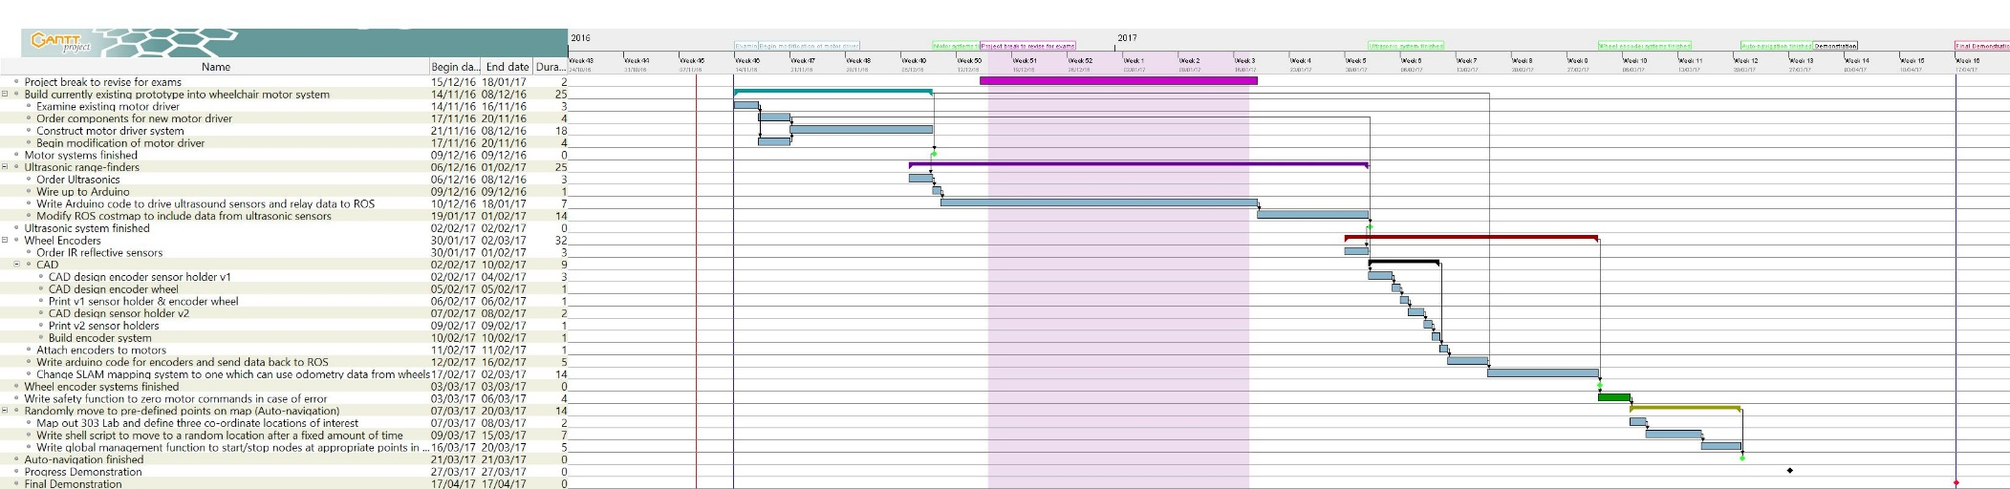

# Appendix 9 – Gantt chart – rev 2

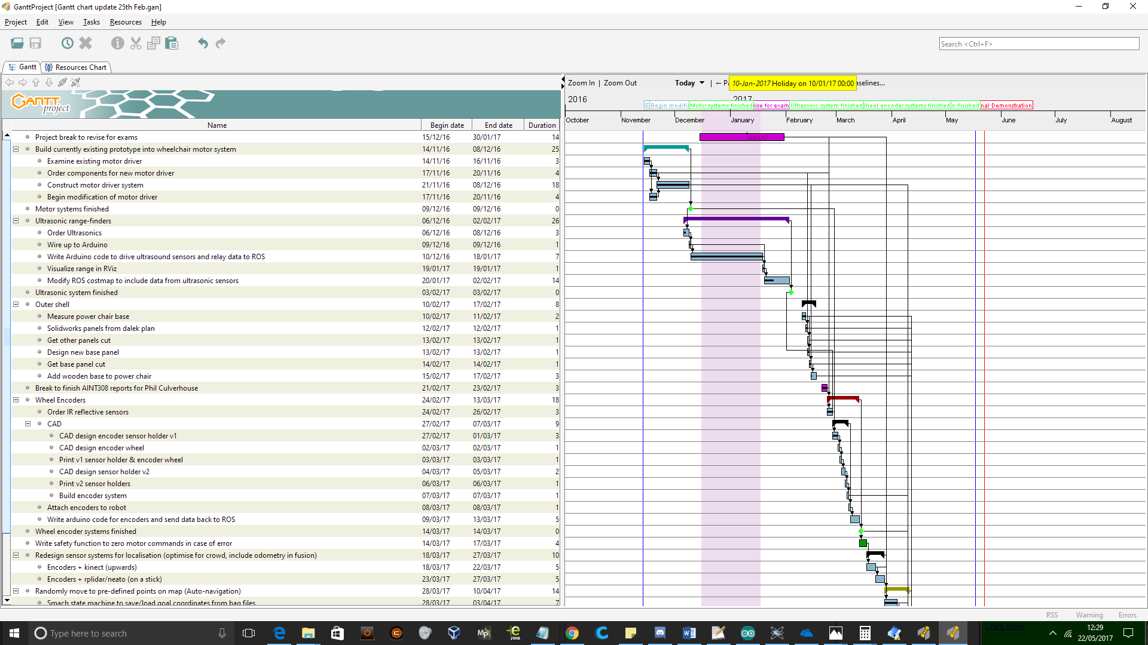

# Appendix 10 – Gantt chart - rev 3

